UNITED STATES

SECURITIES AND EXCHANGE COMMISSION

Washington, D.C. 20549

SCHEDULE 14A INFORMATION

Proxy Statement Pursuant to Section 14(a) of the

Securities Exchange Act of 1934

Filed by the Registrant ☒

Filed by a Party other than the Registrant ☐

Check the appropriate box:

- Preliminary Proxy Statement

- Confidential, For Use of the Commission Only (as permitted by Rule 14a-6(e)(2))

- Definitive Proxy Statement

- Definitive Additional Materials

- Soliciting Material Pursuant to §240.14a-12

FOOT LOCKER, INC.

(Name of Registrant as Specified in its Charter)

(Name of Person(s) Filing Proxy Statement, if Other Than the Registrant)

Payment of Filing Fee (Check the appropriate box):

- No fee required.

- Fee computed on table below per Exchange Act Rules 14a-6(i)(1) and 0-11.

  - Title of each class of securities to which transaction applies:

  - Aggregate number of securities to which transaction applies:

  - Per unit price or other underlying value of transaction computed pursuant to Exchange Act Rule 0-11 (Set forth the amount on which the filing fee is calculated and state how it was determined):

  - Proposed maximum aggregate value of transaction:

  - Total fee paid:

- Fee paid previously with preliminary materials.

- Check box if any part of the fee is offset as provided by Exchange Act Rule 0-11(a)(2) and identify the filing for which the offsetting fee was paid previously. Identify the previous filing by registration statement number, or the Form or Schedule and the date of its filing.

  - Amount Previously Paid:

  - Form, Schedule or Registration Statement No.:

  - Filing Party:

  - Date Filed:



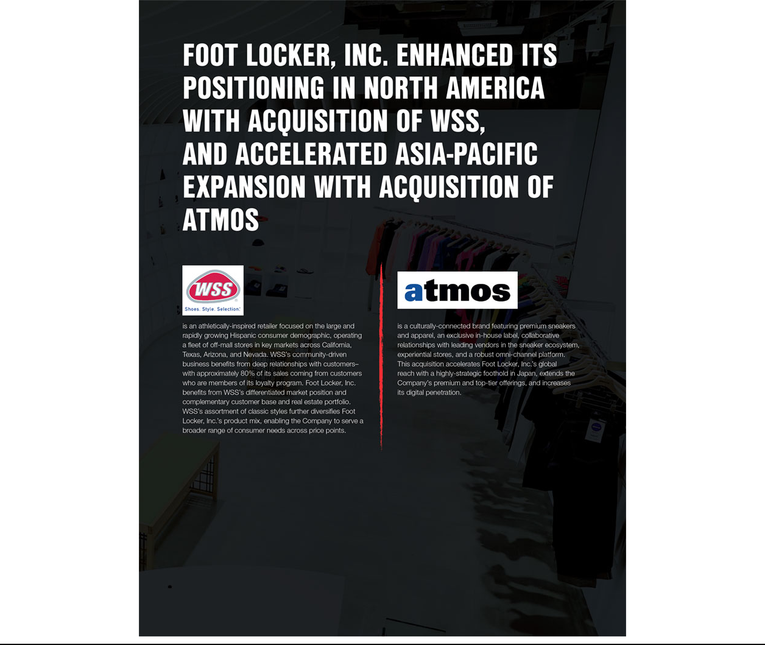



DEFINED TERMS | ii | EXECUTIVE COMPENSATION | 50
FORWARD-LOOKING STATEMENTS | iii | Compensation Discussion and Analysis | 50
FORWARD-LOOKING STATEMENTS | iii | Human Capital Committee Report | 69
NOTICE OF ANNUAL MEETING | 1 | Human Capital Committee Report | 69
NOTICE OF ANNUAL MEETING | 1 | Human Capital Committee Interlocks and Insider Participation | 69
MESSAGE FROM OUR CHAIRMAN AND CEO | 3 | Compensation and Risk | 69
ABOUT FOOT LOCKER, INC. | 5 | Summary Compensation Table | 70
ABOUT FOOT LOCKER, INC. | 5 | Employment Agreements and Other Arrangements | 72
Inspire and Empower Youth Culture | 5 | Employment Agreements and Other Arrangements | 72
Inspire and Empower Youth Culture | 5 | Grants of Plan-Based Awards in Fiscal 2021 | 74
Our Strategic Imperatives | 5 | Grants of Plan-Based Awards in Fiscal 2021 | 74
Our Strategic Imperatives | 5 | Outstanding Equity Awards at Fiscal 2021 Year-End | 78
Our ESG Program | 6 | Outstanding Equity Awards at Fiscal 2021 Year-End | 78
Our ESG Program | 6 | Option Exercises and Stock Vested in Fiscal 2021 | 87
Our Climate Stewardship | 6 | Option Exercises and Stock Vested in Fiscal 2021 | 87
Our Climate Stewardship | 6 | Pension Benefits in Fiscal 2021 | 87
Our Fiscal 2021 Highlights | 7 | Pension Benefits in Fiscal 2021 | 87
Our Fiscal 2021 Highlights | 7 | Defined Benefit Retirement Plans | 88
Emerging Stronger from the COVID-19 Pandemic | 7 | Defined Benefit Retirement Plans | 88
Emerging Stronger from the COVID-19 Pandemic | 7 | 401(k) Plan | 90
Learn More About Our Company | 7 | 401(k) Plan | 90
Learn More About Our Company | 7 | Nonqualified Deferred Compensation in Fiscal 2021 | 91
VOTING ROADMAP | 8 | Nonqualified Deferred Compensation in Fiscal 2021 | 91
VOTING ROADMAP | 8 | Potential Payments Upon Termination or Change in Control | 92
RECOGNITION | 13 | CEO Pay Ratio | 95
PROPOSAL 1: ELECTION OF DIRECTORS | 15 | ESG | 96
Director Nominees | 15 | PROPOSAL 3: ADVISORY VOTE ON | 98
Director Qualifications | 15 | FREQUENCY OF SAY-ON-PAY VOTES
Director Nominees at a Glance | 16 | PROPOSAL 4: RATIFICATION OF APPOINTMENT | 99
Director Nominees’ Skillset Matrix | 23 | OF OUR INDEPENDENT REGISTERED PUBLIC
GOVERNANCE | 25 | ACCOUNTING FIRM
GOVERNANCE | 25 | Audit and Non-Audit Fees | 100
Our Board of Directors | 25 | Audit and Non-Audit Fees | 100
Our Board of Directors | 25 | Audit Committee Preapproval Policies and Procedures | 100
Our Board’s Oversight of Our Business | 33 | Audit Committee Preapproval Policies and Procedures | 100
Our Board’s Oversight of Our Business | 33 | Audit Committee Report | 101
Shareholder Engagement | 38 | Audit Committee Report | 101
Shareholder Engagement | 38 | SHARE OWNERSHIP | 102
Communications with the Board | 39 | SHARE OWNERSHIP | 102
Majority Voting in the Election of Directors | 39 | Directors and Executive Officers | 102
Proxy Access | 39 | Principal Shareholders | 103
BOARD OF DIRECTORS | 40 | DEADLINES AND PROCEDURES FOR | 104
BOARD OF DIRECTORS | 40 | NOMINATIONS AND SHAREHOLDER
Committees | 41 | NOMINATIONS AND SHAREHOLDER
Committees | 41 | PROPOSALS FOR THE 2023 ANNUAL MEETING
Director Compensation | 43 | FREQUENTLY ASKED QUESTIONS | 105
Directors and Officers Indemnification and Insurance | 47 | FREQUENTLY ASKED QUESTIONS | 105
PROPOSAL 2: ADVISORY VOTE TO APPROVE |  | HELPFUL RESOURCES | 107
NEO COMPENSATION | 49
 |  | 2022 PROXY STATEMENT | i
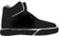



1165(e) Plan | Foot Locker Puerto Rico 1165(e) Plan, as amended and restated
401(k) Plan | Foot Locker 401(k) Plan, as amended and restated
Annual Incentive Plan | Foot Locker Executive Incentive Cash Compensation Plan
Annual Meeting | 2022 Annual Meeting of Shareholders
Annual Report | Annual Report on Form 10-K for the year ended January 29, 2022
Board | Board of Directors
CACM | Consistently Applied Compensation Measure
CAP | Compensation Advisory Partners
CCPA | California Consumer Privacy Act
CD&A | Compensation Discussion and Analysis
Common Stock | Foot Locker’s Common Stock, par value $0.01 per share
Company/Foot Locker | Foot Locker, Inc.
Corporate Headquarters | 330 West 34th Street, New York, New York 10001
DIBs | Diversity, Inclusion, and Belonging
DSU | Deferred Stock Unit (an accounting equivalent of one share of Common Stock)
DTC | Direct-to-Customer
EDT | Eastern Daylight Time
ERG | Employee Resource Group
ERISA | Employee Retirement Income Security Act of 1974, as amended
ESG | Environmental, Social, and Governance
ESPP | 2013 Foot Locker Employees Stock Purchase Plan
Excess Cash Plan | Foot Locker Excess Cash Balance Plan
Excess Savings Plan | Foot Locker Excess Savings Plan
Exchange Act | Securities Exchange Act of 1934, as amended
FASB | Financial Accounting Standards Board
FDRA | Footwear Distributors and Retailers of America
Finance Committee | Finance and Investment Oversight Committee
GAAP | U.S. Generally Accepted Accounting Principles
GDPR | EU General Data Protection Regulation
GHG | Greenhouse Gas
Human Capital Committee | Human Capital and Compensation Committee
IAP | International Assignment Policy
Interest Account | a hypothetical investment account bearing interest at the rate of 120% of the applicable federal long-term rate, compounded annually,
 | and set as of the first day of each plan year
IRC | Internal Revenue Code of 1986, as amended
LEED | Leading in Education and Economic Development
LTI | Foot Locker Long-Term Incentive Program
NACD | National Association of Corporate Directors
NEO | Named Executive Officer
Notice | Notice of Internet Availability of Proxy Materials
NPS | Net Promoter Score
NYSE | New York Stock Exchange
PCAOB | Public Company Accounting Oversight Board
PSU | Performance Stock Unit
Record Date | March 21, 2022
Responsibility Committee | Nominating and Corporate Responsibility Committee
Retirement Plan | Foot Locker Retirement Plan, as amended and restated
RILA | Retail Industry Leaders Association
ROIC | Return on Invested Capital
RSU | Restricted Stock Unit (time-based)
SASB | Sustainability Accounting Standards Board
SEC | U.S. Securities and Exchange Commission
SERP | Foot Locker Supplemental Executive Retirement Plan, as amended and restated
Stock Incentive Plan | Foot Locker 2007 Stock Incentive Plan, as amended and restated
TCFD | Task Force on Climate-related Financial Disclosures
TSR | Total Shareholder Return
VIF | Voting Instruction Form

- FOOT LOCKER, INC.




This Proxy Statement contains forward-looking statements within the meaning of the U.S. securities laws. Other than statements of historical facts, all statements that address activities, events, or developments that the Company anticipates will or may occur in the future, including, but not limited to, future merchandise and vendor mix, real estate opportunities, acquisitions, strategic partnerships, capital expenditures, dividend payments, share repurchases, strategic plans, financial objectives, growth of the Company’s business and operations, and other such matters, are forward-looking statements. These forward-looking statements are based on many assumptions and factors, which are detailed in the Company’s filings with the SEC.


These forward-looking statements are based largely on our expectations and judgments and are subject to a number of risks and uncertainties, many of which are unforeseeable and beyond our control. For additional discussion on risks and uncertainties that may affect forward-looking statements, see “Risk Factors” disclosed in the Annual Report and subsequent filings with the SEC. Any changes in such assumptions or factors could produce significantly different results. The Company undertakes no obligation to update forward-looking statements, whether as a result of new information, future events, or otherwise. Website references throughout this Proxy Statement are provided for convenience only, and the content on the referenced websites is not incorporated by reference into this Proxy Statement.

2022 PROXY STATEMENT _{iii}

This page intentionally left blank.



DATE AND TIME | VIRTUAL | RECORD DATE
May 18, 2022 at | MEETING SITE | Shareholders of record as of
9:00 a.m. EDT | virtualshareholdermeeting.com/FL2022 | March 21, 2022 can vote at
 |  | the Annual Meeting



All shares that have been properly voted and not revoked will be voted at the Annual Meeting. If you sign and return a proxy card but do not give voting instructions, the shares represented by that proxy card will be voted as recommended by the Board. Your vote is very important to us. Please vote your shares.

ITEMS OF BUSINESS

 | Board’s Voting | Vote Required
Proposal | Recommendation | to Approve
Item
 | FOR
Elect ten directors to the Board to serve for one-year terms | each of the
 | nominees
Item
Vote, on an advisory basis, to approve the Company’s NEOs’ | FOR
compensation | FOR
 |  | Majority of
 |  | Votes Cast by
Item |  | Shareholders
Vote, on an advisory basis, on whether the shareholder vote to | FOR
approve the Company’s NEOs’ compensation should occur every | FOR
approve the Company’s NEOs’ compensation should occur every | 1 year
1, 2, or 3 years | 1 year
Item
Ratify the appointment of KPMG LLP as the Company’s
independent registered public accounting firm for the 2022 fiscal | FOR
year




Transact such other business as may properly come before the Annual Meeting and at any adjournment or postponement of the meeting

2022 PROXY STATEMENT | 1

NOTICE OF ANNUAL MEETING

PROXY VOTING

You may vote using any of the following methods:

If you are located within the United States or Canada, you may vote your shares by calling 800-690-6903 and following the recorded instructions. Telephone voting is available 24 hours per day and will be accessible until 11:59 p.m. EDT on May 17, 2022. The telephone voting system has easy to follow instructions and allows you to confirm that the system has properly recorded your vote. If

TELEPHONE you vote by telephone, you do NOT need to return a proxy card or VIF.


 | You may scan the QR Code provided to you to vote your shares through the internet with your mobile device. Internet voting is
 | available 24 hours per day and will be accessible until 11:59 p.m. EDT on May 17, 2022. You will be able to confirm that the system
SCANNING | has properly recorded your vote. If you scan your QR code to vote, you do NOT need to return a proxy card or VIF.


AT THE

VIRTUAL
ANNUAL
MEETING


You may vote at the virtual Annual Meeting using the 16-digit control number included on your Notice, proxy card, and VIF that accompanied your proxy materials.

 | You may vote your shares through the internet at proxyvote.com. Internet voting is available 24 hours per day and will be accessible
 | until 11:59 p.m. EDT on May 17, 2022. You will be able to confirm that the system has properly recorded your vote. If you vote
INTERNET | through the internet, you do NOT need to return a proxy card or VIF.

MAIL

APP

If you received printed copies of the proxy materials by mail, you may vote by mail. Simply mark your proxy card or VIF, date and sign it, and return it in the postage-paid envelope that we included with your materials.

You may vote your shares by using the ProxyVote app. Download the app from the App Store or Google Play, scan or enter your control number, and vote. App voting is available 24 hours per day and will be accessible until 11:59 p.m. EDT on May 17, 2022. You will be able to confirm that the system has properly recorded your vote. If you vote using the app, you do NOT need to return a proxy card or VIF.

Important Notice Regarding the Availability of Proxy Materials for the Annual Meeting to be Held on May 18, 2022

The Company’s Proxy Statement and Annual Report are available at materials.proxyvote.com/344849.

April 8, 2022

SHEILAGH M. CLARKE

Executive Vice President, General Counsel and Secretary

- FOOT LOCKER, INC.



DEAR FELLOW SHAREHOLDERS:

Despite the many challenges we confronted and are continuing to experience—including impacts related to the COVID-19 pandemic, supply chain disruption, inflationary pressures, and an evolving geopolitical environment—we delivered record performance in 2021, which reflects the ongoing momentum we have built in our business. I believe the strategic decisions we have made throughout this period have put the Company in a position of strength to confront certain headwinds in the marketplace, including accelerated strategic shifts to DTC by our vendors, and succeed over the long term by creating shareholder value. Let me share with you a few recent highlights:

- Merchandise and Vendor Diversification. Our journey to diversify our mix of business and expand our reach as a house of brands is ongoing. We made significant progress diversifying our brands, categories, and channels in 2021. We also expanded our customer base across demographics and high-growth geographies with the acquisitions of WSS and atmos. We made investments in our omni-channel platform to advance our DTC offense and expanded our private label merchandise offerings. We will accelerate these initiatives and others in 2022 as a part of our long-term strategy to strengthen our position at the intersection of youth culture, sports and lifestyle, and the sneaker community.

- Investments in Growth. We added two high-growth companies–WSS and atmos–to the Foot Locker, Inc. family in 2021, each with its own differentiated strengths. These strategic acquisitions expand our customer base and geographic reach, strengthen our store footprint, and further diversify our product mix across consumers and price points. WSS, which we expect to double to approximately $1 billion of sales by 2024, gives us a strong off-mall presence in fast-growing markets with a full family offering and a special connection to the Hispanic community. atmos, which we expect to grow by 30% to approximately $300 million of sales over the next three years, provides us with a foothold in Japan and a key launching point into the rest of Asia with a digitally-led business model that combines premium product and creative collaborations to create excitement around the banner.

- Climate Stewardship. Management and the Board have established ESG as a priority for the Company. We are committed to helping our planet remain a sustainable home for current and future generations. Unabated climate change presents risks for our business, industry, and society, but through climate stewardship, we may unlock opportunities to innovate and strengthen our relationships with our customers and the communities we serve. We recently announced our ambition to achieve net zero GHG emissions by 2050 or sooner, in alignment with climate scientists’ recommendations to transition toward a net zero state and avoid the worst impacts of climate change. We have also committed to setting a science-based target in line with the criteria established by the Science Based Target initiative (SBTi) and report our progress against certain metrics regarding our GHG emissions annually in our Impact Report, which is available at investors.footlocker-inc.com/impactreport, and is aligned with the reporting disclosure guidance of the SASB industry standards and the TCFD recommendations. This announcement marks an important milestone in our ESG journey. As the Company looks to fiscal 2022 and beyond, we are committed to building on this progress and strengthening our vision for a more sustainable world. To learn more about our efforts to power a more sustainable future, see ESG on page 96, and our Global Environmental and Climate Change Statement, which is available at investors.footlocker-inc.com/climate.

- Human Rights. Our human capital is our most important asset. Protecting our team members, our customers, and the communities we serve is one of the most pressing challenges we face. We are proud to create jobs and secure livelihoods for our team members, provide products and engagement for our customers, support community development, and provide tax revenue for governments around the world to invest in the well-being of their


“Weknow that our customer demands choice across a variety of brands and categories, so we continue to work to broaden our selection, including leaning into brands where we are under-penetrated, introducing new brand partners, and developing our own private labels.”


people. Specifically, we have policies in place to ensure that we and our partners maintain work environments that respect and support human rights for everyone in our value chain around the world. This is a public good for all stakeholders. For additional information regarding our human rights efforts, see ESG on page 96, our Impact Report, which is available at investors.footlocker-inc.com/impactreport, our Global Human Rights Statement, which is available at investors.footlocker-inc.com/ humanrights, and our Global Sourcing Guidelines, which are available at investors.footlocker-inc.com/gsg.
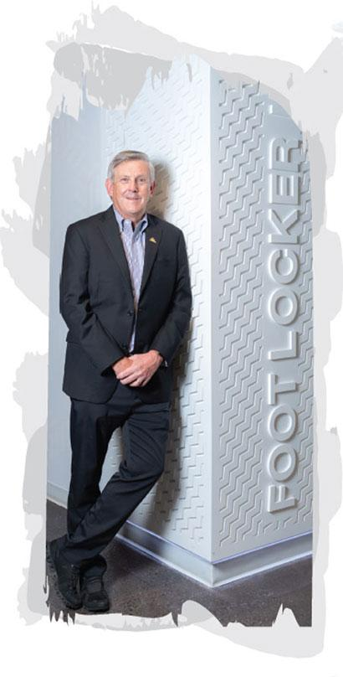
- Organizational Enhancements. In November 2021, we made certain organizational enhancements, including elevating Frank Bracken to the new role of Executive Vice President and Chief Operating Officer. The addition of a Chief Operating Officer creates a more streamlined and agile organizational structure that builds on the success of our geo-focused growth strategy. We believe we will be in a stronger position to address new and emerging opportunities and to grow our connectivity with our consumers and the communities we serve. In March 2022, we recruited Samantha Lomow from outside the Company as our first President, Global Brands, reporting to Frank, to oversee our global brand portfolio and operating divisions across North America, EMEA, and APAC. Also, as part of a planned succession strategy, in April 2021, we recruited Andrew Page from outside the Company as Executive Vice President and Chief Financial Officer, succeeding Lauren Peters, who retired from the Company. Each of these organizational enhancements underscores our focus on aligning our team to drive productivity while we continue to pursue our global growth agenda.

- Board Refreshment. I want to thank Matt McKenna who will be retiring from the Board at the Annual Meeting after serving for 16 years. Matt’s extensive financial experience has been an invaluable source of insights, and I can say on behalf of the Board and myself that he will be truly missed. I also welcome Gina Drosos who joined our Board in February. Gina is a dynamic and transformative leader with an impressive background and track record. She embodies what we seek from our directors–an agile mindset, proven leadership, and innovative thinking.

In addition to this Proxy Statement, I encourage you to review our Annual Report, which is available at investors.footlocker-inc.com/ar.

The Notice and this Proxy Statement each contains details of the business to be conducted at the Annual Meeting. Your vote is very important to us, so please vote your shares.

I am incredibly grateful to our team members, Board, customers, vendor partners, and shareholders.

Thank you for your support of our Company. I ask that you carefully consider the information in this Proxy Statement related to the proposals.

Sincerely,

RICHARD A. JOHNSON

Chairman and Chief Executive Officer

Learn more about the Board’s highlights from 2021 from our Lead Independent Director on page 28


INSPIRE AND EMPOWER YOUTH CULTURE

Foot Locker, Inc. (NYSE: FL) leads the celebration of sneaker and youth culture around the globe through a portfolio of brands, including Foot Locker, Kids Foot Locker, Champs Sports, Eastbay, atmos, WSS, Footaction, and Sidestep, including 2,858 operated stores, as well as websites and mobile apps, in 28 countries across North America, Europe, Asia, Australia, and New Zealand, in addition to 142 franchised stores in the Middle East and Asia.
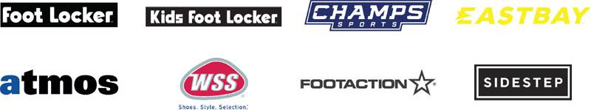

OUR STRATEGIC IMPERATIVES

We have established strategic imperatives for sustained performance centered around our customers:


2022 PROXY STATEMENT | 5

ABOUT FOOT LOCKER, INC.

OUR ESG PROGRAM

Management and the Board understand that how we achieve our purpose is just as important as what results we achieve. We have long established ESG as a priority for the Company and are continuing to improve the environmental and social impacts of our business, measure the impacts we are making, and communicate with and drive accountability to our stakeholders. Our global ESG program is focused on four pillars:


To learn more about our global ESG program, see ESG on page 96, and our Impact Report, which is presented consistent with the SASB reporting standards and TCFD reporting framework and is available at investors.footlocker-inc.com/impactreport.

OUR CLIMATE STEWARDSHIP

The Company recently announced its ambition to achieve net zero GHG emissions by 2050 or sooner.


For additional information regarding the Company’s efforts to power a more sustainable future, see ESG on page 96, the Company’s Impact Report, which is aligned with the reporting disclosure guidance of the SASB industry standards and the TCFD recommendations and is available at investors.footlocker-inc.com/impactreport, and the Company’s Global Environmental and Climate Change Statement, which is available at investors.footlocker-inc.com/climate.

- FOOT LOCKER, INC.

ABOUT FOOT LOCKER, INC.

OUR FISCAL 2021 HIGHLIGHTS

Despite the many challenges we confronted and are continuing to experience—including the COVID-19 pandemic, supply chain disruption, inflationary pressures, and an evolving geopolitical environment—we delivered record performance in 2021, which reflects the ongoing momentum we have built in our business. Highlights include the following:
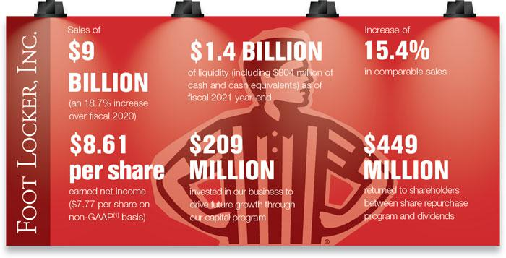

- A reconciliation to GAAP is provided beginning on page 21 of our Annual Report, which is available at investors.footlocker-inc.com/ar.

EMERGING STRONGER FROM THE

COVID-19 PANDEMIC

We recognize the human tragedy of the COVID-19 pandemic. Our foremost priority during the pandemic has been the health, safety, and security of our team members, our customers, and the communities we serve. Our approach is grounded in our Company’s purpose.

LEARN MORE ABOUT OUR COMPANY

You can learn more about the Company by visiting footlocker.com/corp. We also encourage you to read our Annual Report, which is available at investors.footlocker-inc.com/ar.

2022 PROXY STATEMENT | 7

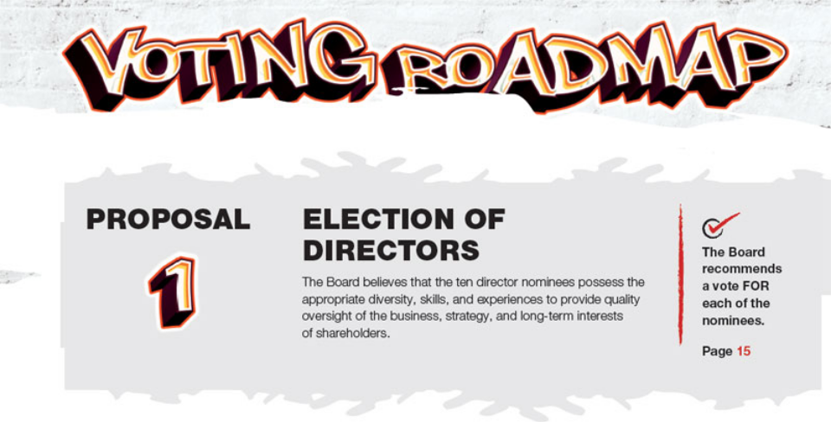

DEMOGRAPHICS

TENURE

- 7 years (Median)

- Directors with varied tenure contribute to a range of perspectives and ensure we transition knowledge and experience from longer-serving members to those newer to our Board. We have a good mix of new and longer-tenured directors.

AGE

- 63 years (Median)

DIVERSITY

- Our director nominees represent a diverse range of backgrounds—in terms of gender, age, ethnicity, skills, and business and board experience—with an equally diverse range of perspectives. What we share is a common desire to support and oversee management in achieving the Company’s purpose to inspire and empower youth culture.
- 70% of the director nominees are women or persons of color.
- 60% of our committees are chaired by women or persons of color.
- Our Responsibility Committee is focused on ensuring continued diversity on the Board during refreshment activities by requiring that candidate pools include diverse individuals meeting the relevant recruitment criteria.

SKILLS AND EXPERIENCES

We believe that our slate of director nominees possesses the appropriate mix of diversity in terms of skills, business and Board experience, and viewpoints.
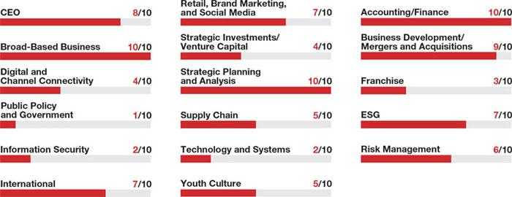

- FOOT LOCKER, INC.

VOTING ROADMAP
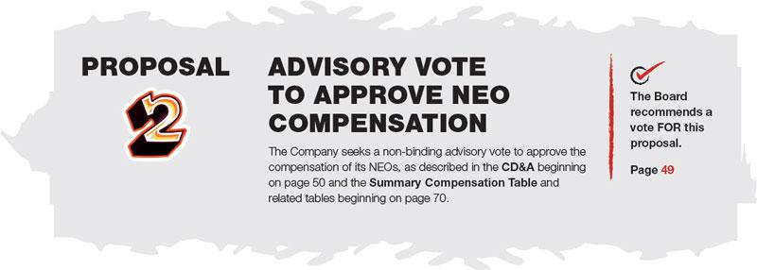

PAY-FOR-PERFORMANCE

The centerpiece of our compensation program is our pay-for-performance philosophy that aligns compensation payouts with the achievements of our annual operating plan and long-term strategy, and consequently shareholder value. This is showcased at senior levels of the Company—particularly the CEO—for which most compensation is tied to the Company’s operating and stock performance, as described below.

Factor | Description
Performance-Based | A significant proportion of the CEO’s compensation is performance-based.
 | Recent Annual Incentive Plan and LTI payouts underscore our pay-for-performance culture. For example, only twice in
Challenging Goals | the past five years has the Annual Incentive Plan paid out greater than target and three of the past five PSU awards
 | were not earned and paid out at 0%.
Formulaic | Our Annual Incentive Plan and LTI payouts are formulaically determined based on performance against challenging
Formulaic | financial and operating goals.
Lower Realized Pay | The CEO’s five-year realized pay is expected to be lower than his five-year target compensation.
Peer Benchmarked | We utilize an objective set of criteria to determine peer companies and position CEO pay at the peer group median.
Reasonable | 2021 compensation for newly-appointed and outgoing executives was reasonable.
Responsive to | Our Say-on-Pay support has been strong in recent years.
Say-on-Pay Vote | Our Say-on-Pay support has been strong in recent years.
Compensation Mix | Beginning with LTI awards granted in 2021, we adopted a consistent mix of PSU awards (60%), stock option awards
Compensation Mix | (20%), and RSU awards (20%).

Recent Annual Incentive Plan and LTI payouts underscore our pay-for-performance culture:

ANNUAL INCENTIVE PLAN PSU AWARDS
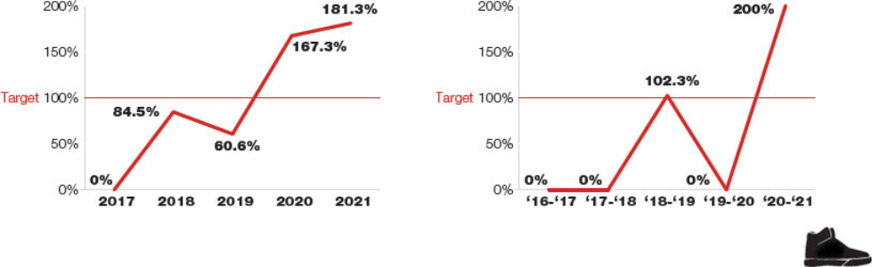

2022 PROXY STATEMENT | 9

VOTING ROADMAP

TARGET COMPENSATION VS. REALIZED PAY⁽¹⁾

Our executives’ realized pay over the past five years further reinforces our pay-for-performance philosophy. Failure to achieve the challenging threshold performance goals set for our Annual Incentive Plan awards and PSU awards results in no payout earned. Also, a decrease in the Company’s stock price results in a decrease in the value of previously-awarded stock option awards—potentially to $0—and no dilution to shareholders, as well as a decrease in the value of previously-awarded RSU awards. When our stock price increases and generates positive returns for our shareholders, the increase impacts an executive’s realized pay during the present fiscal year and for prior fiscal years during which the executive received equity awards that are held or still subject to vesting. Accordingly, a significant portion of our NEOs’ compensation is closely linked to the performance of our stock over time, motivating our executives to generate positive returns for shareholders.

The following chart demonstrates the relationship between the target and realized values of our CEO’s compensation for the past five years:
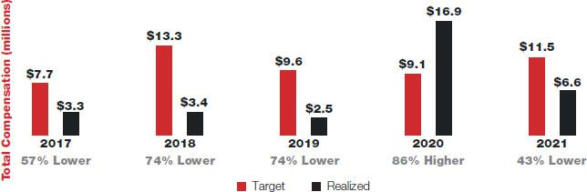

- For each year, these amounts reflect the CEO’s base salary paid, Annual Incentive Plan payouts paid, values of PSU awards earned, stock option award tranches vesting during the year, and RSU awards vesting during the year. For 2020, the CEO’s realized pay includes the value of a one-time Accelerate Future Growth award earned.

COMPENSATION MIX

The Human Capital Committee seeks to align the compensation program with both our business strategy and our shareholders’ interests. In order to achieve these objectives, our executive compensation program includes both a mix of annual and long-term, as well as cash and equity, compensation. As shown in the charts below, for 2021, 90% of the CEO’s target compensation mix, and 72%, on average, of the remaining NEOs’ target compensation mix, was performance based.

CEO’s 2021 TARGET COMPENSATION
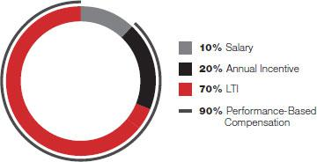

AVERAGE OF REMAINING NEOs’ 2021

TARGET COMPENSATION
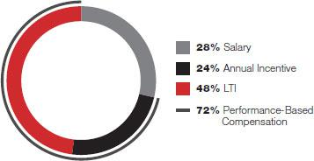

ANNUAL INCENTIVE PLAN

PERFORMANCE METRICS
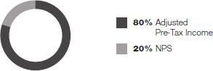

LTI PERFORMANCE METRICS


- FOOT LOCKER, INC.

VOTING ROADMAP
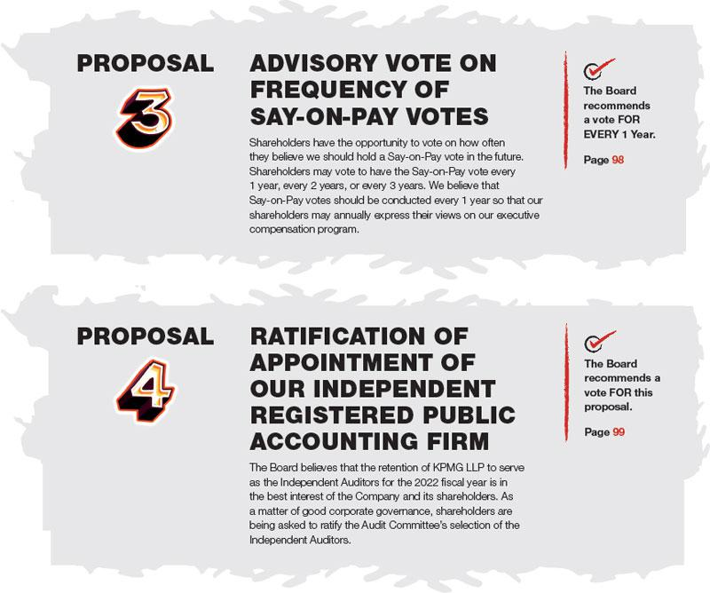

On or about April 8, 2022, we started mailing a Notice to our shareholders.

Proxies are being solicited by the Board to be voted at our Annual Meeting.

2022 PROXY STATEMENT | 11





2022 PROXY STATEMENT | 13

This page intentionally left blank.



There are currently 11 directors on our Board. Mr. McKenna will be retiring when his term expires at the conclusion of the Annual Meeting, and the Board has fixed the number of directors at 10 effective at such time. All current directors other than Mr. McKenna are standing for election for a one-year term at this meeting.

We have refreshed our Board over the past five years, as five highly-qualified directors were added to the Board and, as of the Annual Meeting, five directors will have retired during that time period. We believe that the Board possesses the appropriate mix of diversity in terms of gender, age, ethnicity, skills, business and Board experience, and viewpoints.

DIRECTOR NOMINEES

Our Responsibility Committee is charged with recommending director candidates to fill current and anticipated Board vacancies. The Responsibility Committee identifies and evaluates potential candidates from recommendations from the Company’s directors, management, shareholders, and other outside sources, including professional search firms. In evaluating proposed candidates, the Responsibility Committee may review their résumés, obtain references, and conduct personal interviews. The Responsibility Committee considers, among other factors, the Board’s current and future needs for specific skills and the candidate’s experience, leadership qualities, integrity, diversity, ability to exercise judgment, independence, and ability to make the appropriate time commitment to the Board. The Responsibility Committee strives to ensure the Board has a rich mix of relevant skills, diversity, and experiences to address the Company’s needs.

In 2021, the Responsibility Committee conducted a search to identify and recruit an independent director candidate based on specific criteria it previously established, including CEO experience in the specialty retail sector and expertise requirements under the NYSE rules to serve as an audit committee member. The Responsibility Committee reviewed its findings with the Board. In conducting its search, the Responsibility Committee collected names of potential candidates from the Company’s directors and engaged a third-party search firm to identify and recruit qualified candidates. After reviewing the qualifications of the potential pool of candidates and narrowing the field to a few candidates, the Lead Independent Director and Responsibility Committee Chair each interviewed the candidates, the Chairman reviewed the finalists, and the full Board met the finalist. Based on the Responsibility Committee’s review, the candidates’ résumés, and the other directors’ and Board’s interviews with the candidates, the Responsibility Committee recommended and the Board approved the election of Virginia C. Drosos, who was identified by the third-party search firm.

Virginia C. Drosos, Alan D. Feldman, Richard A. Johnson, Guillermo G. Marmol, Darlene Nicosia, Steven Oakland, Ulice Payne, Jr., Kimberly Underhill, Tristan Walker, and Dona D. Young will be considered for election as directors to serve for one-year terms expiring at the 2023 Annual Meeting. Each nominee has been nominated by the Board for election and has consented to serve. If, prior to the Annual Meeting, any nominee is unable to serve, then the persons designated as proxies for this meeting (Andrew E. Page, Sheilagh M. Clarke, and John A. Maurer) will have full discretion to vote for another person to serve as a director in place of that nominee, or the Board may reduce its size.

DIRECTOR QUALIFICATIONS

The Responsibility Committee reviewed and evaluated the skills, experience, and qualifications catalogued under the Director Nominees’ Skillset Matrix on pages 23 through 24, and demonstrated by the director nominees, in light of the Company’s long-term strategic plan.

The Board, acting through the Responsibility Committee, considers its members, including those directors being nominated for reelection to the Board at the Annual Meeting, to be highly qualified for service on the Board due to a variety of factors reflected in each director’s education, areas of expertise, and experience serving on other organizations’ boards during the past five years. Generally, the Board seeks individuals with broad-based experience and the background, judgment, independence, and integrity to represent the shareholders in overseeing the Company’s management in their operation of the business. Within this framework, specific items relevant to the Board’s determination for each director are listed in each director’s biographical information beginning on page 18. The ages shown are as of April 8, 2022. There are no family relationships among our directors or executive officers.

2022 PROXY STATEMENT | 15

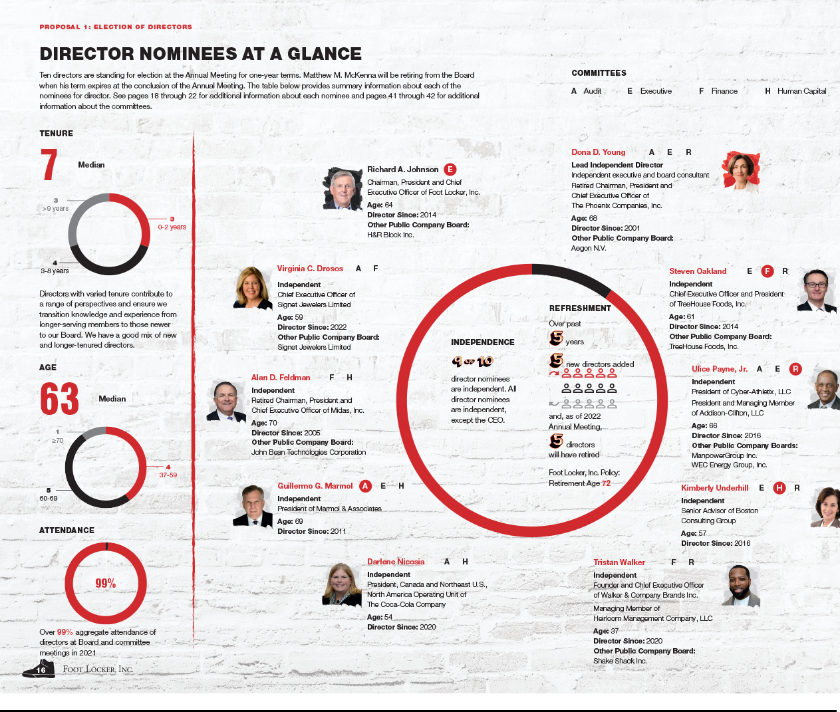

PROPOSAL 1: ELECTION OF DIRECTORS

RICHARD A. JOHNSON

Chairman and Chief Executive Officer

Age: 64
Director since: 2014

PROFESSIONAL EXPERIENCE

Foot Locker, Inc.

- Chairman, since May 2016
- President and Chief Executive Officer, since December 2014

OTHER BOARD SERVICE

- Director and member of the Audit and Compensation committees, H&R Block, Inc., since September 2015
- Director, Maidenform Brands, Inc., January 2013 to October 2013
- Chairman, RILA
- Director, FDRA
- Member, University of Wisconsin—Eau Claire National Leadership Council

REASONS FOR NOMINATION

Mr. Johnson has extensive experience as a retail company chief executive, including 25 years at the Company. He has led almost all of the Company’s major businesses in the United States, International, and Direct-to-Customer, has extensive knowledge of all facets of the Company’s business, and played an integral role in developing and executing the Company’s strategic plans.

COMMITTEE RELEVANT SKILLS


- FOOT LOCKER, INC.

DONA D. YOUNG


Lead Independent Director

Age: 68

Director since: 2001

PROFESSIONAL EXPERIENCE

Independent executive and board consultant

The Phoenix Companies, Inc. (insurance and asset management company)

- Chairman, President and Chief Executive Officer, April 2003 to April 2009

OTHER BOARD SERVICE

- Chairman of the Supervisory Board Risk Committee and member of the Supervisory Board Nomination and Governance Committee, Aegon N.V. (insurance, pension, and asset management company)

- Vice Chair of Audit Committee and member of the Nominating and Governance, and Compensation and Workforce committees, USAA (United Services Automobile Association)

- Director, member of the Compensation Committee, and Chair of the Nominating and Governance Committee, NACD
- Board Member, Spahn & Rose Lumber Co.
- Director and member of the Audit and Governance committees, Save the Children Association and Save the Children International (non-profit organizations)

- Director and member of the Audit Committee, Save the Children U.S.
- Trustee, Saint James School in Saint James, Maryland

REASONS FOR NOMINATION

Ms. Young has significant governance, legal, mergers and acquisitions, risk management, and financial experience given her prior service as a public company General Counsel, and later CEO, which are relevant in her role as Lead Independent Director. The education and experience Ms. Young acquired through her board service at Save the Children are useful in her oversight of the Company’s human rights efforts. In addition, she was named by the Financial Times’ Outstanding Directors Exchange as a member of its Outstanding Directors class of 2021, the NACD Directorship 100 for 2015, and a NACD Board Leadership Fellow since 2013. She is NACD Directorship Certified™, completed the NACD Cyber-Risk Oversight Program, earned a CERT Certificate in Cybersecurity Oversight conferred by Carnegie Mellon University, and was a 2012 Advanced Leadership Fellow at Harvard University.

COMMITTEES RELEVANT SKILLS

A E R
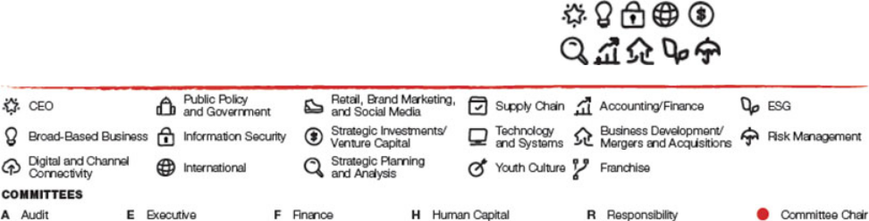

VIRGINIA C. DROSOS


Independent Director

Age: 59
Director since: 2022

PROFESSIONAL EXPERIENCE

Signet Jewelers Limited (specialty jewelry retailer)

- Chief Executive Officer, since August 2017 Assurex Health, Inc. (personalized medicine company)
- President and Chief Executive Officer, August 2013 to July 2017

OTHER BOARD SERVICE

- Director, Signet Jewelers Limited, since 2012
- Director, Akron Children’s Hospital, since April 2019
- Director, American Financial Group, Inc., 2013 to December 2021
- Director, Assurex Health, Inc., August 2013 to July 2017

REASONS FOR NOMINATION

Ms. Drosos brings valuable skills and insights to the Board, including proven expertise in strategy, branding, marketing, digital commerce, and global operations. She has proven retail expertise in mergers and acquisitions and business expansions into new product lines, retail channels, and geographies. Ms. Drosos is the sitting CEO of a specialty retailer, she is a visionary and transformational leader with an entrepreneurial mindset, and she has a proven track record of growing and scaling global businesses through deep consumer understanding, product and experience innovation, and heightened employee engagement. Further, Ms. Drosos is actively involved in financial planning issues as the CEO of a public company, providing her with relevant expertise as a member of the Audit Committee and Finance Committee.

COMMITTEES RELEVANT SKILLS

A F
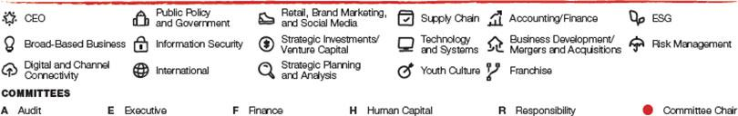


PROPOSAL 1: ELECTION OF DIRECTORS

ALAN D. FELDMAN


Independent Director

Age: 70
Director since: 2005

PROFESSIONAL EXPERIENCE

Midas, Inc. (automotive repair and maintenance service provider)

- Chairman, President and Chief Executive Officer, May 2006 to April 2012
- President and Chief Executive Officer, January 2003 to April 2006

OTHER BOARD SERVICE

- Director, John Bean Technologies Corporation, since July 2008
- Director, GNC Holdings, Inc., June 2013 to June 2020
- Director, Foundation Board, University of Illinois Foundation, since September 2012

REASONS FOR NOMINATION

Mr. Feldman has extensive chief executive, financial, and franchised retail experience as the former CEO of a public company specializing in retail franchises, providing him with relevant expertise as a member of the Human Capital Committee and Finance Committee.

COMMITTEES RELEVANT SKILLS

F H


2022 PROXY STATEMENT | 19

PROPOSAL 1: ELECTION OF DIRECTORS

GUILLERMO G. MARMOL


Independent Director

Age: 69

Director since: 2011

PROFESSIONAL EXPERIENCE

Marmol & Associates (consulting firm that provides advisory services and investment capital to early-stage technology companies)

- President, since March 2007 and October 2000 to May 2003

OTHER BOARD SERVICE

- Non-executive Chief Executive Officer, Viron Therapeutics Holdings Inc., since 2021
- Director and Audit Committee member, Morae Global Corporation, until August 2021
- Director, Vitamin Shoppe, Inc., February 2016 to December 2019
- Chair of the Board of Trustees, Center for a Free Cuba

REASONS FOR NOMINATION

Mr. Marmol has a significant background in information technology and systems, which is highly important to the Company as we continue to invest in our technology and systems and build a more powerful digital business to connect with our customers. Mr. Marmol also has extensive executive, financial, strategic analysis, and business process experience as a management consultant at Marmol & Associates and McKinsey & Company and a former senior executive officer of Luminant Worldwide Corporation, Electronic Data Systems Corporation, and Perot Systems Corporation, providing him with relevant expertise as a member of the Human Capital Committee and Audit Committee Chair.

COMMITTEES RELEVANT SKILLS
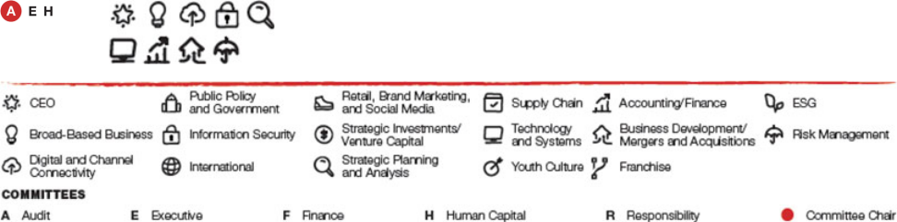

- FOOT LOCKER, INC.

DARLENE NICOSIA


Independent Director

Age: 54
Director since: 2020

PROFESSIONAL EXPERIENCE

The Coca-Cola Company (beverage company)

- President, Canada and Northeast U.S., North America Operating Unit, since January 2021
- President of the Canada Business Unit, January 2019 to January 2021
- Vice President, Commercial Product Supply, May 2016 to January 2019

OTHER BOARD SERVICE

- Advisory Board Member, Georgia Institute of Technology, Scheller College of Business
- Chair of the Board, Canadian Beverage Association
- Member, Food, Health, and Consumer Products of Canada Association

REASONS FOR NOMINATION

Ms. Nicosia brings to our Board a broad-based global business background, particularly brand-building and global supply chain management, gained through her experience in the consumer products industry. Throughout her career, Ms. Nicosia has led sustainability initiatives and navigated complex regulatory environments and shifting consumer preferences. Her extensive understanding of supply chain, marketing operations, third-party risk management, and business transformation is an asset to our Board, particularly our Audit Committee and Human Capital Committee.

COMMITTEES RELEVANT SKILLS

A H



STEVEN OAKLAND


Independent Director

Age: 61
Director since: 2014

PROFESSIONAL EXPERIENCE

TreeHouse Foods, Inc. (manufacturer of packaged foods and beverages)

- Chief Executive Officer and President, since March 2018

The J.M. Smucker Company (manufacturer of packaged foods and beverages)

- Vice Chair and President, U.S. Food and Beverage, May 2016 to March 2018
- President, Coffee and Foodservice, April 2015 to April 2016

OTHER BOARD SERVICE

- Director, TreeHouse Foods, Inc.
- Director and member of Compensation committee, Foster Farms
- Director, Food Industry Association
- Director, MTD Products, Inc., until December 2021

REASONS FOR NOMINATION

Mr. Oakland brings to our Board a broad-based business background and extensive experience in domestic and international consumer products operations, with particular strengths around business development, mergers and acquisitions, risk management, strategic planning, customer engagement, marketing, and brand building. Mr. Oakland is actively involved in governance and financial matters as the sitting CEO of a public company, providing him with relevant expertise as a member of the Responsibility Committee and Finance Committee Chair.

COMMITTEES RELEVANT SKILLS


PROPOSAL 1: ELECTION OF DIRECTORS

ULICE PAYNE, JR.


Independent Director

Age: 66

Director since: 2016

PROFESSIONAL EXPERIENCE

Cyber-Athletix, LLC (esports healthcare company)

- President, since March 2021

Addison-Clifton, LLC (global trade compliance advisory services provider)

- President and Managing Member, since May 2004

OTHER BOARD SERVICE

- Director and member of the Audit and Governance and Sustainability committees, ManpowerGroup, Inc.
- Director and member of the Finance Committee and Compensation Committee Chair, WEC Energy Group, Inc.
- Director, Wisconsin Conservatory of Music
- Director, The Northwestern Mutual Life Insurance Company, January 2005 to May 2018

REASONS FOR NOMINATION

Mr. Payne brings to our Board significant governance, operational, financial, public service, trade compliance, and international experience as a result of the many senior positions he has held, including as President and Managing Member of Addison-Clifton, LLC since May 2004, President and Chief Executive Officer of the Milwaukee Brewers Baseball Club from September 2002 to December 2003, Managing Partner of Foley & Lardner, LLP from 2001 to 2002, Partner of Foley & Lardner, LLP from February 1998 to September 2002, and the Wisconsin Commissioner of Securities from February 1985 to December 1987. Mr. Payne’s extensive experience provides him with relevant expertise as a member of the Audit Committee and Responsibility Committee Chair.

COMMITTEES RELEVANT SKILLS


2022 PROXY STATEMENT | 21

PROPOSAL 1: ELECTION OF DIRECTORS

KIMBERLY UNDERHILL


Independent Director

Age: 57

Director since: 2016

PROFESSIONAL EXPERIENCE

Boston Consulting Group (management consulting firm)

- Senior Advisor, since November 2021

Kimberly-Clark Corporation (manufacturer of branded personal care, consumer tissue, and professional healthcare products)

- President, North America Consumer, May 2018 to September 2021
- Global President of Kimberly-Clark Professional, April 2014 to May 2018

OTHER BOARD SERVICE

- Advisory board member, Rawhide Youth Services
- Director, Board of Trustees, ThedaCare
- Co-Chair and Leadership Giving Chair, United Way Fox Cities Campaign
- Director and Compensation Committee Chair, Network of Executive Women, until 2021
- Director, Kimberly-Clark de Mexico, S.A.B. de C.V., until September 2021
- Director, Food Industry Association, until 2021

REASONS FOR NOMINATION

Ms. Underhill brings to our Board a broad-based business background and extensive experience in domestic and international consumer products operations, with particular strengths in marketing, brand building, strategic planning, international business, and business development. She is NACD Directorship

CertifiedTM. Ms. Underhill’s management resources experience from her prior service as a senior executive of a public company is relevant to both our Human Capital Committee, of which she is Chair, and Responsibility Committee, of which she is a member.

COMMITTEES RELEVANT SKILLS
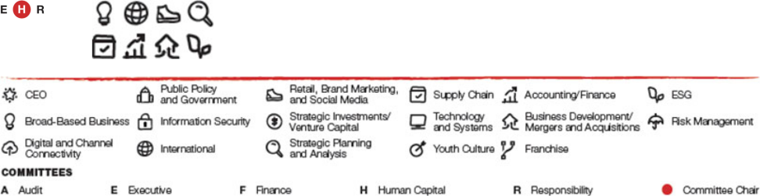

TRISTAN WALKER


Independent Director

Age: 37

Director since: 2020

PROFESSIONAL EXPERIENCE

Walker & Company Brands Inc. (manufacturer of health and beauty products for persons of color), a subsidiary of the Procter & Gamble Company

- Founder and Chief Executive Officer, since April 2013 Heirloom Management Company, LLC (micro venture capital fund)
- Managing Member, since March 2022

OTHER BOARD SERVICE

- Director, Shake Shack, Inc.
- Trustee, Children’s Healthcare of Atlanta
- Chairman, CODE2040 (non-profit organization that matches high-performing Black and Latino software engineering students and graduates with technology firms and start-ups), until January 2020

REASONS FOR NOMINATION

Mr. Walker’s brand marketing and technology experience are deeply connected to the mission of designing solutions for consumers while bridging the gap between technology product innovation and youth culture. Mr. Walker understands how to utilize innovation and technology to drive change and deliver growth. His work at the intersection of technology and the consumer experience benefits our Board, and his financial and ESG experience as a CEO provides him with relevant expertise as a member of the Finance Committee and Responsibility Committee.

COMMITTEES RELEVANT SKILLS

F R



- FOOT LOCKER, INC.

PROPOSAL 1: ELECTION OF DIRECTORS

DIRECTOR NOMINEES’ SKILLSET MATRIX

We believe that the director nominees possess the appropriate mix of diversity in terms of gender, age, ethnicity, skills, business and Board experience, and viewpoints. We have refreshed our Board over the past five years, as five highly-qualified directors were added to the Board and, as of the Annual Meeting, five directors will have retired during that time period.
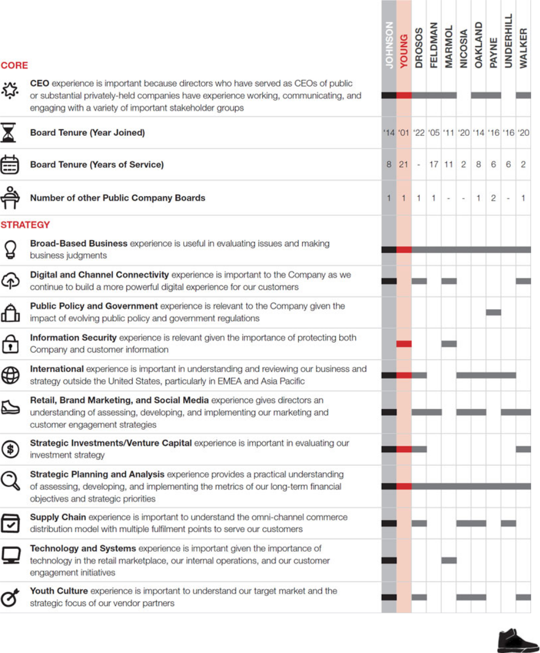

2022 PROXY STATEMENT | 23

PROPOSAL 1: ELECTION OF DIRECTORS

Each director is individually qualified to make unique and substantial contributions. Collectively, our directors’ diverse viewpoints and independent-mindedness enhance the quality and effectiveness of Board deliberations and decision making. This blend of qualifications, attributes, and tenure results in highly-effective oversight.
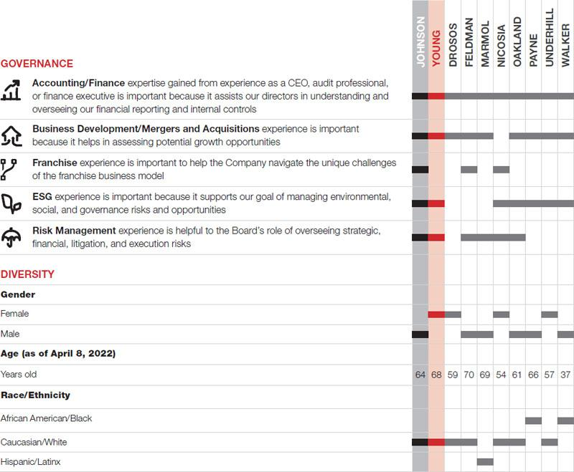

- FOOT LOCKER, INC.


OUR BOARD OF DIRECTORS

Our By-Laws provide for a Board consisting of between 7 and 13 directors. The exact number of directors is determined from time to time by the entire Board. There are currently 11 directors on our Board. Mr. McKenna will be retiring when his term expires at the conclusion of the Annual Meeting, and the Board has fixed the number of directors at 10 effective at such time.

DIRECTORS’ INDEPENDENCE

A director is not considered independent under NYSE rules if they have a material relationship with the Company that would impair their independence. In addition to the independence criteria established by the NYSE, the Board has adopted categorical standards to assist it in making its independence determinations regarding individual directors. These categorical standards are contained in the Corporate Governance Guidelines, which are available at investors.footlocker-inc.com/cgg.

The Board has determined that the following categories of relationships are immaterial for purposes of determining whether a director is independent under the NYSE listing standards:

Categorical Relationship | Description
Investment Relationships with the Company | A director and any family member may own equities or other securities of
 | the Company.
Relationships with Other Business Entities | A director and any family member may be a director, employee (other
 | than an executive officer), or beneficial owner of less than 10% of the
 | shares of a business entity with which the Company does business,
 | provided that the aggregate amount involved in a fiscal year does not
 | exceed the greater of $1 million or 2% of either that entity’s or the
 | Company’s annual consolidated gross revenue.
Relationships with Not-for-Profit Entities | A director and any family member may be a director or employee (other
 | than an executive officer or the equivalent) of a not-for-profit organization
 | to which the Company (including the Foot Locker Foundation) makes
 | contributions, provided that the aggregate amount of the Company’s
 | contributions in any fiscal year do not exceed the greater of $1 million or
 | 2% of the not-for-profit entity’s total annual receipts.

We individually inquire of each of our directors and executive officers about any transactions in which the Company and any of these related persons or their immediate family members are participants. We also make inquiries within the Company’s records for information on any of these kinds of transactions. Once we gather the information, we then review all relationships and transactions of which we are aware in which the Company and any of our directors, executive officers, their immediate family members, or 5% shareholders are participants to determine, based on the facts and circumstances, whether the related persons have a direct or indirect material interest. Our General Counsel’s office coordinates the related person transaction review process. The Responsibility Committee reviews any reported transactions involving directors and their immediate family members in making its recommendation to the Board on the independence of the directors. In approving, ratifying, or rejecting a related person transaction, the Responsibility Committee considers such information as it deems important to determine whether the transaction is on reasonable and competitive terms and is fair to the Company. The Company’s written policies and procedures for related person transactions are included within both the Corporate Governance Guidelines and the Code of Business Conduct. There were no related person transactions in 2021.

2022 PROXY STATEMENT | 25

GOVERNANCE

The Board, upon the recommendation of the Responsibility Committee, has determined that the following directors are independent under the NYSE rules because they have no material relationship with the Company that would impair their independence:


DONA D. | VIRGINIA C. | ALAN D. | GUILLERMO G. | MATTHEW M.
YOUNG | DROSOS | FELDMAN | MARMOL | MCKENNA
Age: 68 | Age: 59 | Age: 70 | Age: 69 | Age: 71
Director since: 2001 | Director since: 2022 | Director since: 2005 | Director since: 2011 | Director since: 2006
Lead Independent
Director


DARLENE | STEVEN | ULICE | KIMBERLY | TRISTAN
NICOSIA | OAKLAND | PAYNE, JR. | UNDERHILL | WALKER
Age: 54 | Age: 61 | Age: 66 | Age: 57 | Age: 37
Director since: 2020 | Director since: 2014 | Director since: 2016 | Director since: 2016 | Director since: 2020

directors are independent. All directors are independent, except the CEO.


- FOOT LOCKER, INC.

Maxine Clark served as a director of the Company during 2021 until her retirement from the Board in May 2021. The Board determined that Ms. Clark was independent under NYSE rules through the end of her term as a director because she had no material relationship with the Company that would impair her independence.

In making its independence determination, the Board reviewed recommendations of the Responsibility Committee and considered Mr. Payne and Ms. Young’s relationships as directors of companies with which we do business. The Board has determined that these relationships meet the categorical standard for Relationships with Other Business Entities and are immaterial with respect to determining independence.

The Board has determined that all members of the Audit Committee, the Finance Committee, the Human Capital Committee, and the Responsibility Committee are independent as defined under the NYSE listing standards and the director independence standards adopted by the Board.

GOVERNANCE

BOARD TENURE AND TERM LIMITS

The Company is focused on having a well-constructed and high-performing Board. To that end, the Responsibility Committee selects director nominees who think and act independently and can clearly and effectively communicate their convictions. The Board does not believe long tenure alone presumptively renders a director to not be independent. Conversely, the Board recognizes the contributions experienced directors add to the Board. The Board has determined that its longer-tenured directors have important experience, bring diverse perspectives, and provide tangible value to the Board and the Company. The Board has also determined that their length of tenure has allowed these directors to accumulate valuable knowledge and experience based upon their history with the Company. This knowledge and experience improves the ability of the Board to provide constructive guidance and informed oversight to management. Furthermore, in the Board’s opinion, the length of tenure of its members has not in any way impaired the willingness of any director to question and confront any issue or exercise independent and impartial oversight of the Company in any area. The Board benefits from the contributions of its experienced directors who have developed insight into the Company over the course of their service on the Board.

The Responsibility Committee has specifically considered the feedback of some shareholders as well as the discussions of some commentators that suggest lengthy Board tenure should be balanced with new perspectives. Specific to the Company, the Responsibility Committee has structured the Board such that there are directors of varying tenures, with new directors and perspectives joining the Board over time while retaining the institutional memory of longer-tenured directors. Longer-tenured directors, balanced with newer directors, enhance the Board’s oversight capabilities. The Board believes it is important to balance refreshment with the need to retain directors who have developed, over time, significant insight into the Company and its operations and who continue to make valuable contributions to the Company that benefit our shareholders. The Board believes that it has an appropriate mix of longer-tenured directors and newer directors, which provides an appropriate and dynamic balance.

Furthermore, the Board has not adopted formal director term limits, in part, because the imposition of director term limits on a board implicitly discounts the value of experience and continuity among directors and runs the risk of excluding experienced and potentially valuable directors as a result of an arbitrary determination. In addition, imposing this restriction means the Board would lose the contributions of longer-tenured directors who have developed a deeper knowledge and understanding of the Company over time. The Board does not believe that long tenure impairs a director’s ability to act independently of management.

BOARD LEADERSHIP STRUCTURE

Our Board evaluates, from time to time as appropriate, whether the same person should serve as Chairman and CEO, or whether the positions should be held by different persons, in light of all relevant facts and circumstances and what it considers to be in the best interests of the Company and our shareholders. Since May 2016, the positions of Chairman and CEO have been held by Mr. Johnson, with Ms. Young serving as Lead Independent Director. The Board has utilized various leadership structures since 2010, as shown below:
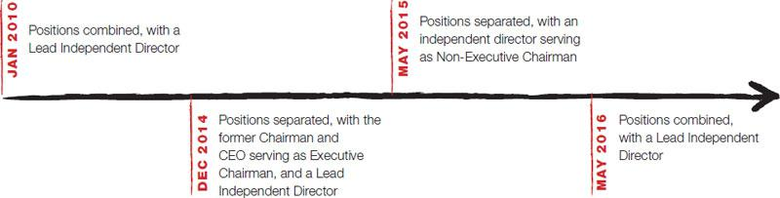

The Board believes that, based on the Company’s current facts and circumstances, its Board leadership structure is appropriate.

2022 PROXY STATEMENT | 27

GOVERNANCE

LEAD INDEPENDENT DIRECTOR

The Board believes that, because the positions of Chairman and CEO are combined, a lead independent director is appropriate.

The Lead Independent Director’s responsibilities include:

- presiding at executive sessions of the independent directors, and Board meetings at which the Chairman is absent;

- attending meetings of each of the Board committees;

- encouraging and facilitating active participation by, and communication among, all directors;
- serving as the liaison between the independent directors and the Chairman;

- approving Board meeting agendas and schedules after conferring with the Chairman and other members of the Board, as appropriate, and adding agenda items in her discretion;

- possessing the authority to call meetings of the independent directors;

- leading the Board’s annual CEO performance evaluation;

- advising the Chairman and the committee chairs in fulfilling their designated roles and responsibilities; and

- performing such other functions as the Board or other directors may request.

The Board periodically considers the rotation of the Lead Independent Director, taking into account experience, continuity of leadership, and the best interests of the Company.

Ms. Young currently serves as the Lead Independent Director. The Board believes that Ms. Young is well suited to serve as Lead Independent Director, given her governance, business, and financial background. The Board also recognizes that it benefits from Ms. Young’s tenure as an experienced director who has developed insight into the Company over the course of her service on the Board, which improves her ability to provide constructive, independent, and informed guidance and oversight to management.

- FOOT LOCKER, INC.

NOTE FROM OUR LEAD INDEPENDENT DIRECTOR


Despite the many challenges we confronted and are continuing to experience—including impacts related to the COVID-19 pandemic, supply chain disruption, inflationary pressures, and an evolving geopolitical environment—we delivered record performance in 2021. While it is important to celebrate this achievement, the Board, like management, never rests because we recognize certain headwinds in the marketplace. Our Board is engaged in confronting these challenges and believes that our strategic plan puts the Company in a position of strength. On behalf of the Board, I am pleased to share with you some highlights of the governance work we have done to navigate these challenges and make strategic choices to create long-term, consistent shareholder value:

- Long-Term Strategy Oversight. The Board has overseen the long-term strategy initiatives implemented in 2021 to diversify our brands, categories, and channels, as well as expand our demographic and geographic customer base with the acquisitions of WSS and atmos. As the business and industry continue to evolve, the Board remains engaged and committed to accelerating certain initiatives in 2022 as a part of our long-term strategy to address the accelerated strategic shift to DTC by our vendors while also returning capital to shareholders, including further diversification of our merchandise and vendor mix, accelerating our off-mall pivot and key growth banner rollout, enhancing omni-channel evolution efforts, and implementing a new cost savings program.

- Board Refreshment. Ongoing Board refreshment is critical to ensure we have the right mix of skills, diversity, and expertise to support the Company’s progress. We recently strengthened our Board with the election of Gina Drosos in February 2022 in anticipation of Matt McKenna’s retirement from the Board in May 2022. Gina brings significant financial, industry, and operational experience from her current role as a sitting CEO of a speciality retailer.

- Succession Planning. The Board believes that a high-performing management team is critical to our success as a global brand that leads with purpose. To ensure we have the appropriate succession plan in place, the full Board is engaged in a long-term process with management to maximize the pool of emerging diverse talent who possess the skills, experiences, and attributes required to be effective leaders in light of the Company’s global business strategies, opportunities, and challenges. For additional information, see Human Capital Management and Succession Planning Oversight on page 34.

- Shareholder Engagement. Our Board serves at the pleasure of you, our shareholders. Therefore, as a Board, one of our highest priorities is hearing from you, our shareholders, who have entrusted us with this responsibility. For the past five years, I have led, on behalf of our Board, a structured and governance-focused shareholder engagement program designed to accomplish this by facilitating transparency and creating a platform to receive shareholder feedback to share with the Board. For additional information, see Shareholder Engagement on page 38.

- ESG. ESG is embedded in our ability to achieve our strategic imperatives. The Board has worked with management in its oversight capacity to support the integration of its ESG efforts into its over-arching growth strategy, as illustrated in our Impact Report. For example, we believe DIBs is a strategic business driver. Management and the Board have been tested in multiple ways throughout the pandemic and our diversity has proven to be an important asset, which has led us to make better strategic decisions. For additional information regarding our global ESG program and Board oversight, see ESG on page 96, ESG Oversight on page 35, and our Impact Report, which is available at investors.footlocker-inc.com/impactreport.

The Board is incredibly grateful to all our stakeholders for their continued commitment to supporting the Company.

“While the Board knows that it is important to celebrate the Company’s record performance in 2021, the Board, like management, never rests because we recognize certain headwinds in the marketplace and our oversight responsibility to make the strategic decisions necessary to create long-term, consistent value for you, our shareholders.”

DONA D. YOUNG

Lead Independent Director

GOVERNANCE

DIRECTOR ON-BOARDING

We have a two-phase on-boarding program for new directors that is intended to educate a new director on the Company and the Board’s practices:
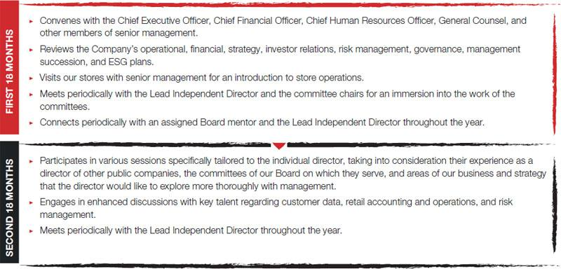

DIRECTOR CONTINUING EDUCATION

Director education is an ongoing process, which begins when a director joins our Board. We host quarterly Board and committee presentations and separate education sessions to keep directors appropriately apprised of key developments concerning the following topics so they can effectively carry out their oversight responsibilities:


We also encourage all directors to attend other continuing education programs to maintain their expertise and share takeaways with the other directors on these programs. We reimburse directors for reasonable expenses incurred in attending continuing education programs. Our directors have attended a variety of continuing education programs, conferences, and events hosted by universities, trade groups, law firms, accounting firms, and other advisory service firms on a variety of topics, including the following:
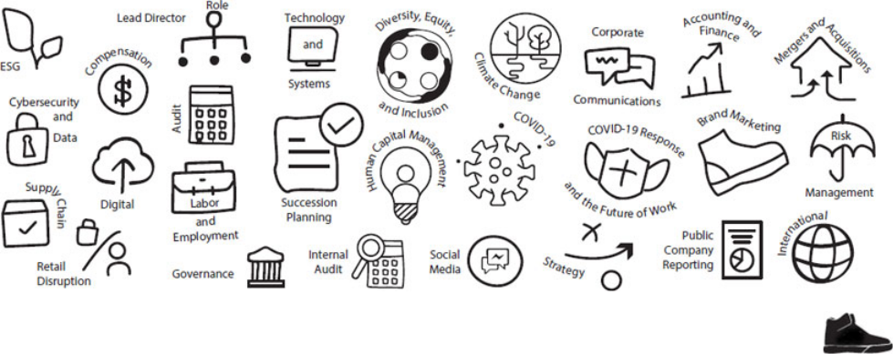

2022 PROXY STATEMENT | 29

GOVERNANCE

MANDATORY RESIGNATION OR RETIREMENT

The Board has established a policy whereby a non-employee director is required to advise the Responsibility Committee Chair of any change to their principal employment. If requested by the Responsibility Committee Chair, after consultation with the other members of the Responsibility Committee, the director is required to submit a letter of resignation to the Responsibility Committee Chair, for the Responsibility Committee to consider.

The Corporate Governance Guidelines also require that directors retire from the Board at the annual meeting following the director’s 72nd birthday.

CORPORATE GOVERNANCE GUIDELINES

The Corporate Governance Guidelines assist the Board in the exercise of its governance responsibilities and serve as a framework within which the

Board may conduct its business, including the following duties:

► Director Responsibilities | ► Director Independence | ► Director Qualifications
► Board Leadership | ► Board Committees | ► Director Retirement Policy
► Change in Director’s Principal Employment | ► Director Resignation Policy | ► Setting Board Meeting Agendas
► Media and Stakeholder Engagement | ► Board Access to Management and Independent Advisors | ► Director Compensation
► Stock Ownership Guidelines | ► Director On-Boarding | ► Director Continuing Education
► Human Capital Management and Succession | ► CEO and Board Evaluations | ► Policy on Outside Directorships
Planning Oversight

The Board periodically reviews the guidelines and revises them, as appropriate. The Corporate Governance Guidelines are available at investors.footlocker-inc.com/cgg.

BOARD ATTENDANCE

The Board held 11 meetings during 2021. Each director attended at least 95% of the aggregate of all Board and committee meetings for the committees on which they served during 2021.

The Board holds regularly-scheduled executive sessions of independent directors in conjunction with each Board meeting. Ms. Young, as Lead Independent Director, presides at these executive sessions.

Directors are expected to attend annual meetings. The annual meeting is typically scheduled on the same day as a quarterly Board meeting. In 2021, all of the directors attended the annual meeting, which was held virtually given the health and safety concerns surrounding the COVID-19 pandemic.

RETENTION OF OUTSIDE ADVISORS

The Board and all of its committees have authority to retain outside advisors and consultants that they consider necessary or appropriate in carrying out their respective responsibilities. The independent accountants are retained by, and report directly to, the Audit Committee. In addition, the Audit Committee is responsible for overseeing the qualifications, performance, and compensation of the internal auditors, which the Company has partially outsourced to an independent public accounting firm. Similarly, the consultant retained by the Human Capital Committee to assist in evaluating senior executive compensation reports directly to that committee.

- FOOT LOCKER, INC.

GOVERNANCE

BOARD EVALUATIONS

The Board and its committees engage in a robust Board and committee assessment process every year, and a 360-degree peer and self-assessment facilitated by an independent third party approximately every three years, both designed to elicit candid feedback regarding the areas in which the Board and its committees could improve, as described in the table below. The Board last conducted a 360-degree peer and self-assessment in 2021.

Action Item | Board and Committee Assessment | 360-Degree Peer and Self-Assessment
Cadence | Annual | Triennial
 | Each director completes a separate detailed assessment to evaluate the | Each independent director completes a detailed peer and self-
 | Board and each committee on which they serve. | assessment.
 | Topics covered include, among others: | Topics covered include, among others, whether each director:
 | ► Board and committee structure, size, composition, skills, diversity, | ► Demonstrates commitment to the Company’s core values.
 | and succession planning. | ► Participates actively and constructively in, and is well-prepared
 | ► The effectiveness of the Board, committees, and committee chairs. | for, Board and committee meetings.
 | ► Board strategy and operational oversight. | ► Exercises independent judgment when considering issues before
Assessments | ► Board strategy and operational oversight. | the Board and committees.
 | ► Board culture and dynamics, including the effectiveness of | ► Seeks opportunities to proactively strengthen their understanding
 | discussion and debate at Board and committee meetings.
 | discussion and debate at Board and committee meetings. | of their role as a director and are open to ongoing training and
 | ► The quality of Board and committee agendas, meeting length, and | constructive feedback.

presentations.

- The appropriateness of Board and committee priorities.

- Board interactions with management, including the quality of meeting materials and the information provided to the Board and committees.

- Brings functional expertise to the Board to augment management’s thinking and development.

- Seeks opportunities to better understand the Company’s business and issues that are important to shareholders and offers innovative solutions to these challenges.

 |  | The results of the assessments are processed as follows: | The results of the peer and self-evaluations are processed as follows:
 |  | The results of the assessments are processed as follows: | ► An independent third party tabulates the results of the evaluation
 |  | ► The General Counsel reviews and summarizes the responses from
 |  |  | and prepares individual, confidential reports reflecting the
 |  | each director’s assessment for the Lead Independent Director and | directors’ peer and self-evaluation findings and
 |  | each of the committee chairs. | recommendations.
 | Reporting | ► Each director participates in a confidential, open-ended, one-on-one | ► The reports are provided to the Lead Independent Director,
 | Reporting | interview facilitated by the Lead Independent Director to discuss the | except the report on the Lead Independent Director, which is
 |  | results of the assessments regarding Board and committee | provided to the Responsibility Committee Chair.
 |  | performance, and solicit input on the performance and effectiveness | ► The Lead Independent Director briefs the CEO on the results.
 |  | of the Board and the committees (except the Lead Independent
 |  | Director, who meets with the Responsibility Committee Chair). | ► Confidential, open-ended, one-on-one interviews are facilitated by
 |  | ► Each committee chair meets separately with each of its members to
 |  |  | the Lead Independent Director and, for the Lead Independent
 |  | discuss the results of that committee’s assessment. | Director, by the Responsibility Committee Chair.
 |  | These evaluations have consistently found that the Board and its | These evaluations have consistently identified development
 |  | committees are operating effectively. | opportunities for each director. They have also found that each
 |  | This evaluation process has led to various refinements designed to | director:
 |  | increase Board effectiveness over the past few years, including: | ► Demonstrates a commitment to the Company’s core values.
 |  | ► Adding additional responsibilities for the Responsibility Committee, | ► Participates actively and constructively in, and is well-prepared
 |  | including overseeing the Company’s ESG efforts. | for, Board and committee meetings.
 | Action | ► Ensuring that Board and committee agendas are appropriately | ► Exercises independent judgment when considering issues before
 | Action | focused on strategic priorities. | the Board and committees.
 | Planning | focused on strategic priorities. | the Board and committees.
 |  | ► Increasing focus on continuous Board succession planning and | ► Seeks opportunities to proactively strengthen their understanding
 |  | refreshment. | of their role as a director and is open to ongoing training and
 |  | ► Continuing to prioritize diversity when seeking new Board candidates. | constructive feedback.
 |  |  | ► Brings functional expertise to the Board to augment
 |  | ► Enhancing Board evaluation process with a 360-degree peer and | ► Brings functional expertise to the Board to augment
 |  |  | management’s thinking and development.
 |  | self-assessment facilitated by an independent third party. | ► Seeks opportunities to better understand the Company’s
 |  |  | business and issues that are important to shareholders and offers
 |  |  | innovative solutions to these challenges.
 |  |  | 2022 PROXY STATEMENT | 31

GOVERNANCE

STOCK OWNERSHIP GUIDELINES

The Company’s Stock Ownership Guidelines align the interests of non-employee directors and executives with the interests of shareholders, and promote the Company’s commitment to sound corporate governance. These guidelines apply to the Company’s non-employee directors, executive officers, corporate officers, and certain other executives. The participants are expected to achieve and maintain beneficial ownership of Common Stock having a value equal to at least the multiple indicated in the table below of the remuneration payable to them from time to time. The individual guidelines established for each participant are as follows:

Position | Multiple
Non-Employee Director | 4x | Annual Retainer Fee
Non-Employee Director | 4x | (both Cash and Equity)
Chief Executive Officer | 6x | Annual Base Salary Rate
Chief Operating Officer | 4x | Annual Base Salary Rate
Executive Vice President | 3x | Annual Base Salary Rate
Senior Vice President | 2x | Annual Base Salary Rate
Senior Vice President and General Manager | 2x | Annual Base Salary Rate
Corporate Vice President | 0.5x
Vice President and General Manager | 0.5x | Annual Base Salary Rate
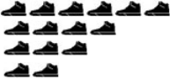
Select Vice Presidents

For purposes of calculating beneficial ownership, (i) Common Stock, RSUs, and DSUs count towards ownership, (ii) PSUs and ESPP shares count once earned and purchased, respectively, and (iii) stock options and shares held through the 401(k) Plan are disregarded.

Executives and Non-Employee Directors are required to achieve their Stock Ownership Guideline within five years of their hiring or promotion effective date that caused such employee to be covered by these guidelines, and their election to the Board, respectively. In the event of any increase in the required ownership level, either as a result of an increase in the remuneration paid or the multiple, the target date for compliance with such increased ownership guideline is five years after the effective date of such increase.

In the event any person subject to these guidelines fails to be in compliance by the applicable compliance date, they are required to hold the net shares obtained through all future stock option exercises and RSU vestings, after withholding for the payment of applicable taxes, until such person is in compliance; provided, however, that in order to take into consideration fluctuations in the Company’s stock price, any person who has been in compliance as of the end of at least one of the two preceding fiscal years and who has not subsequently sold shares will not be subject to the holding requirements.

The Responsibility Committee will consider a Non-Employee Director’s failure to comply with these guidelines when considering that director for re-election to the Board.

The Company measures compliance at the end of each fiscal year, with the compliance determination at that point in time applying for the entire ensuing fiscal year, regardless of fluctuations in the Company’s stock price.

All director nominees, the CEO, and all other executives subject to these guidelines were in compliance as of the end of the 2021 fiscal year.

POLITICAL CONTRIBUTIONS AND PUBLIC ADVOCACY

Our Code of Business Conduct prohibits making contributions on behalf of the Company to political parties, political action committees, political candidates, or holders of public office.

The Company is a member of certain trade associations, which support their member companies by offering educational forums, public policy advocacy, networking, and advancement of issues important to the retail and footwear industries, as well as the business community generally. Given the diversity of interests, viewpoints, and broad membership represented by these trade associations, the positions they take may not always reflect the Company’s positions. Also, we monitor the use of membership dues paid to trade associations for consistency with the Company’s values and business objectives.

- FOOT LOCKER, INC.

GOVERNANCE

The Company is a member of, and has paid membership fees to, the following organizations which, as part of their overall activities, may engage in advocacy activities with regard to issues important to the retail or footwear industries or the business community generally, as applicable:

- FDRA

- RILA

- U.S. Chamber of Commerce

Mr. Johnson is a director of FDRA and Chairman of RILA.

Notwithstanding these policies, we believe that our stakeholders look to us for leadership and to have a voice that is aligned with their values. As a purpose-driven organization, we have an obligation to add our voice and actions to drive meaningful and lasting change within our Company and the communities we serve.

For additional information regarding our Board’s political and public advocacy oversight, see Political and Public Advocacy Oversight on page 36.

OUR BOARD’S OVERSIGHT OF OUR BUSINESS

Oversight of the Company’s business strategy is a key responsibility of the Board, including work embedded in the Board committees. The Board believes that overseeing and monitoring strategy is a continuous process and takes a multilayered approach in exercising its duties. The Board’s oversight and management’s execution of business strategy are viewed with a long-term mindset and a focus on assessing both opportunities for, and potential risks to, the Company. In addition to financial and operational performance, other measures, including ESG goals, are discussed regularly by the Board and its committees.

The Board believes deeply that it must be fit for its purpose and provide strategic value to the Company. This dynamic has been highlighted during the COVID-19 pandemic, as the Board’s focus quickly pivoted toward protecting the communities we serve, keeping our team members safe, and maintaining financial stability for our shareholders.

While the Board and its committees oversee strategic planning, management is charged with developing and executing the business strategy. Management is completely transparent with the Board. To monitor the performance of the Company’s strategic goals, the Board maintains an open dialogue with, has regular access to, and receives ongoing updates from, management. For example, our Lead Independent Director has monthly calls with management, and each of the committee chairs regularly engages with their respective management liaisons. These discussions are enhanced with “hands-on” experiences, such as store and facility visits, to provide directors with opportunities to see strategy execution first hand.

2022 PROXY STATEMENT | 33

GOVERNANCE

HUMAN CAPITAL MANAGEMENT AND SUCCESSION PLANNING OVERSIGHT

The Board believes that the strength of the Company’s workforce is one of the significant contributors to our success as a global brand that leads with purpose. One of the primary responsibilities of the Board is to ensure that the Company has a high-performing CEO and management team. To meet that goal, the Board, the Human Capital Committee, the Responsibility Committee, and management share responsibility for management development and succession planning:

Responsible Party | Oversight Area
Board | Oversight of these topics as part of its overall oversight role, including regular reviews of management
 | development and succession planning to maximize the pool of emerging diverse talent who can assume top
 | management positions without undue interruption.
 | In assessing possible CEO and other senior leadership candidates, our independent directors identify the skills,
 | experiences, and attributes they believe are required to be an effective leader in light of the Company’s global
 | business strategies, opportunities, and challenges. This process is designed to prepare the Company for both
 | expected successions, such as those arising from anticipated retirements, as well as those occurring when
 | executives leave unexpectedly, or due to death, disability, or other unforeseen events. Each director has complete
 | and open access to any member of management. Members of management, including those several levels below
 | senior management, are invited regularly to make presentations at Board and committee meetings and meet with
 | directors in informal settings to allow the directors to form a more complete understanding of the executives’ skills
 | and character. We maintain updated emergency succession plans for the CEO and other executive committee
 | members. Succession reviews for key executive roles consist of an assessment of internal candidates as well as
 | external talent identified by executive search firms.
Human Capital Committee | As described in its charter, primary responsibility for organizational talent and development and management
 | succession planning, including regular reviews of executive performance, potential, and succession planning with a
 | deeper focus than the full Board review, emphasizing career development of promising management talent. The
 | Board made human capital management a priority through its Human Capital Committee, which oversees the
 | Company’s strategies and initiatives on diversity and inclusion, employee well-being, compensation and benefits
 | program, and engagement.
Responsibility Committee | As described in its charter, primary responsibility for reviewing and making recommendations regarding the
 | governance and process around CEO succession planning. The Board made ESG a priority through its
 | Responsibility Committee, which oversees the Company’s ESG efforts, including diversity and inclusion and the
 | LEED initiative, which serve as talent recruitment tools.
Management | Collaboration of the Chief Human Resources Officer and senior Human Resources leaders with functional leaders
 | across the Company in developing and implementing programs to attract, assess, and develop management-level
 | talent for possible future senior leadership positions.

For additional information on the Company’s human capital management strategies and initiatives, see our Annual Report, which is available at investors.footlocker-inc.com/ar.

- FOOT LOCKER, INC.

GOVERNANCE

ESG OVERSIGHT

The Board is actively engaged in the oversight of the Company’s global ESG program. In exercising its authority, the Board recognizes that the long-term interests of our shareholders are best advanced when considering other stakeholders and interested parties, including customers, team members, business partners, and the communities we serve. The Responsibility Committee oversees our global ESG program, and the Board receives updates from the Responsibility Committee Chair throughout the year. In addition, each of the Audit Committee, Finance Committee, and Human Capital Committee have certain ESG oversight responsibilities relevant to their respective committees.


Inspired by engagement with our shareholders, the Company has begun publishing an annual

Impact Report. The Impact Report provides details on our global ESG program, consistent with
the SASB reporting standards and TCFD reporting framework. Our global ESG program is
focused on:

For additional information regarding our global ESG program and Board oversight, see ESG on

page 96, ESG Oversight on page 35, and our Impact Report, which is available at
investors.footlocker-inc.com/impactreport.

The Company has adopted the following policy statements related to its global ESG program:

 | Policy Statement | Purpose
 | Global Environmental and Climate Change Statement | Sets out certain sustainability and environmental commitments and priorities, including
 |  | reducing GHG emissions that have an adverse effect on climate change, and certain
 |  | responsibilities of its suppliers. This policy statement is available at
 |  | investors.footlocker-inc.com/climate.
 | Global Human Rights Statement | Sets out certain commitments, including maintaining a work environment that | respects
 |  | and supports the provision of basic human rights to all of its team members around the
 |  | world, regardless of the country in which they work, to the full extent permitted by law,
 |  | and certain responsibilities of its suppliers. This policy statement is available at
 |  | investors.footlocker-inc.com/humanrights.
 | Global Occupational Health and Safety Statement | Sets out certain commitments, including operating in a safe and responsible manner to
 |  | protect the health and safety of its team members, partners, and customers, and certain
 |  | responsibilities of its suppliers. This policy statement is available at
 |  | investors.footlocker-inc.com/safety.
 | Global Water Stewardship Statement | Sets out certain commitments, including operating in a safe and responsible manner to
 |  | protect against water risks and seeking to promote the human right to water and
 |  | sanitation, and certain responsibilities of its suppliers. This policy statement is available
 |  | at investors.footlocker-inc.com/water.
 |  | 2022 PROXY STATEMENT | 35

GOVERNANCE

POLITICAL AND PUBLIC ADVOCACY OVERSIGHT

Our Board has political and public advocacy oversight responsibility, including ensuring that management’s political and lobbying expenditures are aligned with the Company’s strategy. The Board has adopted policies and procedures to oversee political and lobbying expenditures. As part of its ESG oversight responsibility, the Responsibility Committee reviews annually the Board’s policies and procedures regarding politics and public advocacy and that the Company’s publicly-stated positions are aligned with its related activities and spending. For additional information regarding our policies concerning political contributions and public advocacy, see Political Contributions and Public Advocacy beginning on page 32.

RISK OVERSIGHT

The Board has oversight responsibilities regarding risks that could affect the Company. Oversight for some of these risks is assigned to the committees— largely the Audit Committee—based on the individual risk.

The Audit Committee has established procedures for reviewing the Company’s risks. These procedures include regular risk monitoring by management to update current risks and identify potential new and emerging risks, quarterly risk reviews by management with the Audit Committee, and an annual risk report to the Board. In addition, the Audit Committee receives regular briefings from our Chief Information Security Officer, Chief Financial Officer, Chief Accounting Officer, General Counsel, Vice President of Internal Audit, and outside experts on cybersecurity risks and cyber risk oversight. During these meetings, the Audit Committee and management discuss these risks, risk management activities and efforts, best practices, lessons learned from incidents at other companies, the effectiveness of our security measures, and other related matters. The Audit Committee Chair reports on the committee’s meetings, considerations, and actions to the Board at the next Board meeting following each Audit Committee meeting.

The Human Capital Committee considers risk in relation to the Company’s compensation policies and practices. The Human Capital Committee’s independent compensation consultant provides an annual report to the committee on risk relative to the Company’s compensation programs.

The Company believes that this risk oversight process is appropriate in light of the Company’s business, size, and active senior management participation, including by the CEO, in managing risk and holding regular discussions on risk with the Audit Committee, the Human Capital Committee, and the Board.

CYBERSECURITY

We are subject to technology risks, including failures, security breaches, and cybersecurity risks, that could harm our business, damage our reputation, and increase our costs in an effort to protect against such risks. Our cybersecurity program includes the following elements:

Element | Strategy
Technology | We employ a layered “defense, detect, and respond” strategy.
Benchmarking and External Engagement | We benchmark our security practices against other organizations and are active in the
 | information security community.
Third-Party Assessments | We engage a range of outside experts to regularly assess our organizational security
 | programs, processes, and capabilities.
Internal Assessments | We regularly test and improve our information systems through security risk and compliance
 | review, user access campaigns, and other strategies.

PRIVACY

Our Privacy Policies and Privacy Statements govern our treatment of customer data. Our policies provide explanations of the types of customer personal information we collect, how we use and share that information, and the measures we take to protect the security of that information. Our policies provide multiple points of contact through which our customers may initiate inquiries, requests, and raise concerns to us regarding our collection, sharing, and use of their personal data. Our privacy policies and practices in the European Union were updated in 2018 in response to the GDPR requirements. Similarly, our privacy statements and practices in the United States were updated in response to CCPA, which came into force in January 2020.

- FOOT LOCKER, INC.

GOVERNANCE

CODE OF BUSINESS CONDUCT

The Company has adopted a Code of Business Conduct applicable to directors, officers, and all other team members. The Company periodically reviews the Code of Business Conduct and revises it, as appropriate. Any waivers of the Code of Business Conduct for directors and officers must be approved by the Audit Committee. The Code of Business Conduct is available at investors.footlocker-inc.com/cobc, and all current waivers for directors and officers are available at investors.footlocker-inc.com/cobcwaivers.

GLOBAL SOURCING GUIDELINES

Without a sound commitment to human rights and implementation through due diligence, jobs can be precarious, compensation can be below a living wage, and individuals can be subjected to modern day slavery, among a range of other potential impacts. Therefore, as part of our ESG program, we have policies, processes, and practices in place to systematize our human rights approach and how we respond to serious allegations. This is a public good for all stakeholders.

Our Global Sourcing Guidelines require all of our suppliers to respect certain employment standards that we believe should be universal, notwithstanding more relaxed standards (if any) imposed by law. In the selection of our suppliers, we work hard to choose reputable business partners who are committed to our ethical standards and business practices. The Global Sourcing Guidelines are distributed annually to each of our suppliers and each supplier agrees that, by accepting orders from us, it will abide by and implement its terms and require the same from each of its subcontractors. Each of our suppliers acknowledges that its failure to honor these guidelines will compel us to reevaluate, and possibly terminate, our business relationship with them. The Global Sourcing Guidelines are an integral part of our purchase agreements with suppliers, and to assure conformity with the Global Sourcing Guidelines, we reserve the right to make periodic, unannounced inspections of their facilities, and suppliers agree to maintain and provide upon request all documentation necessary to demonstrate compliance.

Our Global Sourcing Guidelines provide the following:

Standard | Policy
Employment | We will only do business with suppliers whose workers are, in all cases, present voluntarily, compensated fairly,
 | allowed the right of free association, and who are not put at risk of physical harm, discriminated against, or
 | exploited in any way. For additional information regarding our commitment to human rights, see our Global Human
 | Rights Statement available at investors.footlocker-inc.com/humanrights.
Child Labor | Child labor is not permissible.
Forced Labor | Forced labor, whether in the form of prison labor, involuntary or slave labor (including human trafficking), indentured
 | labor, bonded labor, or otherwise is not permissible. Employment must always be on a voluntary basis.
Wages and Benefits | We will only deal with suppliers who compensate their employees fairly by providing wages, overtime premiums,
 | and benefits that, at the very least, comply with legally-mandated minimum standards.
Working Hours | We will only deal with suppliers who maintain reasonable work hours, not exceeding prevailing local standards, or
 | any maximum prescribed by applicable laws.
Health and Safety | We will only deal with suppliers who provide their employees with a safe and healthy work environment, designed
 | to prevent accidents and injury to health arising out of or occurring in the course of work. At a minimum, we require
 | that suppliers comply with all applicable, legally-mandated standards for workplace health and safety. For
 | additional information regarding our commitment to health and safety, see our Global Occupational Health and
 | Safety Statement available at investors.footlocker-inc.com/safety.
Nondiscrimination | We believe that employment should be based on ability and not on belief or any other personal characteristics. We
 | will only deal with suppliers who do not practice discrimination in employment, including in hiring, salary, benefits,
 | advancement, discipline, termination, retirement, or in other aspects of employment on the basis of race, color,
 | nationality, ethnic origin, gender, religion, age, sexual orientation, disability, or similar factors.
Harassment and Abuse | We expect all employees to be treated with respect and dignity. We will not deal with suppliers whose employees
 | are subjected to physical, sexual, psychological, or verbal harassment or abuse.
Freedom of Association | We expect all of our suppliers to grant their employees the right to choose to affiliate with legally-sanctioned
 | organizations or associations without interference.
Subcontracting | Our suppliers may not utilize subcontractors to manufacture our products without our prior written approval and
 | only after the subcontractor has agreed to comply with the Global Sourcing Guidelines.

The Company periodically reviews the guidelines and revises them, as appropriate. The Global Sourcing Guidelines are available at investors.footlocker-inc.com/gsg.

2022 PROXY STATEMENT | 37

GOVERNANCE


SHAREHOLDER ENGAGEMENT
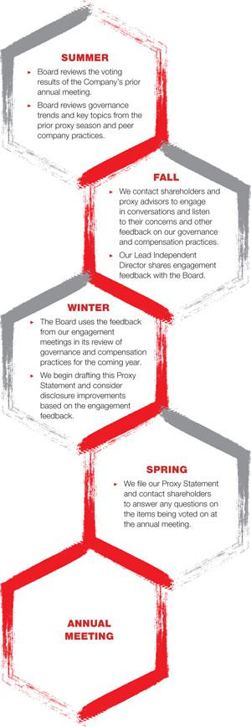

WHY WE ENGAGE

The Board’s relationship with shareholders is an important part of the Company’s success. The Board believes it is important to foster long-term relationships with shareholders and understand their perspectives. The Board has a long tradition of engaging with shareholders. The Board values an open dialogue with shareholders, and the Board believes that regular communication is a critical part of the Company’s long-term success. Through these activities, the Board discusses the Company’s corporate governance, executive compensation programs, ESG, and other topics of interest to shareholders. We also closely monitor policy statements and areas of focus for shareholders. These engagement efforts allow the Board to better understand the Company’s shareholders’ priorities and perspectives and provide the Board with useful input concerning the Company’s compensation, corporate governance, and ESG practices.

The Board is committed to:

- Accountability. Drive and support leading corporate governance and board practices.

- Transparency. Maintain high levels of transparency on a range of financial, governance, and ESG issues to build trust and sustain two-way dialogue.

- Engagement. Proactively engage with shareholders and proxy advisory firms on a range of topics to identify emerging trends and issues to inform the Board’s thinking and approach.

This shareholder engagement program complements the ongoing dialogue throughout the year among shareholders and our Chief Executive Officer, Chief Financial Officer, and Investor Relations team on our financial and strategic performance.

WHO WE ENGAGE

During the 2021–22 season, our Lead Independent Director, General Counsel, and the head of our global ESG leadership team will have met individually with shareholders representing approximately 30% of our total shares outstanding, as well as proxy advisory firms.

TOPICS OF ENGAGEMENT

► Board Refreshment and Composition | ► Human Capital Management
► Board Evaluation Process | ► Executive Compensation Programs
► Boardroom and Company Culture | ► ESG

HOW WE HAVE BEEN RESPONSIVE TO ENGAGEMENT

The Lead Independent Director shares the feedback gained from our shareholder engagement meetings with the Board and the Responsibility Committee, as well as compensation-specific feedback with the Human Capital Committee. In recent years, we have taken a number of actions based on shareholder feedback to strengthen our governance practices, global ESG program, and disclosure. For example, the Board voluntarily adopted proxy access, amended our By-Laws to implement a majority voting standard in uncontested director elections, and added the Director Nominees’ Skillset Matrix to this Proxy Statement to describe each director’s qualifications. The Company also enhanced its ESG disclosure by publishing an Impact Report, which is presented consistent with the SASB reporting standards and TCFD reporting framework and is available at investors.footlocker-inc.com/impactreport. These examples evidence our continued commitment to remain responsive on a variety of shareholder concerns. Please continue to share your thoughts or concerns at any time. The Board has established a process to facilitate shareholder communications with the Board, described below.

- FOOT LOCKER, INC.

GOVERNANCE

COMMUNICATIONS WITH THE BOARD

Shareholders and other interested parties who wish to communicate directly with the independent directors of the Board should send a letter to the Board. The Procedures for Communications with the Board are available at investors.footlocker-inc.com/boardcomms. Our Secretary will promptly send a copy of the communication to the Lead Independent Director, who may direct our Secretary to send a copy of the communication to the other independent directors and may determine whether a meeting of the independent directors should be called to review the communication.

MAJORITY VOTING IN THE ELECTION OF DIRECTORS

Directors must be elected by a majority of the votes cast in elections for which the number of nominees for election does not exceed the number of directors to be elected. A plurality vote standard applies to contested elections where the number of nominees exceeds the number of directors to be elected. Our Corporate Governance Guidelines provide that any incumbent director who does not receive a majority of the votes cast in an uncontested election is required to tender their resignation for consideration by the Responsibility Committee. The Responsibility Committee will make a recommendation to the Board whether to accept or reject the resignation, or take other action. The director who tenders their resignation will not participate in the Responsibility Committee or Board’s decision. In determining its recommendation to the Board, the Responsibility Committee will consider all factors that it deems relevant. Following such determination, the Company will promptly publicly disclose the Board’s decision, including, if applicable, the reasons for rejecting the tendered resignation.

PROXY ACCESS

Under our proxy access by-law, a shareholder, or a group of up to 20 shareholders, owning at least 3% of the Common Stock continuously for at least three years as of the date of the notice of nomination, may nominate and include in the Company’s proxy materials director nominees constituting up to two individuals or 20% of the Board, whichever is greater (subject to certain limitations set forth in the By-Laws), provided that the shareholder(s) and nominee(s) satisfy the requirements specified in the By-Laws.


2022 PROXY STATEMENT | 39



Our Board consists of individuals from a diverse range of backgrounds—in terms of gender, age, ethnicity, skills, and business and Board experience— with an equally diverse range of perspectives. What our Board shares is a common desire to support and oversee management in achieving the Company’s purpose to inspire and empower youth culture.

The Board has delegated certain duties to its committees, which assist the Board in carrying out its responsibilities. There are five standing committees of the Board. Each independent director serves on at least two committees.

The Board has adopted charters for each of the Audit Committee (investors.footlocker-inc.com/audit), Finance Committee (investors. footlocker-inc.com/finance), Human Capital Committee (investors.footlocker-inc.com/comp), and Responsibility Committee (investors.footlocker-inc.com/gov).

As a general principle, the Board believes that the periodic rotation of committee and committee chair assignments on a staggered basis provides opportunities to foster diverse perspectives, develops further the depth and breadth of knowledge within the Board, and prepares the Board for future director succession. In May 2021, Mr. McKenna rotated off as Chair of the Finance Committee, and was replaced by Mr. Oakland, and Mr. Oakland rotated off as Chair of the Responsibility Committee, and was replaced by Mr. Payne. In February 2022, Ms. Drosos was added to the Audit and Finance Committees.

- FOOT LOCKER, INC.

BOARD OF DIRECTORS

COMMITTEES

The key oversight responsibilities of the committees, the current committee memberships, and the number of meetings held during 2021 are as follows:


AUDIT

GUILLERMO G. | Other Members: | 9 meetings in 2021
GUILLERMO G. | Drosos, McKenna, Nicosia,
MARMOL Chair | Payne, and Young

KEY OVERSIGHT RESPONSIBILITIES

- appoints the independent auditors
- approves the independent auditors’ compensation
- assists the Board in fulfilling its oversight responsibilities in the following areas:

  - accounting policies and practices
  - the integrity of the Company’s financial statements
  - compliance with legal and regulatory requirements
  - the Company’s risk assessment and risk management policies
  - cybersecurity

  - the qualifications, independence, and performance of the independent auditors
  - the qualifications, performance, and compensation of the internal auditors

  - reviews and monitors compliance with the Code of Business Conduct

- establishes procedures for the receipt, retention, and treatment of complaints regarding accounting, internal accounting and audit controls, and auditing matters
- reviews and discusses risk assessments from management with respect to ESG-related risks, and relevant ESG metrics and attestations associated with these metrics

This committee consists of six independent directors, as independence is defined under the SEC and NYSE rules applicable to audit committee members. All of the members meet the expertise requirements under the NYSE rules. The Board has determined that Mr. McKenna qualifies as an “audit committee financial expert,” as defined by the rules under the Exchange Act, through his relevant experience as a former senior financial executive of a large multinational corporation. The Board believes that there are other directors who would also qualify for this designation and the Board will designate a new “audit committee financial expert” upon Mr. McKenna’s retirement.

The Audit Committee Report appears on page 101.


EXECUTIVE

RICHARD A. | Other Members:
RICHARD A. | Marmol, Oakland, Payne, | No meetings in 2021
JOHNSON Chair | Underhill, and Young

KEY OVERSIGHT RESPONSIBILITY

- shares all of the powers of the Board during intervals between Board meetings, except for certain matters reserved to the Board


FINANCE

STEVEN | Other Members:
STEVEN | Drosos, Feldman, McKenna, | 5 meetings in 2021
OAKLAND Chair | and Walker

KEY OVERSIGHT RESPONSIBILITIES

- reviews the Company’s financial plans and objectives
- reviews and makes recommendations to the Board regarding the Company’s annual operating budget and two-year plans

- reviews the Company’s allocation of budget for, and policies related to, capital

- reviews and makes recommendations to the Board regarding the Company’s uses of cash, including capital expenditures, stock and bond repurchases, and dividend payments
- reviews and makes recommendations to the Board regarding the Company’s cash requirements and sources of cash, including debt or equity issuances, revolving credit facilities, or other debt instruments or facilities

- reviews the Company’s insurance and self-insurance reserves
- reviews the Company’s derivatives policy and its use of derivatives

- reviews and makes recommendations to the Board regarding proposed mergers, combinations, acquisitions, offers to purchase the Company’s shares or significant assets, divestitures, and strategic investments
- reviews the Company’s corporate development approval process

- reviews reports from the Company’s Retirement Plan Committee regarding the asset allocation and investment performance of the Company’s North America pension funds

2022 PROXY STATEMENT | 41

BOARD OF DIRECTORS


HUMAN CAPITAL

KIMBERLY | Other Members: | 4 meetings in 2021
UNDERHILL Chair | Feldman, Marmol, and Nicosia

KEY OVERSIGHT RESPONSIBILITIES

- determines the CEO’s compensation
- reviews and approves the executive officers’ and corporate officers’ compensation

- approves team members’ equity compensation
- assesses risk in relation to the Company’s compensation policies and practices

- administers the Company’s compensation plans
- reviews and makes recommendations to the Board concerning executive development and succession

- reviews non-employee directors’ compensation and makes recommendations to the Board concerning the form and amount of non-employee directors’ compensation

This committee consists of four independent directors, as independence is defined under the NYSE rules applicable to compensation committee members.

See the CD&A beginning on page 50 for a discussion of the Human Capital Committee’s procedures for determining compensation, and the Human Capital Committee Report on page 69.


RESPONSIBILITY

ULICE | Other Members:
ULICE | Oakland, Underhill, Walker, | 4 meetings in 2021
PAYNE, JR. Chair | and Young

KEY OVERSIGHT RESPONSIBILITIES

- oversees corporate governance matters affecting the Company, including developing and recommending criteria and policies relating to director service and tenure

- establishes criteria for Board candidates
- retains a third-party search firm from time to time to identify potential director candidates

- selects new director nominees to recommend to the Board
- considers the re-nomination of existing directors after it conducts an annual review of each director’s qualifications, experience, and independence

- reviews membership on the Board committees and, after consultation with the CEO and Lead Independent Director, makes recommendations to the Board annually regarding both committee and committee chair assignments

- reviews trends and governance with regard to nonemployee directors’ compensation

- oversees the Company’s ESG initiatives and reviews and considers related public reporting, including the Company’s annual Impact Report, and the role of ESG in the Company’s strategy

Shareholders who wish to recommend candidates for Board membership may contact the Responsibility Committee in the manner described under Communications with the Board on page 39. Shareholder nominations must be made according to the procedures required under, and within the timeframe described in, the By-Laws and under Deadlines and Procedures for Nominations and Shareholder Proposals for the 2023 Annual Meeting on page 104. Shareholder-recommended candidates and shareholder nominees whose nominations comply with these procedures will be evaluated by the Responsibility Committee in the same manner as the Company’s nominees.

- FOOT LOCKER, INC.

BOARD OF DIRECTORS

DIRECTOR COMPENSATION

This discussion relates to the compensation we pay to non-employee directors. We do not pay additional compensation to any director for service on the Board or any committee who is also a Company employee.

KEY PRINCIPLES OF DIRECTOR COMPENSATION PROGRAM

The Company compensates its non-employee directors for their service according to the following principles:

 | Category | Description
 | Pay Position | The targeted pay position for our outside directors’ compensation program is the median of the retail and general industry
 |  | market reference points.
 | Peer Groups | When establishing reference points for market comparisons of our outside directors’ compensation program, we consider
 |  | the retail peer group used for our executive compensation purposes and general industry data for similarly-sized
 |  | companies. See Benchmarking Approach on page 65 for more information on our peer group.
 | Pay Evaluation | When assessing the competitive position of our outside directors’ compensation program, the primary focus is on total
 | Perspective | targeted compensation opportunity.
 | Pay Mix | Our outside directors’ compensation program consists of a balance of cash and equity, with an emphasis on equity over
 |  | cash. See Components of Director Compensation Program on page 44 for further information.
 | Differentiation | The outside directors’ compensation provides additional compensation for leadership positions on the Board, including
 |  | lead independent director and committee chair roles. See Components of Director Compensation Program on page
 |  | 44 for further information.
 | Stock Ownership | Significant stock ownership guidelines established for outside directors encourage better alignment with shareholders’
 |  | interests, with compliance measured at least annually, as described further in Stock Ownership Guidelines beginning
 |  | on page 32.
 | Deferral Opportunities | Non-employee directors may elect to receive all or a portion of the cash component of their annual retainer fee, including
 |  | committee chair retainers, in the form of DSUs or to have these amounts placed in an interest account. Directors may
 |  | also elect to receive all or a portion of the stock component of their annual retainer fee in the form of DSUs. Beginning in
 |  | 2022, directors may also elect to receive all or a portion of their RSU awards in the form of DSUs.
 | Total Compensation | Meaningful limits on outside directors’ compensation have been established to ensure consistency with sound
 | Limits | governance practices. See Components of Director Compensation Program on page 44 for further information.
 | Regular Review | The Responsibility Committee conducts regular reviews of governance practices and trends in directors’ compensation to
 |  | ensure consistency of our program with sound governance practices and makes recommendations, as appropriate, to the
 |  | Board. The Human Capital Committee conducts regular reviews of our outside directors’ compensation program and
 |  | makes recommendations to the Board regarding the amount and form of directors’ compensation each year.
 |  | 2022 PROXY STATEMENT | 43

BOARD OF DIRECTORS

COMPONENTS OF DIRECTOR COMPENSATION PROGRAM

The Company’s non-employee directors were paid in the following fees in 2021:

Fee | Amount | Form of Payment
Annual Retainer | $150,000
Committee Chair Retainer
Audit Committee | $25,000
Finance Committee | $15,000 | 50% cash⁽¹⁾ and 50% Common Stock⁽²⁾
Human Capital Committee | $25,000
Responsibility Committee | $15,000
Lead Independent Director Retainer | $50,000 | Cash
Meeting Fee⁽³⁾ | $2,000 per Board and committee meeting | Cash
RSU Award | $70,057 | RSUs⁽⁴⁾

- Directors may defer all or a portion of the fee in the form of DSUs or have these amounts placed in an Interest Account.

- Directors may defer all or a portion of the fee in the form of DSUs.

- The Company also reimburses reasonable expenses incurred in attending Board and committee meetings, other meetings with management, and continuing education programs, including transportation, hotel accommodations, and meals.
- Beginning in 2022, directors may defer all or a portion of the RSU awards in the form of DSUs.

Each non-employee director’s compensation, inclusive of cash and equity, is capped at $600,000 per fiscal year. Directors are eligible to receive the same discount on purchases of merchandise from our stores, catalogs, and websites that is available to team members.

For all compensation periods through and including fiscal 2021, six of our current directors have previously elected to defer all or a portion of one or more of their annual retainers into DSUs, and none of the current directors have elected to place any amount of their annual retainer fees into an interest account.

GOVERNANCE

The Human Capital Committee and Responsibility Committee jointly oversee our non-employee director compensation program, conduct annual reviews, and make recommendations for adjustments, as appropriate, to the Board. The Responsibility Committee reviews trends and governance with regard to non-employee directors’ compensation. Following consultation with the Responsibility Committee, the Human Capital Committee reviews non-employee directors’ compensation and makes recommendations to the Board concerning the form and amount of non-employee directors’ compensation.

In connection with the review conducted in fiscal year 2021, the outside compensation consultant assessed the compensation paid to our non-employee directors against non-employee director compensation trends and data from our company peer group, including overall trends and governance principles, market competitiveness of our program, and the mix of cash and equity provided under our program. Following this review, no changes were made to the non-employee director compensation program in 2021 because the program was competitive with the Company’s peer group median. Other aspects of the program, including the mix of cash and equity, were found to be aligned with industry norms and best practices.

- FOOT LOCKER, INC.

BOARD OF DIRECTORS

FISCAL 2021 DIRECTOR COMPENSATION

The amounts paid to each non-employee director for fiscal 2021, including amounts deferred under the Stock Incentive Plan, and the RSUs granted to each director are reported in the tables below:

(a) | (b) | (c) | (d)
 | Fees Earned | Stock
 | or Paid in | Stock
 | Cash | Awards | Total
Name | ($) | ($)⁽¹⁾ | ($)
Clark⁽²⁾ | 41,004 | 31,246 | 72,250
Feldman | 111,058 | 175,201 | 286,259
Marmol | 131,547 | 157,510 | 289,057
McKenna | 124,165 | 148,142 | 272,307
Nicosia | 112,808 | 163,878 | 276,686
Oakland | 118,500 | 158,193 | 276,693
Payne | 124,262 | 150,733 | 274,995
Underhill | 121,547 | 157,510 | 279,057
Walker | 111,000 | 146,035 | 257,035
Young | 100,250 | 275,378 | 375,628

- Column (c) reflects the following three items:

  - the grant date fair value determined in accordance with FASB ASC 718 for the portion of a director’s annual retainer fees (including committee chair retainer fees) for fiscal year 2021 paid in shares of Common Stock (including any portions deferred in the form of DSUs under the Stock Incentive Plan) ($61.63 per share representing the closing price of a share of Common Stock on June 30, 2021). Such shares of Common Stock are fully vested on grant, regardless of whether deferred into DSUs.

  - the grant date fair value determined in accordance with FASB ASC 718 for RSUs granted in fiscal year 2021 ($61.67 per share representing the closing price of a share of Common Stock on the grant date). In May 2021, each director received an award of 1,136 RSUs. The number of RSUs granted was calculated by dividing $70,000 by the closing price of a share of Common Stock on the grant date. The RSUs will vest in May 2022, provided the director continues to serve on the Board through the vesting date. Each RSU represents the right to receive one share of Common Stock on the vesting date. No dividends are paid or accrued on the RSU awards. The amounts shown exclude the impact of estimated forfeitures related to service-based vesting conditions.

  - the grant date fair value, determined in accordance with FASB ASC 718, for dividend equivalents paid on DSUs and credited in the form of additional DSUs, made to Messrs. Feldman, Oakland, Payne, and Walker, and Mses. Nicosia and Young ($58.98 per share for DSUs granted on April 30, 2021, $57.06 per share for DSUs granted on July 30, 2021, $47.67 per share for DSUs granted on October 29, 2021, and $44.43 per share for DSUs granted on January 28, 2022, representing the closing price of a share of Common Stock on the quarterly payment date). Such additional DSUs are fully vested on grant.

2022 PROXY STATEMENT | 45

BOARD OF DIRECTORS

The following table sets forth the grant date fair value of the above stock awards granted to our directors in fiscal year 2021:

 | Stock Fees | RSUs | DSUs | Total
Name | ($) | ($) | ($) | ($)
Clark⁽²⁾ | 31,246 | — | — | 31,246
Feldman | 74,942 | 70,057 | 30,202 | 175,201
Marmol | 87,453 | 70,057 | — | 157,510
McKenna | 78,085 | 70,057 | — | 148,142
Nicosia | 74,942 | 70,057 | 18,750 | 163,878
Oakland | 82,500 | 70,057 | 5,636 | 158,193
Payne | 79,637 | 70,057 | 1,039 | 150,733
Underhill | 87,453 | 70,057 | — | 157,510
Walker | 75,000 | 70,057 | 978 | 146,035
Young | 131,250 | 70,057 | 74,071 | 275,378

- Ms. Clark served as a director during 2021 until her retirement from the Board in May 2021.

For additional information on the valuation assumptions, refer to Note 21 to the Company’s financial statements in our Annual Report, which is available at investors. footlocker-inc.com/ar.

As of the end of fiscal year 2021, the number of RSUs and DSUs held by our directors were as follows:

 | RSUs | DSUs
Name | (#) | (#)
Feldman | 1,136 | 30,603
Marmol, McKenna, and Underhill | 1,136 | —
Nicosia | 1,136 | 433
Oakland | 1,136 | 5,981
Payne | 1,136 | 1,314
Walker | 1,136 | 1,237
Young | 1,136 | 75,523

46 | FOOT LOCKER, INC.

BOARD OF DIRECTORS

DIRECTORS AND OFFICERS INDEMNIFICATION AND INSURANCE

The Company has entered into indemnification agreements with its directors and officers, as approved by shareholders at the 1987 annual meeting.

We have purchased directors and officers liability and corporation reimbursement insurance from the following group of insurers:

► ACE American Insurance Co. (Chubb) | ► Chubb Bermuda Insurance Ltd. (Chubb) | ► Hartford Accident & Indemnity (The Hartford)
► American International Group (AIG) | ► Continental Casualty Co. (CNA) | ► Markel Insurance Co.
► Arch Insurance Co. | ► Endurance American Insurance Co. (Sompo | ► North American Specialty Insurance Co. (Swiss
► Argonaut Insurance Co. (Argo RE) | International) | Re)
► Beazley Insurance Co. | ► Freedom Specialty Insurance Co. (Nationwide) | ► Zurich American Insurance Company
► Berkley Insurance Co. (W.R. Berkley)

These policies insure all of the directors and officers of the Company and its covered subsidiaries, as well as the Company and all of its wholly-owned subsidiaries. The policies were written for a 12-month term, expiring October 12, 2022. The total annual premium for these policies, including fees and taxes, is $1,553,815.

Directors and officers of the Company, as well as all other team members with fiduciary responsibilities under ERISA, are insured under policies issued by the following group of insurers:

► | ACE American Insurance Co. (Chubb) | ► Endurance American Insurance Co. (Sompo | ► | Hudson Insurance Co. (Euclid)
► | Continental asualty Co. (CNA) | International) | ► | Zurich American Insurance Co.

The policies were written for a 12-month term, expiring October 12, 2022. The total annual premium for these policies, including fees and taxes, is $251,168.

2022 PROXY STATEMENT | 47

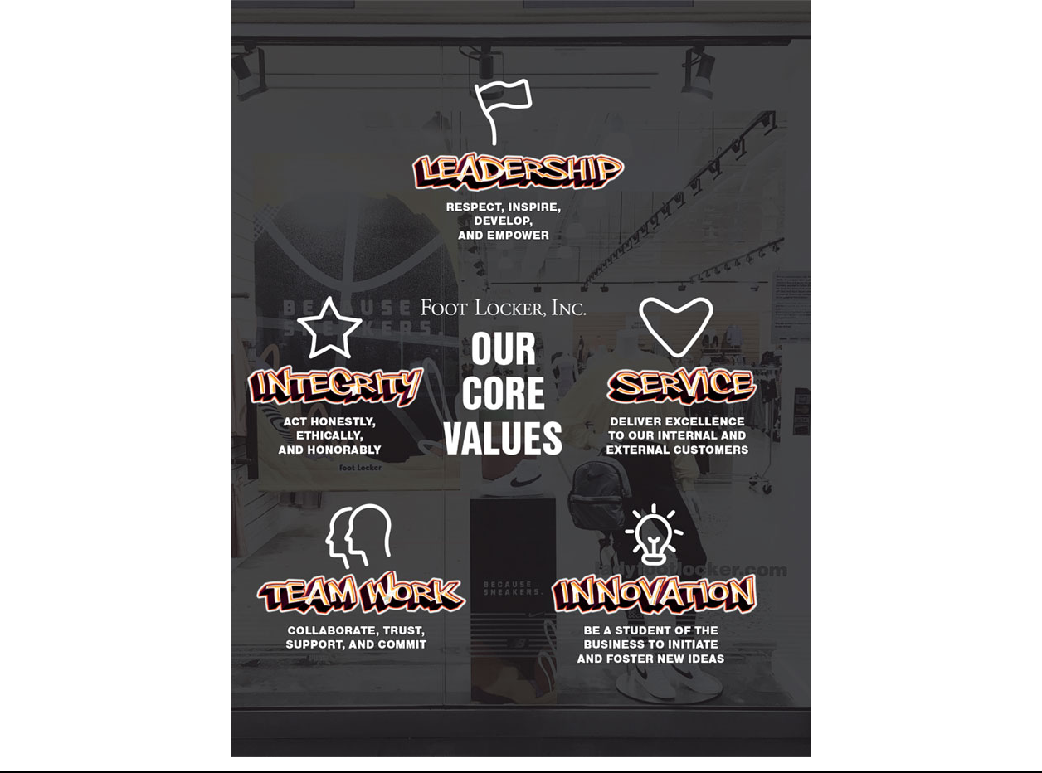



In accordance with the requirements of Section 14A of the Exchange Act and the related SEC rules, our shareholders have the opportunity to cast an annual non-binding, advisory vote to approve the compensation of our NEOs, as disclosed beginning on page 50 (a “Say-on-Pay” vote). We currently hold our “Say-on-Pay” vote every year.

As described in detail in the CD&A beginning on page 50, our compensation program is designed to attract, motivate, and retain talented executives responsible for leading our strategic priorities and, in turn, deliver value to our shareholders. Our executive compensation program ties pay closely to performance. A significant portion of the compensation provided to the NEOs is based upon the Company’s performance or the performance of our share price, and we believe this compensation structure closely aligns the interests of our executives with the interests of our shareholders. The higher an executive’s position, the greater percentage of their compensation is tied to performance.

“Say-on-Pay” received nearly 96% support at last year’s annual meeting. The Human Capital Committee believes this affirms our shareholders’ support for the Company’s approach to executive compensation. We also have discussions with many of our shareholders on an ongoing basis regarding various corporate governance topics, including executive compensation, and take into account the views of shareholders regarding the design and effectiveness of our executive compensation program. We believe you should read the CD&A, beginning on page 50, and the compensation tables beginning on page 70, in determining whether to vote in favor of this proposal.

Shareholders are being asked to approve the following resolution at the Annual Meeting:

“RESOLVED, that the Company’s shareholders approve, on an advisory basis, the compensation of our NEOs, as disclosed in the Company’s Proxy Statement for the Annual Meeting pursuant to the SEC’s compensation disclosure rules, including the CD&A, the 2021 Summary Compensation Table, and the other related tables and disclosures.”

As an advisory vote, this proposal is not binding on the Company, the Human Capital Committee, or the Board. However, the Human Capital Committee and the Board value the opinions expressed by shareholders in their votes on this proposal and will consider the outcome of the vote when making future compensation decisions regarding our NEOs.

2022 PROXY STATEMENT | 49



COMPENSATION DISCUSSION AND ANALYSIS

This CD&A describes our compensation philosophy and objectives, provides context for compensation decisions for our NEOs, and describes how our 2021 compensation is linked to performance against the goals that were established for the Annual Incentive Plan and LTI.

For 2021, our NEOs were as follows:



RICHARD A. | ANDREW E. | FRANKLIN R. | W. SCOTT | ANDREW I.
JOHNSON | PAGE⁽¹⁾ | BRACKEN⁽²⁾ | MARTIN⁽³⁾ | GRAY
Chairman, | Executive Vice | Executive Vice | Executive Vice | Executive
President and | President and | President and | President, | Vice President
Chief Executive | Chief Financial | Chief Operating | Chief Strategy | and Chief
Officer | Officer | Officer | and Corporate | Commercial
 |  |  | Development | Officer
 |  |  | Officer

- Mr. Page joined the Company as Executive Vice President and Chief Financial Officer on April 12, 2021.

- Mr. Bracken served as Executive Vice President and Chief Executive Officer—North America until November 15, 2021, and was promoted to Executive Vice President and Chief Operating Officer, effective November 16, 2021.

- W. Scott Martin served as Executive Vice President and Chief Executive Officer—Asia Pacific and Chief Strategy and Development Officer until November 15, 2021, President—Asia Pacific from November 16, 2021 through March 17, 2022, and Executive Vice President, Chief Strategy and Corporate Development Officer, effective March 18, 2022.

LAUREN B. PETERS⁽⁴⁾ | VIJAY TALWAR⁽⁵⁾
Former Executive Vice President and | Former Executive Vice President and
Chief Financial Officer | Chief Executive Officer─EMEA

- Ms. Peters served as Executive Vice President and Chief Financial Officer until April 12, 2021, and retired from the Company on May 1, 2021.

- Mr. Talwar served as Executive Vice President and Chief Executive Officer—EMEA until November 17, 2021, and departed from the Company on December 16, 2021.

TABLE OF


CONTENTS

- Fiscal 2021 Highlights

- Financial Performance
- Leadership Appointments
- Say-on-Pay Shareholder Vote

- Compensation Program Design and Structure
52 Pay-for-Performance
- Components of Executive Compensation Program
- Base Salary
- Annual Incentive Plan
59 LTI Awards
- Retirement Plan and Excess Cash Plan
- 401(k) Plan and Excess Savings Plan
- Supplemental Executive Retirement Plan
- International Assignment Compensation
- Perquisites
- Employment Agreements and Other Arrangements

- Procedures for Determining Compensation
- Setting Compensation, Establishing Goals, and Evaluating Performance
- Benchmarking Approach
- Use of Compensation Consultants
- Management Involvement in Developing the Compensation Program

- Additional Information

- Key Compensation Governance Policies
- Compensation Program and Risk
- Delegation of Authority
68 Accounting and Tax Considerations

- 2022 Compensation Program Design Changes

- FOOT LOCKER, INC.

EXECUTIVE COMPENSATION

FISCAL 2021 HIGHLIGHTS

FINANCIAL PERFORMANCE

Despite the many challenges we confronted and are continuing to experience—including the COVID-19 pandemic, supply chain disruption, inflationary pressures, and an evolving geopolitical environment—we delivered record performance in 2021, which reflects the ongoing momentum we have built in our business. Highlights include the following:
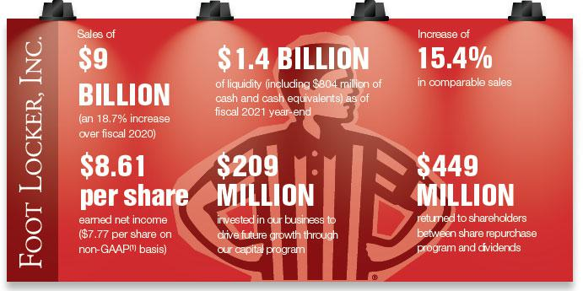

- A reconciliation to GAAP is provided beginning on page 21 of our Annual Report, which is available at investors.footlocker-inc.com/ar.

Our 2021 compensation program, as outlined in detail in the following pages, was tied to our key objectives, demonstrating our strong connection between pay and performance.

LEADERSHIP APPOINTMENTS

As part of a planned succession strategy, in 2021, we recruited Mr. Page from outside the Company to serve as Executive Vice President and Chief Financial Officer, replacing Ms. Peters, who retired from the Company. Also, in 2021, we made certain organizational enhancements, including elevating Mr. Bracken to the new role of Executive Vice President and Chief Operating Officer, to advance our long-term global growth and power our omni-channel ecosystem. The addition of a Chief Operating Officer creates a more streamlined and agile organizational structure that builds on the success of our geo-focused growth strategy. Both of these organizational enhancements underscore our focus on enhancing our finance and operations teams to drive organizational productivity.

CHIEF FINANCIAL OFFICER

In connection with Mr. Page’s employment, the Human Capital Committee approved a compensation package that reflects the competition for talented senior finance executives, particularly in retail companies. The Human Capital Committee set his annual base salary at $615,000. Mr. Page was (1) granted a sign-on equity award in the form of RSUs having a value on the grant date of $750,000, and (2) granted a sign-on cash payment in the amount of $500,000 (repayable if termination occurs within two years of hire). The sign-on awards were intended to replace certain stock-based awards and other compensation that Mr. Page forfeited from prior employment in connection with his recruitment to the Company. Mr. Page is also eligible to receive Annual Incentive Plan (prorated) and LTI awards (prorated) at target of 75% and 150%, respectively, of base salary. The RSU award vests one third on each of the first three anniversaries of grant subject to continued employment with the Company through the vesting dates. Mr. Page also participated in our regular annual LTI grants commensurate with his job level.

CHIEF OPERATING OFFICER

In connection with Mr. Bracken’s promotion, the Human Capital Committee approved a compensation package that reflects the increased responsibilities of his new role as well as the competition for talented senior operating executives, particularly in our industry. The Human Capital Committee set his annual base salary at $800,000 effective November 2021. Mr. Bracken was (1) granted an equity award in the form of RSUs having a value on the grant date of $600,000, and (2) eligible to receive Annual Incentive Plan (prorated) and LTI awards at target of 100% and 200%, respectively, of base salary and prorated between these targets. The RSU award vests in full on the third anniversary of grant subject to continued employment with the Company through the vesting date.

2022 PROXY STATEMENT | 51

EXECUTIVE COMPENSATION

SAY-ON-PAY SHAREHOLDER VOTE

At our 2021 annual meeting, nearly 96% of shares voted on the advisory vote on executive compensation supported the executive compensation program. The Human Capital Committee considered the results of the 2021 Say-on-Pay vote and our shareholders’ support of our executive compensation program in reviewing the program for 2022. See page 38 for more details on our shareholder engagement program. In light of this support, the Human Capital Committee decided to retain the general program design. Beginning in 2021, the Human Capital Committee adopted a consistent mix of LTI awards. In the future, the Human Capital Committee will continue to assess the executive compensation program against changing business conditions and shareholder feedback. Our Say-on-Pay vote is currently held every year, consistent with the preference expressed by a majority of our shareholders.
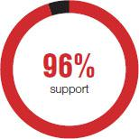

COMPENSATION PROGRAM DESIGN AND STRUCTURE

PAY-FOR-PERFORMANCE

The centerpiece of our compensation program is our pay-for-performance philosophy that aligns compensation payouts with the achievements of our annual operating plan and long-term strategy, and consequently shareholder value. This is showcased at senior levels of the Company—particularly the CEO—for which most compensation is tied to the achievement of metrics driving the Company’s operating and stock performance, as described below.

Factor | Description
Performance-Based | A significant proportion of the CEO’s compensation is performance-based.
 | Recent Annual Incentive Plan and PSU payouts underscore our pay-for-performance culture. For example,
Challenging Goals | only twice in the past five years has the Annual Incentive Plan paid out greater than target and three of the
 | past five PSU awards were not earned and paid out at 0%.
Formulaic | Our Annual Incentive Plan and PSU payouts are formulaically determined based on performance against
Formulaic | challenging financial and operating goals.
Lower Realized Pay | The CEO’s five-year realized pay is expected to be lower than his five-year target compensation.
Peer Benchmarked | We utilize an objective set of criteria to determine peer companies and position CEO pay at the peer group
Peer Benchmarked | median.
Reasonable | 2021 compensation for newly-appointed and outgoing executives was determined to be reasonable.
Responsive to Say-on-Pay Vote | Our Say-on-Pay support has been strong in recent years.
Compensation Mix | Beginning with LTI awards granted in 2021, we adopted a consistent mix of PSU awards (60%), stock
Compensation Mix | option awards (20%), and RSU awards (20%).

52 | FOOT LOCKER, INC.

EXECUTIVE COMPENSATION

Recent Annual Incentive Plan and LTI payouts underscore our pay-for-performance culture:

ANNUAL INCENTIVE PLAN PSU AWARDS
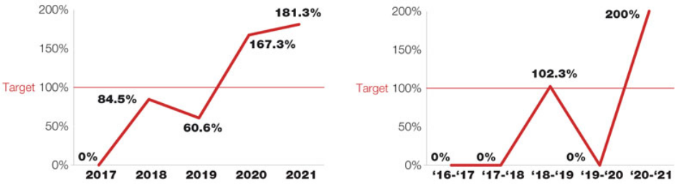

TARGET COMPENSATION VS. REALIZED PAY⁽¹⁾
Our executives’ realized pay over the past five years further evidences our pay-for-performance philosophy. Failure to achieve the challenging threshold performance goals set for our Annual Incentive Plan awards and PSU awards results in no payout earned. Also, a decrease in the Company’s stock price results in a decrease in the value of previously-awarded stock option awards—potentially to $0— and no dilution to shareholders, as well as a decrease in the value of previously-awarded RSU awards. When our stock price increases and generates positive returns for our shareholders, the increase impacts an executive’s realized pay during the present fiscal year and for prior fiscal years during which the executive received equity awards that are held or remain subject to vesting requirements. Accordingly, a significant portion of our NEOs’ compensation is closely linked to the performance of our stock over time, motivating our executives to generate positive returns for shareholders and aligning interests.

The following chart demonstrates the relationship between the target and realized values of our CEO’s compensation for the past five years:
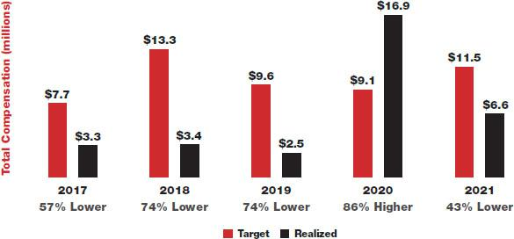

- For each year, these amounts reflect the CEO’s base salary paid, Annual Incentive Plan payouts paid, values of PSU awards earned, stock option award tranches vesting during the year, and RSU awards vesting during the year. For 2020, the CEO’s realized pay includes the value of a one-time Accelerate Future Growth award earned.

2022 PROXY STATEMENT | 53

EXECUTIVE COMPENSATION

COMPENSATION MIX

The Human Capital Committee seeks to align the compensation program with both our business strategy and our shareholders’ interests. In order to achieve these objectives, our executive compensation program includes both a mix of annual and long-term, as well as cash and equity, compensation. As shown in the charts below, for 2021, 90% of the CEO’s target compensation mix, and 72%, on average, of the remaining NEOs’ target compensation mix, was variable based on performance.

CEO’s 2021 TARGET COMPENSATION
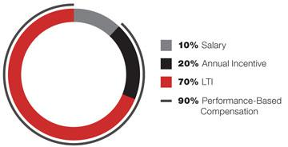

AVERAGE OF REMAINING NEOs’ 2021 TARGET

COMPENSATION
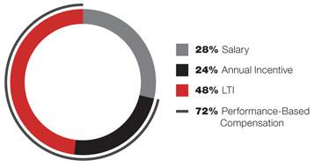

ANNUAL INCENTIVE PLAN PERFORMANCE METRICS LTI PERFORMANCE METRICS


COMPONENTS OF EXECUTIVE COMPENSATION PROGRAM

The key components of our executive compensation program are described in the following table:
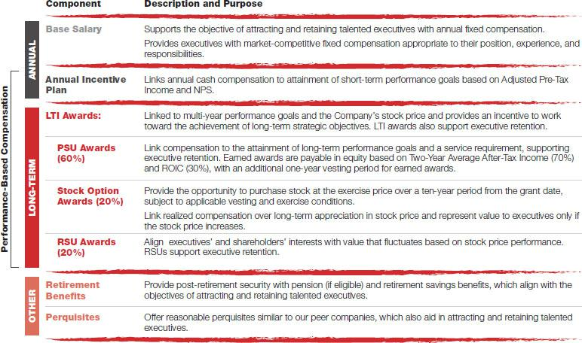

- FOOT LOCKER, INC.

EXECUTIVE COMPENSATION

BASE SALARY

As part of its annual review of compensation, the Human Capital Committee approved base salary increases effective May 1, 2021, for Messrs.

Bracken, Martin, Gray, and Talwar, as shown below, based on each NEO’s performance and a position-oriented analysis of market salaries.

Beginning in fiscal 2021, individual performance goals are aligned around the Company’s four strategic imperatives:
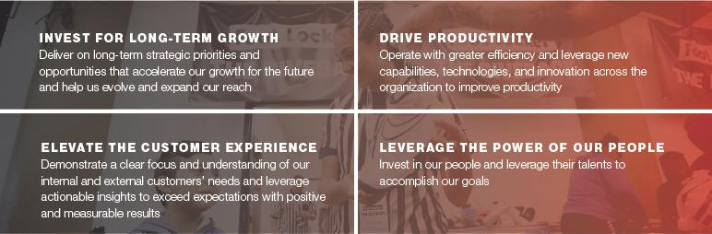

The Company strives for DIBs to be ingrained in our culture to ensure the Company is a world-class organization according to our customers, community leadership, and team members. To achieve this goal, all team members, including the NEOs, need to play a key role in our DIBs strategy, which is centered on five strategic pillars:


Within the Leverage the Power of Our People performance objective, all team members are measured against a DIBs goal:


2022 PROXY STATEMENT | 55

EXECUTIVE COMPENSATION
 | Year-End 2020 | Year-End 2021 | Base Salary
 | Base Salary Rate | Base Salary Rate | Rate Increase
Name | ($) | ($) | (%)
Bracken⁽¹⁾ | 575,000 | 800,000⁽¹⁾ | 39.1
Martin and Gray | 600,000 | 615,000 | 2.5
Talwar | 650,000 | 665,000 | 2.3

- Mr. Bracken received an increase in his annual base salary to $615,000, effective May 2021, based on his performance and a position-oriented analysis of market salary. Mr. Bracken was promoted to Executive Vice President and Chief Operating Officer in November 2021 and received a salary increase to $800,000.

ANNUAL INCENTIVE PLAN

Consistent with our pay-for-performance culture, the Human Capital Committee established rigorous Adjusted Pre-Tax Income and NPS targets for 2021. The targets the Human Capital Committee established were based on the Company achieving Adjusted Pre-Tax Income of $668.4 million (which accounts for 80% of the payout), and a certain NPS score (which accounts for 20% of the payout), each as illustrated below. We drove strong Adjusted Pre-Tax Income in 2021, particularly given the COVID-19 pandemic and supply chain challenges.
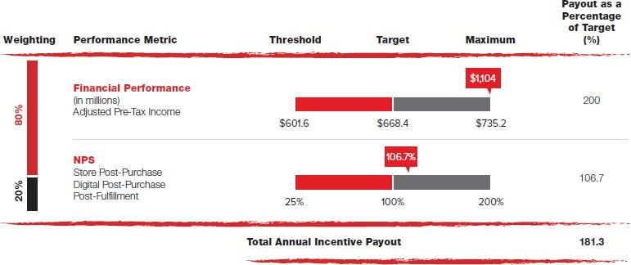

The Human Capital Committee established Adjusted Pre-Tax Income as one of the performance targets in connection with the Annual Incentive Plan in 2021. This was a return to our long-standing practice after the disruptions caused by COVID-19 pandemic and social unrest in 2020, which had resulted in store closures. In 2020, sales had been established as a performance metric under the Annual Incentive Plan to allow for measurement based on when stores were open. The Annual Incentive Plan Adjusted Pre-Tax Income metric is calculated by deducting the following items from our non-GAAP income: the income related to completed acquisitions ($18 million), the income associated with minority investments ($69 million), and the effect of COVID-19 on our results ($85 million).

- FOOT LOCKER, INC.

EXECUTIVE COMPENSATION

FINANCIAL PERFORMANCE

ADJUSTED PRE-TAX INCOME
The Human Capital Committee established the 2021 Adjusted Pre-Tax Income target of $668.4 million based upon the business plan and budget reviewed each year by our Finance Committee and approved by the Board. Messrs. Johnson, Page, and Gray earned annual incentive payouts of

181.3% of their respective target awards based on strong performance against the goal. Mr. Page was appointed in 2021, so his payout was prorated for the 2021 performance period.

As a division executive, Mr. Martin’s annual incentive awards were based on the Company’s Adjusted Pre-Tax Income (weighted 20%), division profit (weighted 60%), and division NPS (weighted 20%). Mr. Martin earned an annual incentive payout of 186.7% of his target award based on strong performance against these goals.

During 2021, Mr. Bracken served as Executive Vice President and Chief Executive Officer—North America until November 15, 2021, and then as Executive Vice President and Chief Operating Officer, so his annual incentive award was prorated between division and corporate performance. Mr. Bracken earned annual incentive payouts of 178.7% and 181.3% of his prorated target awards for his division and corporate roles, respectively.

Ms. Peters and Mr. Talwar’s employment with the Company terminated prior to the end of 2021; they were, therefore, ineligible to receive annual incentive payouts.

In 2021, the Company’s Adjusted Pre-Tax Income was based on the following banners for each of the North America, EMEA, and Asia Pacific divisions:
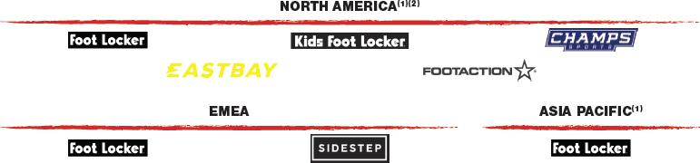

- For 2021, atmos was excluded from the Company’s Adjusted Pre-Tax Income because this banner was acquired in November 2021 and was, therefore, not included in the Company’s targets at the time they were set by the Human Capital Committee.

- For 2021, WSS was excluded from the Company’s Adjusted Pre-Tax Income because this banner was acquired in September 2021 and was, therefore, not included in the Company’s targets at the time they were set by the Human Capital Committee.

For competitive reasons, we do not disclose the Adjusted Pre-Tax Income targets for the North America, EMEA, or Asia Pacific divisions, as we do not publicly disclose results of these divisions on a separate basis, and we consider it competitively harmful to make that information public. Our objective is to set challenging performance goals throughout the Company. We believe that achieving these challenging performance goals for these divisions is demanding.

NPS

The Human Capital Committee established NPS targets for the NEOs. NPS is a metric used to measure customer experience and predict future business growth. NPS is calculated using the answers to questions posed to customers scored on a 0-10 scale. Respondents are grouped as follows:

- Promoters (score 9-10) are loyal enthusiasts who will keep buying and refer others, fueling growth.

- Passives (score 7-8) are satisfied but unenthusiastic customers who are vulnerable to competitive offerings.

- Detractors (score 0-6) are unhappy customers who can damage the brand and impede growth through negative word-of-mouth.

Subtracting the percentage of Detractors from the percentage of Promoters yields the NPS, which can range from a low of -100% (if every customer is a Detractor) to a high of 100% (if every customer is a Promoter). The Human Capital Committee established three touchpoints for measuring NPS by each geographic region, each of which is assessed as a stand-alone performance to allow for balanced focus on each area of opportunity to improve an “omni-” customer experience: Store Post-Purchase, Digital Post-Purchase, and Post-Fulfillment. The survey responses are aggregated by region (North America, EMEA, and Asia Pacific) and are scored individually by touchpoint. Each customer touchpoint has its own threshold, target, and maximum, but they ultimately roll up into one payout percentage. The evaluation of full-year NPS utilizes the Company’s global performance management rating scale, in which performance can range from 25% to 200% based on the relative achievement of the metrics.

2022 PROXY STATEMENT | 57

EXECUTIVE COMPENSATION

ESG

NPS is an ESG metric because it measures customer satisfaction and brand perception, which are dependent on factors that include ESG. Key features of NPS are:

Feature | Description
Linked to ESG | “Leveraging the Power of Our People and Communities” is one of the four pillars of our global ESG program focused on ensuring
Linked to ESG | that our customers enjoy world-class engagement and an environment that encourages the pursuit of excellence every day in
Program
Program | our purpose to inspire and empower youth culture.
Reputational | NPS measures customer satisfaction and brand perception, which are influenced by customers’ sentiments concerning the
Reputational | Company’s ESG program.
 | NPS measures loyal enthusiasts who will keep buying and refer others, fueling long-term and sustainable future growth. Strong
Long Term | ESG principles and performance are necessary for the Company’s success over the long term, including attracting and retaining
 | customers.
Quantifiable | NPS is calculated using a 0-10 scale used to measure customer experience and predict future business growth.
No Discretion | NPS is formula-driven based upon Company performance and does not provide for discretionary adjustments.

During our engagement sessions with our shareholders, they have shared with us that they also believe NPS is a good measure of the performance of our ESG program. See page 38 for more details on our shareholder engagement program.

To learn more about our global ESG program, see ESG on page 96, and our Impact Report, which is presented consistent with SASB and TCFD reporting standards and is available at investors.footlocker-inc.com/impactreport.

ADDITIONAL INFORMATION

The Annual Incentive Plan for the NEOs makes incentive payments based upon the Company or relevant division’s results, without individual performance adjustments. However, executives who receive a “not meeting expectations” rating in their annual performance review are ineligible to receive an annual incentive payment. All annual incentive targets and calculations are based on the results of continuing operations through the end of the 2021 fiscal year.

Annual Incentive Plan awards are calculated based on a percentage of the executive’s base salary rate during the year. The maximum payout under this plan is 200% of target, with a maximum payout in any year for any participant capped at $6 million.

Annual incentive payouts are calculated on the basis of straight-line interpolation between the threshold (90%), target (100%), and maximum (110%)

points.

 | Target as a | Actual 2021 Payout
 | Percentage of | as a Percentage of | Actual
 | Base Salary Rate | Target | 2021 Payout
Name | (%) | (%) | ($)
Johnson | 200 | 181.3 | 4,169,900
Page⁽¹⁾ | 75 | 181.3 | 675,870
Bracken⁽²⁾ | 75 | 178.7 | 637,298
 | 100 | 181.3 | 305,975
Martin | 75 | 186.7 | 856,032
Gray | 75 | 181.3 | 831,273

- Mr. Page joined the Company as Executive Vice President and Chief Financial Officer in April 2021. His target Annual Incentive Award was prorated for the 2021 performance period.

- Mr. Bracken, served as Executive Vice President and Chief Executive Officer–North America until November 2021. His target award was set at 75% of his base salary rate at that time. Mr. Bracken was promoted to Executive Vice President and Chief Operating Officer in November 2021. His target award was set at 100% of his base salary rate at that time. His target Annual Incentive Award was prorated for the 2021 performance period between these targets.

All participants, including the NEOs, are required to be employed on the payment date to receive payment of the annual incentive.

Prior to the Human Capital Committee determining whether the Annual Incentive Plan targets have been achieved, the Company’s independent registered public accounting firm, at the request, and for the restricted use, of the Human Capital Committee, reviews the Annual Incentive Plan calculations to ensure that the payout is calculated in accordance with the plan.

- FOOT LOCKER, INC.

EXECUTIVE COMPENSATION

Annual incentive payments are formula-driven based upon Company performance, and our 2021 program for the NEOs does not provide for discretionary adjustments based upon individual performance. The Human Capital Committee did not exercise discretion in the amounts payable to the NEOs or any other executive officers under this incentive program.

LTI AWARDS

Our LTI awards include a combination of PSU awards and other long-term equity awards granted annually under the Stock Incentive Plan in the form of stock options and RSUs. Beginning in 2021, our LTI awards are awarded as 60% PSUs, 20% stock options, and 20% RSUs.

PSU AWARDS

The PSU awards are designed to reward executives for achieving multi-year performance targets. The PSU awards are formula-driven, with targets established by the Human Capital Committee based upon financial targets included in the business plan reviewed each year by our Finance Committee and approved by the Board. The actual number of PSUs awarded will be based upon the Company’s performance results, without individual performance adjustments. Key design features of the PSU awards are:

Feature | Description
100% Equity | 100% of earned payouts are made in equity in the form of PSUs payable under the Stock Incentive Plan for all of the NEOs.
Settlement at End of | Earned payouts are calculated following the end of a two-year performance period, but settlement requires continued employment and
Three-Year Period | is subject to forfeiture and stock price fluctuations, for one more year.
Two-Year Average | The performance targets are based on Two-Year Average After-Tax Income (70%) and ROIC (30%) that are contained in the business
After-Tax Income and | and financial plan reviewed by the Finance Committee and approved by the Board for the performance period.
ROIC Targets

PSU AWARDS (2020-21)

Consistent with our pay-for-performance culture, the Human Capital Committee established Two-Year Average After-Tax Income and ROIC targets in 2020 for the 2020-21 performance period that were rigorous and appropriate in light of the Company’s prior performance, and set a “performance floor” for each performance measure. The targets the Human Capital Committee established were based on the Company achieving Two-Year Average After-Tax Income of $342.9 million (which accounts for 70% of the payout) and ROIC of 9.6% (which accounts for 30% of the payout). The Company achieved Two-Year Average After-Tax Income of $547.3 million and ROIC of 13.1% for this performance period. As a result, a 200% payout was earned for this performance period.

The targets, along with the adjusted actual performance for the period, and the calculation of ROIC are shown in the table below:
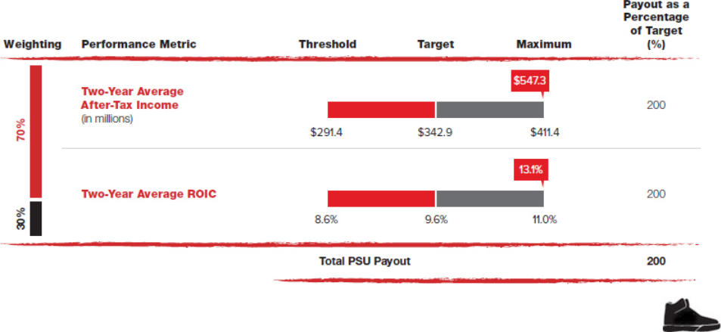

2022 PROXY STATEMENT | 59

EXECUTIVE COMPENSATION

Mr. Page was appointed in 2021, and Messrs. Bracken, Gray, and Martin were promoted, in 2020, so their payouts were prorated for the 2020-21 performance period. Due to Ms. Peters’s retirement in 2021, she earned the pro rata portion of her PSUs due for the 2020-21 performance period based on actual performance, which will be paid at the same time as the payouts to the other NEOs in 2023. Mr. Talwar forfeited these PSUs in connection with the termination of his employment.

The Human Capital Committee establishes certain performance targets in connection with determining the Company’s PSU payouts. The PSU payouts provide for the exclusion of certain items from such performance targets that the Human Capital Committee considers to be unusual or non-recurring. These items, if they occur, are excluded when calculating the PSU payouts, however, such unusual or non-recurring items may not be material for purposes of the non-GAAP measures presented in the Annual Report. In addition, certain items may not be adjusted for purposes of the PSU payouts, as they do not exceed a pre-established adjustment threshold, although they are adjusted for financial reporting purposes in the Annual Report consistent with past practices.

Two-Year Average After-Tax Income Calculation for 2020-21 PSU Payouts. Please note the following reconciliation:

 |  | 2021 |  | 2020 |  | Average
 |  | ($ in millions)
After-tax income:
Net income attributable to Foot Locker, Inc. | $ | 893 | $ | 323
After-tax adjustments excluded from GAAP:
Impairment and other charges, net of income tax benefit of $42 million and $24 million, respectively⁽¹⁾ |  | 130 |  | 93
Other income, net of income tax expense of $80 million and $50 million, respectively⁽¹⁾ |  | (226) |  | (140)
Tax charge related to revaluation of certain intellectual property rights⁽¹⁾ |  | 11 |  | 25
Tax expense related to tax law rate changes⁽¹⁾ |  | (1) |  | (5)
Two-Year Average After-Tax Income (non-GAAP) | $ | 807 | $ | 296
Disregarded items for the PSU awards, not part of non-GAAP adjustments⁽²⁾ |  | (5) |  | (2)
Two-Year Average After-Tax Income (PSU payouts) | $ | 802 | $ | 294 | $ | 548
- See pages 21 through 22 of our Annual Report for a description of this item.

- The PSU awards provide for the exclusion of certain items that the Human Capital Committee considers unusual or non-recurring. The disregarded items permitted under the PSU awards include adjustments relating to the income associated with completed acquisitions, the profit or loss from minority investments, the effect of COVID-19 on our results, and excess tax benefits.

- FOOT LOCKER, INC.

EXECUTIVE COMPENSATION

ROIC Calculation for 2020-21 PSU Payouts. Please note the following reconciliation:

 |  | 2021 |  | 2020 |  | Average
 |  | ($ in millions)
Pre-tax income:
Income before income taxes | $ | 1,240 | $ | 494
Pre-tax adjustments excluded from GAAP:
Impairment and other charges⁽¹⁾ |  | 172 |  | 117
Other income, net⁽¹⁾ |  | (306) |  | (190)
Adjusted income before income taxes (non-GAAP) | $ | 1,106 | $ | 421
Disregarded items for the PSU awards, not part of non-GAAP adjustments⁽²⁾ |  | (3) |  | (2)
Interest expense, net |  | (14) |  | (7)
Adjusted EBIT (PSU awards) | $ | 1,117 | $ | 426
+ Interest component of straight-line rent expense⁽¹⁾ |  | 144 |  | 158
Adjusted net operating profit |  | 1,261 |  | 584
- Adjusted income tax expense⁽¹⁾ |  | (342) |  | (168)
+ Net loss attributable to noncontrolling interests |  | 1 |  | —
= Adjusted return after taxes | $ | 920 | $ | 416 | $ | 668
Average total assets | $ | 7,589 | $ | 6,816
- Average cash and cash equivalents |  | (1,242) |  | (1,294)
- Average non-interest-bearing current liabilities |  | (1,060) |  | (819)
- Average merchandise inventories |  | (1,095) |  | (1,066)
+ 13-month average merchandise inventories |  | 1,116 |  | 1,243
= Average invested capital | $ | 5,308 | $ | 4,880 | $ | 5,094
ROIC % (PSU payouts) |  | 17.3% |  | 8.5% |  | 13.1%

- See pages 21 through 23 of our Annual Report for a description of these items.

- The PSU awards provide for the exclusion of certain items that the Human Capital Committee considers unusual or non-recurring. The disregarded items permitted under the PSU awards include adjustments relating to the income associated with completed acquisitions, the profit or loss from minority investments, the effect of COVID-19 on our results, and excess tax benefits.

Prior to the Human Capital Committee determining whether the PSU performance targets have been achieved, the Company’s independent registered public accounting firm, at the request, and for the restricted use, of the Human Capital Committee, reviews the PSU calculations to ensure that the payout is calculated in accordance with the plan.

The PSU payouts are formula-driven based upon Company performance, and our 2021 program for the NEOs does not provide for discretionary adjustments based upon individual performance. The Human Capital Committee did not exercise discretion in the amounts payable to the NEOs or any other executive officers under this incentive program.

2022 PROXY STATEMENT | 61

EXECUTIVE COMPENSATION

The target PSU awards for the 2020-21 performance period for the NEOs are listed in the following table:

 | Target Award as a
 | Percentage of Base Salary Rate
Name | (%)
Johnson | 325
Page⁽¹⁾ | 90
Bracken⁽²⁾ | 30
 | 75
Martin | 75
Gray⁽³⁾ | 50
 | 75
Peters⁽⁴⁾ | 100
Talwar⁽⁵⁾ | 75

- Mr. Page joined the Company as Executive Vice President and Chief Financial Officer in April 2021. His target PSU award was prorated for the 2020-21 performance period.

- Mr. Bracken served as Senior Vice President and General Manager, Foot Locker, Lady Foot Locker, and Kids Foot Locker until July 2020. His target award was set at 30% of his base salary rate at that time. Mr. Bracken was promoted to Executive Vice President and Chief Executive Officer—North America in July 2020. His target award was set at 75% of his base salary rate at that time. His target PSU award was prorated for the 2020 performance period.

- Mr. Gray served as Vice President and Chief Merchandising Officer—North America until July 2020. His target award was set at 50% of his base salary rate at that time. Mr. Gray was promoted to Executive Vice President and Chief Commercial Officer in July 2020. His target award was set at 75% of his base salary rate at that time. His target PSU award was prorated for the 2020 performance period.

- Due to Ms. Peters’s retirement in 2021, she earned the pro rata portion of her PSUs due for the 2020-21 performance period, based on actual performance, which will be paid at the same time as the payouts to the other NEOs in 2023.

- Mr. Talwar forfeited these PSUs in connection with the termination of his employment.

PSU AWARDS (2021-22)

In 2021, the Human Capital Committee established PSU performance targets for the 2021-22 performance period, which are also based on Two-Year Average After-Tax Income (70%) and ROIC (30%). For competitive reasons, since this performance period is still ongoing, we have not disclosed the targets established for the period. The Human Capital Committee will determine whether payouts have been earned following the end of the Company’s 2022 fiscal year, and we will provide specific information on the targets and results after the completion of the performance period. If awards are earned for the 2021-22 performance period, payment will be made to participating executives in 2024, following the completion of a one-year vesting period.

The target PSU values for the NEOs for the 2021-22 performance period if the performance goals are achieved are listed in the following table:

 | PSU Values at Target
Name | ($)
Johnson | 4,830,000
Page⁽¹⁾ | 499,519
Bracken | 597,620
Martin and Gray | 584,250
Talwar⁽²⁾ | 606,173

- Mr. Page joined the Company as Executive Vice President and Chief Financial Officer in April 2021. His target PSU award was prorated for the 2021-22 performance period.

- Mr. Talwar forfeited these PSUs in connection with the termination of his employment.

STOCK OPTIONS AND RSUs

The Human Capital Committee granted equity awards to the NEOs in 2021, splitting the total value of the award between stock options and RSUs in order to enhance the retentive value of the LTI awards. In deciding to grant these awards and determining the value of the awards, the Human Capital Committee considered each executive’s performance, position, and career potential and the competitive market for equivalent talent. See the Grants of Plan-Based Awards in Fiscal 2021 beginning on page 74 for additional information on awards granted in the Company’s 2021 fiscal year.

- FOOT LOCKER, INC.

EXECUTIVE COMPENSATION

The values shown in the Grants of Plan-Based Awards in Fiscal 2021 for the stock option grants in 2021 are based on the applicable Black-Scholes value on the grant date. The amounts shown in the table do not necessarily reflect the actual value that may be realized by the NEOs. The option exercise price is equal to the closing price of the Common Stock on the grant date. Stock options normally vest at the rate of one-third of the total grant per year over the first three years of the ten-year option term, subject to continuous service through each vesting date and accelerated vesting in certain limited circumstances. RSUs cliff vest generally after a period of three years based on continued employment. The Human Capital Committee does not normally consider an executive’s gains from prior stock awards in granting new awards as compensation in the current year. The Human Capital Committee determines the number of options granted based on a fixed value, using the Black-Scholes value on the grant date.

SPECIAL RSU AWARDS

The Human Capital Committee granted special RSU awards in 2021 to Mr. Page at sign-on, as discussed above, in order to replace compensation Mr. Page forfeited when he was recruited by us, and to Mr. Bracken in connection with his promotion to Executive Vice President and Chief Operating Officer, and to Messrs. Martin and Gray for retention purposes. In deciding to grant these awards and determining the value of the awards, the Human Capital Committee considered each executive’s position, including those with expanded scope and responsibilities, and the Company’s recruiting needs. Messrs. Martin and Gray received special one-time RSU awards for retention purposes. In approving such one-time awards, the Human Capital Committee considered the need to ensure management stability and continuity, as well as labor market conditions and competition for top talent in the current environment and during the COVID-19 pandemic. The Human Capital Committee also viewed the one-time awards as necessary in connection with the Company’s succession planning for key roles. The Human Capital Committee determined that the one-time awards were in the best interests of the Company and its shareholders. For Mr. Page, the RSUs will vest on each of the first three anniversaries of the grant date (a long-term incentive similar to the Company’s annual grant of RSUs), subject to his continued employment through each such anniversary date. All of the special awards for Messrs. Bracken, Martin, and Gray will vest on the third anniversary of the grant date, subject to continued employment through the vesting date. All of these values, and corresponding grant dates, are shown in the table below.

 | RSUs | RSUs | Grant Date
 | 04/12/21 | 11/16/21 | Fair Value
Name | (#) | (#) | ($)
Page | 12,557 | — | 750,030
Bracken | — | 10,661 | 600,001
Martin | — | 3,554 | 200,019
Gray | — | 5,331 | 300,029

RETIREMENT PLAN AND EXCESS CASH PLAN

The NEOs, other than Mr. Page, because the plans were frozen for new participants as of December 31, 2019, and Ms. Peters and Mr. Talwar, who have departed the organization, participate in the Retirement Plan and the Excess Cash Plan. These plans, as well as the method of calculating benefits payable under these plans, are described beginning on page 88.

401(k) PLAN AND EXCESS SAVINGS PLAN

Messrs. Johnson, Bracken, Martin, and Gray participate in the 401(k) Plan and the Excess Savings Plan. These plans, as well as the method of calculating contributions under these plans, are described on page 90.

SUPPLEMENTAL EXECUTIVE RETIREMENT PLAN

The Company maintains a SERP for certain senior officers of the Company and other key employees, including the NEOs who met the eligibility requirements prior to the plan being frozen for new participants (including rehires) after December 31, 2018. See page 90 for additional information regarding the SERP.

INTERNATIONAL ASSIGNMENT COMPENSATION

We provide team members on long-term international assignments with additional benefits and allowances that are designed to minimize any financial detriment or gain to the team member from an international assignment. Except for Expatriate Tax Payments, none of the NEOs, other than Mr. Talwar, received any compensation under the IAP during 2021.

2022 PROXY STATEMENT | 63

EXECUTIVE COMPENSATION

PERQUISITES

We provide the NEOs with certain perquisites, which the Human Capital Committee believes to be reasonable and consistent with its overall objective of attracting and retaining talented executives in a competitive labor market. The Company provides the NEOs with an automobile reimbursement, medical expense reimbursement, supplemental long-term disability insurance, and financial planning. In addition, the Company reimburses Mr. Johnson for reasonable car service expenses for transportation in the New York metropolitan area for increased personal security and efficiency. We also provide for continuation of medical and dental insurance benefits following retirement to participants who vested in the SERP prior to February 2, 2014. We do not provide a gross-up to executives for the income tax liability they incur due to their receipt of these perquisites.

EMPLOYMENT AGREEMENTS AND OTHER ARRANGEMENTS

As more fully described on pages 72 through 73, we have employment agreements with each of our NEOs, except Messrs. Page, Bracken, and Gray.

Other than the agreement with Mr. Johnson, the agreements are substantially in the same form.

PROCEDURES FOR DETERMINING COMPENSATION

SETTING COMPENSATION, ESTABLISHING GOALS, AND EVALUATING PERFORMANCE

As reflected in the following timeline, the Human Capital Committee oversees a rigorous and comprehensive compensation approval, goal setting, and performance review process:

Year-Round:
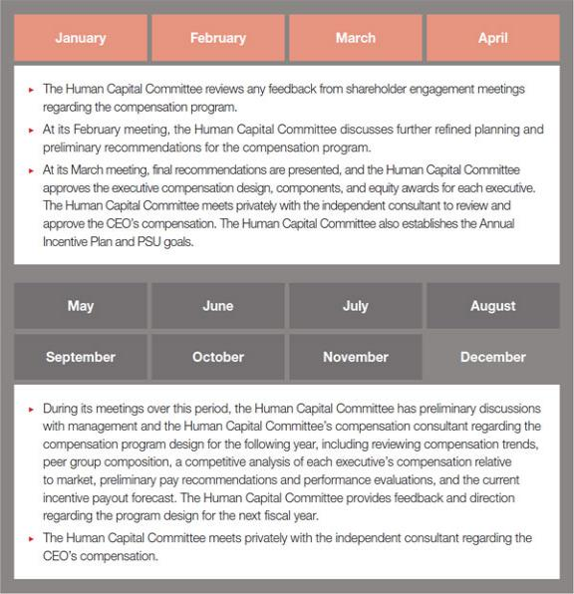

► The Human Capital Committee meets at other times throughout the year with management and privately with the independent consultant to review performance against the established performance goals, discuss developments and emerging trends, and review specific executive compensation and management resources issues. The Human Capital Committee is also responsible each year for reviewing the compensation paid to non-employee directors and making recommendations to the Board regarding the directors’ compensation program.

- FOOT LOCKER, INC.

EXECUTIVE COMPENSATION

BENCHMARKING APPROACH

We have established benchmarks for compensation, including cash and equity, for each NEO. These benchmarks are reviewed annually and are based upon compensation for comparable positions in a peer group consisting of (i) companies having revenues of approximately 0.5 to 2 times the Company’s revenue and market capitalization of approximately 0.25 to 4 times the Company’s market capitalization; and (ii) select sub-industries within the consumer discretionary sector most comparable to the Company’s business, including apparel retail; apparel, accessories, and luxury goods; footwear; home furnishing retail; internet and direct marketing retail; and specialty stores. We also use the peer group data to assess the competitiveness of total direct compensation awarded to our senior executives and as a data point in designing compensation plans, benefits, and perquisites.

The Human Capital Committee determined that the following companies, which comprised the peer group for 2021 compensation decisions, were appropriate for executive compensation purposes based upon the nature of their businesses, revenues, and the pool from which they recruit their executives.

PEER GROUP | ► | American Eagle Outfitters, Inc. | ► | Hanesbrands Inc. | ► | Tapestry, Inc.
FOR 2021 | ► | Bath and Body Works, Inc. | ► The Michaels Companies, Inc. |  | ► | Tiffany & Co.
COMPENSATION |  | f/k/a L Brands, Inc. | ► | PVH Corp. | ► | Tractor Supply Company
DECISIONS
DECISIONS | ► Bed Bath & Beyond Inc. |  | ► | Qurate Retail, Inc. | ► | Ulta Beauty, Inc.
 | ► | Burlington Stores, Inc. | ► | Ralph Lauren Corporation | ► | Under Armour, Inc.
 | ► Dick’s Sporting Goods, Inc. |  | ► Sally Beauty Holdings, Inc. |  | ► | Urban Outfitters, Inc.
 | ► | Expedia Group, Inc. | ► | Signet Jewelers Limited | ► | Wayfair Inc.
 | ► | The Gap, Inc. | ► | Skechers USA, Inc. | ► | Williams Sonoma, Inc.

One goal of the Human Capital Committee is to provide competitive total compensation opportunities for the NEOs that vary with Company performance. The Human Capital Committee uses the peer group benchmark information as a reference point in evaluating executive compensation, assessing the competitiveness of total direct compensation awarded to our senior executives, and designing compensation plans, benefits, and perquisites. It does not, however, attempt to match the compensation of each executive position in the Company precisely with that of an equivalent position in the peer group. In general, the Human Capital Committee looks to position an executive’s total compensation at the median of comparable positions at peer companies, consistent with the Company’s revenue in relation to peer companies. The Human Capital Committee also considers other factors, including performance, responsibility, experience, tenure, internal equity, and market positioning, when determining compensation.

2022 PROXY STATEMENT | 65

EXECUTIVE COMPENSATION

During 2018, the Human Capital Committee developed the criteria for determining the Company’s peer group. At that time, the Human Capital Committee endeavored to refresh the peer group every three years, with annual adjustments limited to merger and acquisition activity or going private transactions. To that goal, in 2021, the Human Capital Committee reviewed the criteria established in 2018 and determined that it was still appropriate. Based on this criteria and the companies’ 2021 revenues and market capitalizations, the peer group for 2022 compensation planning was refreshed, as provided below, to reflect a larger and more diverse group of peers:

DELETIONS | ► | Expedia Group, Inc. | ► | Tiffany & Co. | ► | Wayfair Inc.
DELETIONS | ► The Michaels Companies, Inc.
 | ► | Academy Sports and | ► | Levi Strauss & Co. | ► Petco Health and Wellness
ADDITIONS |  | Outdoors, Inc. | ► | The ODP Corporation |  | Company, Inc.
 | ► | Capri Holdings Limited
PEER GROUP | ► | Academy Sports and | ► | The Gap Inc. | ► | Signet Jewelers Limited
FOR 2022 |  | Outdoors, Inc. | ► | Hanesbrands, Inc. | ► | Skechers USA, Inc.
COMPENSATION
COMPENSATION | ► | American Eagle | ► | Levi Strauss & Co. | ► | Tapestry, Inc.
DECISIONS
DECISIONS |  | Outfitters, Inc. | ► | The ODP Corporation | ► | Tractor Supply Co.
 | ► Bath and Body Works, |  | ► | Petco Health and | ► | Ulta Beauty, Inc.
 |  | Inc. f/k/a L Brands, Inc. |  | Wellness Company, Inc. | ► | Under Armour, Inc.
 | ► Bed Bath & Beyond, Inc. |  | ► | PVH Corp. | ► | Urban Outfitters, Inc.
 | ► | Burlington Stores, Inc. | ► | Qurate Retail, Inc. | ► | Williams Sonoma, Inc.
 | ► | Capri Holdings Limited | ► | Ralph Lauren Corp.
 | ► Dick’s Sporting Goods Inc. |  | ► | Sally Beauty Holdings, Inc.

USE OF COMPENSATION CONSULTANTS

The Human Capital Committee has retained CAP, a nationally-recognized compensation consultant that is independent and performs no work for management, as its advisor. CAP reports directly to the Human Capital Committee, meets with the Human Capital Committee privately without management present, and regularly communicates privately with the Human Capital Committee Chair. CAP also meets with the Responsibility Committee regarding non-employee directors’ compensation and reports on related governance and trends. The Human Capital Committee has assessed the independence of CAP based on standards promulgated by the SEC and concluded that no conflict of interest exists that would prevent it from serving as an independent consultant to the Human Capital Committee. Each year, CAP reviews a report on risk in relation to the Company’s compensation policies and practices, provides a pay-for-performance analysis of our executive compensation program, and reviews the CEO’s compensation. In addition, each year CAP reviews and makes recommendations regarding the compensation program for non-employee directors, and the Human Capital Committee considers CAP’s report on the program. In 2021, management utilized the services of ClearBridge Compensation Group, a nationally-recognized compensation consultant, to provide advice on the executive compensation program and plan design.

MANAGEMENT INVOLVEMENT IN DEVELOPING THE COMPENSATION PROGRAM

Management is involved in various aspects of developing the executive compensation program. Our Chief Human Resources Officer, Vice President-Total Rewards, and staff in the Human Resources Department work with our CEO to develop compensation recommendations for all corporate and executive officers other than the CEO. The CEO or the Chief Human Resources Officer reviews these proposals with the Human Capital Committee Chair, and may make changes to the recommendations based upon her input, before the recommendations are presented to the Human Capital Committee for review. As part of her responsibilities, the Lead Independent Director also attends all Human Capital Committee meetings and advises the Human Capital Committee Chair in fulfilling her designated role and responsibilities. Our General Counsel also attends meetings of the Human Capital Committee and participates in some of these discussions and preparations.

- FOOT LOCKER, INC.

ADDITIONAL INFORMATION

KEY COMPENSATION GOVERNANCE POLICIES


WHAT WE DO

Align executive pay closely with Company’s performance and strategy
Set rigorous and objective performance goals Maintain a clawback policy
Impose and monitor meaningful stock ownership guidelines
Require a one-year time-based vesting period for earned PSU payouts following attainment of performance goals
Include double-trigger change in control provisions in employment agreements and equity awards
Mitigate undue risk in compensation programs
Retain independent compensation consultant to advise the Human Capital Committee
Hold annual “Say-on-Pay” advisory vote

Conduct shareholder engagement outreach to regularly obtain feedback on compensation and other topics

CLAWBACK POLICY

EXECUTIVE COMPENSATION

WHAT WE DO NOT DO

No changes to in-flight performance cycles
No tax gross-up for any compensation, benefit, perquisite, or change in control payments (other than the IAP and relocation program that is available to all employees)
No hedging or pledging of the Company’s stock

No repricing of stock options without shareholder approval No stock options granted below fair market value
No dividends or dividend equivalents on RSUs or PSUs

No excessive severance benefits

We have adopted a clawback policy that provides for the recovery of incentive compensation paid in cash or equity if the Human Capital Committee determines that the participant (1) engaged in fraud or gross misconduct which results in an accounting adjustment, whether or not the adjustment results in a restatement of our financial statements, or (2) committed a significant legal or compliance violation of the Code of Business Conduct or other policies. The Human Capital Committee is closely monitoring the proposed SEC rules regarding recoupment of incentive-based compensation, and will amend our policy as necessary.

STOCK OWNERSHIP GUIDELINES

We have meaningful stock ownership guidelines for our senior executives. At the end of 2021, all of the NEOs met or exceeded their applicable ownership guidelines. These guidelines are described on page 32.

COMPENSATION PROGRAM AND RISK

We believe that our compensation program encourages our NEOs to take action to improve the Company’s performance without encouraging them to take undue risk. The Annual Incentive Plan and PSU awards are paid based upon performance as compared to the Company’s annual and two-year financial plans, respectively, which are prepared each year by management, reviewed by the Finance Committee, and approved by the Board. No incentive awards are earned or paid unless the applicable performance goals are achieved. We believe that, on balance, the plans are rigorous, but reasonably achievable under normal business conditions. This encourages our executives to manage the business well without pressuring them to take undue risks in order to obtain a payout.

Our LTI awards for the NEOs are designed with a similar goal in mind. We believe that our LTI awards are reasonable in relation to overall compensation. Stock options normally vest ratably over a three-year period and have a 10-year term, and RSUs cliff vest generally after a period of three years, thereby each reducing the risk that an executive will take short-term action to inflate the price of the Company’s stock for a brief period. PSU payouts are calculated at the conclusion of a two-year performance period, but are not actually paid to the participant until after an additional year of vesting has been satisfied. In addition to serving as a retention vehicle, this also requires that the executive continues to have the value of their award at risk and dependent on fluctuations in stock price, for an additional year. It also allows a year to pass in which any issues concerning the Company’s operating or financial performance may come to light before payments are made.

2022 PROXY STATEMENT | 67

EXECUTIVE COMPENSATION

In addition, there are certain other factors related to our compensation programs for the NEOs that we believe help reduce the likelihood that our compensation programs will encourage our executives to take undue risk, as described below.

Factor | Description
 | As a retail company, we believe that one of the potential risks we have is that management will attempt to achieve
ROIC as PSU Award Measurement | profit targets without taking into account the capital used, particularly working capital invested in inventory and
ROIC as PSU Award Measurement | operating leases. We have, therefore, designed our PSU awards for senior management, including the NEOs, to
 | take into account ROIC as well as Two-Year Average After-Tax Income in determining whether a PSU award payout
 | will be paid.
No Bonus Payments to Executives with | We have designed our plans so that executives who receive a “Not Meeting Performance” rating under the
No Bonus Payments to Executives with | Company’s annual performance appraisal process are not eligible to receive an annual incentive payout. This helps
Poor Performance Ratings | prevent an individual executive from taking any action inconsistent with the business plan or otherwise exposing the
 | Company to undue risk.
Incentive Targets | Annual Incentive Plan targets are based on the financial plan that is reviewed by the Finance Committee and
Incentive Targets | approved by the Board.
Annual Incentive Payout Caps | Annual incentive payouts to executives are capped and do not include excessive leverage.
Mix of Components | We use a mix of annual and long-term incentive components, as well as a mix between the use of cash and equity.

DELEGATION OF AUTHORITY

The Human Capital Committee currently has delegated authority to its Chair to approve, between committee meetings, RSU awards up to 7,500 RSUs per individual award and stock option awards up to 25,000 shares per individual award, in both cases only to executives who are not corporate or executive officers of the Company, or general managers. It is expected that the Chair would use this authority to approve awards made during the course of the year in connection with promotions, new hires, or special retention purposes. Options are priced at fair market value on the date the Chair signs the approval, which is the grant date for awards made under this delegation authority. Similarly, the value of RSU awards is based on the fair market value on the date the Chair signs the approval. The Chair used this authority twice during 2021. The Human Capital Committee has not delegated authority to management to make stock option, RSU, or other equity-based awards.

ACCOUNTING AND TAX CONSIDERATIONS

While we review both the accounting and tax effects of various components of compensation, these effects are not a significant factor in the Human Capital Committee’s allocation of compensation among the different components. The Human Capital Committee believes that in certain instances it is in the best interests of the Company and our shareholders to have the flexibility to pay compensation that is not tax deductible so that we may provide compensation consistent with our program and objectives.

2022 COMPENSATION PROGRAM DESIGN CHANGES

In March 2022, the Human Capital Committee established the performance goals under the Annual Incentive Plan for the 2022 fiscal year and PSU awards for the performance period beginning in 2022. Under the Annual Incentive Plan, the goals are based (a) 80% on Adjusted Pre-Tax Income, and
- 20% on NPS. Under the PSU awards, the preliminary goals are based (a) 70% on Two-Year Average After-Tax Income, and (b) 30% on Two-Year Average ROIC. The preliminary PSU payout would be adjusted by a TSR modifier, to represent the Company’s TSR percent rank over a three-year performance period commencing at the beginning of the 2022 fiscal year relative to the companies in the S&P 1500 Specialty Retail Index, such that it is multiplied by between 75% for TSR below the 30th percentile to 125% for TSR above the 80th percentile. The TSR modifier is designed to enhance the alignment of internal incentive plan payouts with changes in external shareholder value. Additionally, recognizing the Company’s change in vendor mix and expected substantial investments in the business, the Human Capital Committee reduced the maximum payouts to 150% of target from 200% in prior years for participants under the Annual Incentive Plan and PSU awards (notwithstanding the TSR modifier), respectively, to ensure alignment between management’s payouts and shareholders’ expectations if the target goals are exceeded. The Human Capital Committee believes that the introduction of a TSR modifier to the PSU awards and a reduction in the maximum payouts under the Annual Incentive Plan and PSU awards are appropriate in a year in which all parties–management and shareholders–are making important investments in our Company’s future.

- FOOT LOCKER, INC.

EXECUTIVE COMPENSATION

HUMAN CAPITAL COMMITTEE REPORT

The Human Capital Committee has reviewed and discussed the CD&A with management and, based on that review and discussion, has recommended to the Board that the CD&A be included in this Proxy Statement.

MEMBERS OF THE HUMAN CAPITAL COMMITTEE



KIMBERLY | ALAN D. | GUILLERMO G. | DARLENE
UNDERHILL | FELDMAN | MARMOL | NICOSIA
Chair | Member | Member | Member

HUMAN CAPITAL COMMITTEE INTERLOCKS AND INSIDER PARTICIPATION

Ms. Underhill, Mr. Feldman, Mr. Marmol, and Ms. Nicosia served on the Human Capital Committee during 2021. In addition, Ms. Clark served on the Human Capital Committee during 2021 prior to her retirement in May 2021. None of the committee members was an officer or employee of the Company or any of its subsidiaries, and there were no interlocks with other companies within the meaning of the SEC’s proxy rules.

COMPENSATION AND RISK

The Company has completed a risk-related review and assessment of our compensation program and concluded that our compensation policies and practices, including executive compensation, are not reasonably likely to result in a material adverse effect on the Company. As part of this review, the independent compensation consultant to the Human Capital Committee reviewed risk in relation to the Company’s compensation policies and practices with the Company’s human resources executives directly involved in compensation matters. The consultant reviewed the compensation policies and practices in effect for corporate and division team members through the manager level, store managers, and store team members, and reviewed the features we have built into the compensation programs to discourage excessive risk taking by team members, including a balance between different elements of compensation, differing time periods for different elements, consistent Company-wide programs, plan performance targets based on the corporate budgeting process, and stock ownership guidelines.

2022 PROXY STATEMENT | 69

EXECUTIVE COMPENSATION |  |  |  |  |  |  |  | EXECUTIVE COMPENSATION
SUMMARY COMPENSATION TABLE
(a) | (b) | (c) | (d) | (e) | (f) | (g) | (h) | (i) | (j)
 |  |  |  |  |  |  | Change in Pension Value
 |  |  |  | Stock | Option | Non-Equity Incentive | and Non-Qualified Deferred | All Other
 |  | Salary | Bonus | Awards | Awards | Plan Compensation | Compensation Earnings | Compensation | Total
Name and Principal Position | Year | ($)⁽¹⁾ | ($)⁽²⁾ | _{($)}(3)(4) | ($)⁽³⁾ | _{($)}(1)(5) | ($)⁽⁶⁾ | ($)⁽⁷⁾ | ($)
Richard A. Johnson | 2021 | 1,150,000 | — | 6,440,063 | 1,610,012 | 4,169,900 | 1,038,044 | 50,306 | 14,458,325
Chairman, President and | 2020 | 996,667 | — | 4,937,518 | 1,200,002 | 3,847,900 | 880,582 | 78,651 | 11,941,320
Chief Executive Officer
Chief Executive Officer | 2019 | 1,137,500 | — | 4,937,521 | 1,200,004 | 1,378,650 | 521,588 | 46,942 | 9,222,205
Andrew E. Page | 2021 | 496,193 | 500,000 | 1,656,881 | 184,503 | 675,870 | — | 21,048 | 3,534,495
Executive Vice President and
Chief Financial Officer
Franklin R. Bracken | 2021 | 643,542 | — | 1,396,860 | 199,212 | 943,273 | — | 231,301 | 3,414,188
Executive Vice President and
Chief Operating Officer
W. Scott Martin | 2021 | 611,250 | — | 979,079 | 199,212 | 856,032 | 161,918 | 79,963 | 2,887,454
Executive Vice President, | 2020 | 538,659 | — | 641,277 | 200,000 | 549,398 | 133,364 | 64,429 | 2,127,127
Chief Strategy and Corporate
Chief Strategy and Corporate | 2019 | 518,750 | — | 612,563 | 200,015 | 204,336 | 63,354 | 24,622 | 1,623,640⁽⁸⁾
Development Officer
Andrew I. Gray | 2021 | 611,250 | — | 1,079,089 | 194,763 | 831,273 | 81,944 | 62,034 | 2,860,353
Executive Vice President and | 2020 | 512,663 | — | 419,349 | 75,002 | 613,695 | 60,216 | 202,416⁽⁸⁾ | 1,883,341⁽⁸⁾
Chief Commercial Officer
Lauren B. Peters⁽⁹⁾ | 2021 | 175,000 | — | — | — | — | — | 70,762 | 245,762
Former Executive Vice President | 2020 | 653,333 | — | 673,111 | 250,002 | 878,325 | 384,221 | 81,301 | 2,920,293
and Chief Financial Officer | 2019 | 693,750 | — | 950,053 | 250,006 | 315,309 | 298,364 | 18,455 | 2,525,937
Vijay Talwar⁽¹⁰⁾ | 2021 | 576,920 | — | 808,332 | 202,071 | — | — | 2,296,335 | 3,883,658
Vijay Talwar⁽¹⁰⁾ | 2020 | 606,667 | — | 737,544 | 250,002 | 780,000 | 170,661 | 265,480⁽⁸⁾ | 2,810,354⁽⁸⁾
Former Executive Vice President
and Chief Executive Officer—EMEA | 2019 | 650,000 | — | 737,575 | 250,006 | — | 68,966 | 790,303⁽⁸⁾ | 2,496,850⁽⁸⁾

- The amounts in columns (c) and (g) reflect the annual base salaries and non-equity incentive plan compensation, respectively, earned by our NEOs for the designated years. For 2021, these combined amounts represented the following percentages of the NEOs’ total compensation: Mr. Johnson (36.8%), Mr. Page (33.2%), Mr. Bracken (46.5%), Mr. Martin (50.8%), Mr. Gray (50.4%), Ms. Peters (71.2%), and Mr. Talwar (14.9%). Information on the NEOs’ employment agreements, as applicable, appears beginning on page 72.

- The amount in column (d) reflects the sign-on bonus that Mr. Page received in connection with the commencement of his employment in April 2021.

- The amounts reflected in columns (e) and (f) reflect the stock and option awards granted in the designated years. The amounts represent the aggregate grant date fair value of the awards granted in each respective year computed in accordance with stock-based compensation accounting rules. A discussion of the assumptions used in computing the award values may be found in Note 21 to our financial statements in our Annual Report, which is available at investors.footlocker-inc.com/ar. As provided under the SEC’s rules, the amounts shown exclude the impact of estimated forfeitures related to service-based vesting conditions. See the Grants of Plan-Based Awards in Fiscal 2021 beginning on page 74 for additional information on awards granted in 2021. The amounts shown in the table do not necessarily reflect the actual value that may be recognized by the NEOs.

- The amounts in column (e) include the grant date fair value of PSU awards granted for the 2021-22, 2020-21, and 2019-20 long-term performance periods, valued at grant date based upon the probable outcome of meeting the performance conditions, which is based on the target performance level. The amounts are consistent with the estimates of the aggregate compensation cost to be recognized over the service period determined at the grant date under stock-based compensation accounting rules, and exclude the effect of estimated forfeitures. Assuming the maximum performance level, the grant date fair value of the PSU awards granted for the 2021-22 long-term performance period would be $9,660,040 for Mr. Johnson; $999,044 for Mr. Page; $1,195,289 for Mr. Bracken; $1,168,537 for Mr. Martin; $1,168,537 for Mr. Gray; and $1,212,390 for Mr. Talwar. This column also includes RSU awards, where applicable. See the Grants of Plan-Based Awards in Fiscal 2021 beginning on page 74 for additional information on the awards granted in 2021.

- The amounts in column (g) reflect the cash incentive bonuses earned under the Annual Incentive Plan for the designated years, which amounts are paid to the NEO in the following year (subject to the NEO’s employment on such payment date).
- The amounts in column (h) represent the annual change in pension value for the designated years. See pages 87 through 88 for more information on fiscal 2021 pension benefits.
- The amounts in column (i) represent perquisites and other compensation attributable to the NEOs for 2021, valued at the incremental cost to the Company of providing them, which represents the actual cost, as reflected in the table below.

 |  |  |  |  |  |  |  | Match
 |  |  |  |  |  |  |  | Under
 |  |  |  |  |  |  |  | 401(k)
 |  | Car | Med. | Accrual | Supp. | Univ. |  | and |  |  | Expatriate |  | Accrued
 | Auto | Car | Med. | for | LTD | Life | Financial | Excess |  | Foreign | Expatriate | Vacation | Accrued
 | Auto | Service | Expense | Post-Ret. | Ins. | Ins. | Financial | Savings | Relo. | Foreign | Tax | Vacation | Severance | Total
Name | Allow. | Reimb. | Reimb. | Med. | Prem. | Prem. | Planning | Plans | Relo. | Earnings | Payments | Payout | Benefits | Total
Name | ($) | ($) | ($)^{(A)} | ($) | ($) | ($) | ($)^{(B)} | ($)^{(C)} | ($)^{(D)} | ($)^{(E)} | ($)^{(E)} | ($) | ($) | ($)
Johnson | 12,679 | 1,154 | 7,670 | — | 5,666 | 3,987 | 9,000 | 10,150 | — | — | — | — | — | 50,306
Page | 12,442 | — | 5,000 | — | 1,309 | 2,297 | — | — | — | — | — | — | — | 21,048
Bracken | 23,291 | — | 3,687 | — | 4,130 | 1,929 | 10,455 | 42,476 | 145,333 | — | — | — | — | 231,301
Martin | 21,329 | — | — | — | 4,426 | — | 13,629 | 40,579 | — | — | — | — | — | 79,963
Gray | 18,304 | — | 4,588 | — | 3,527 | 1,898 | 8,775 | 10,150 | — | — | 14,792 | — | — | 62,034
Peters^{(F)} | — | — | 1,755 | 56,979 | — | 1,878 | — | 10,150 | — | — | — | — | — | 70,762
Talwar^{(F)} | — | — | 7,335 | — | 4,130 | 2,845 | 10,455 | 10,150 | 177,685 | 113,900 | 269,777 | 2,558 | 1,697,500 | 2,296,335

- The amounts shown reflect amounts reimbursed in 2021, which may also include reimbursements of amounts submitted in 2021 for expenses incurred in 2020.

70 | FOOT LOCKER, INC. | 2022 PROXY STATEMENT | 71

EXECUTIVE COMPENSATION

  - The amounts shown reflect the total amounts paid, including fees.

  - The amounts shown reflect the Company’s matching contributions under our defined contribution plans, the 401(k) Plan and Excess Savings Plan, made to the NEO’s accounts.

  - For Mr. Bracken, the amount shown reflects expenses in connection with his relocation to the Company’s office in Bradenton, Florida, and for Mr. Talwar, the amount shown reflects expenses in connection with his relocation to the United States upon the termination of his employment.

  - For Mr. Gray, the amount shown reflects tax equalization payments, and U.S. and foreign tax payments net of hypothetical tax deductions, in connection with his international assignment for 2020 that were paid in 2021, and for Mr. Talwar, the amounts shown reflect expatriate compensation in connection with his role as Executive Vice President and Chief Executive Officer—EMEA in Vianen, The Netherlands. Under Foreign Earnings, the amount shown includes expatriate benefits and allowances for certain goods and services differential, housing, automobile costs, and tax preparation assistance in connection with his international assignment. Mr. Talwar received the majority of these benefits under the IAP, which applies to employees on international assignment and is designed to minimize any financial detriment or gain to the employee on assignment. Under Expatriate Tax Payments, the amount shown includes tax equalization payments, and U.S. and foreign tax payments net of hypothetical tax deductions, in connection with his international assignment. These payments were made under the IAP and are designed to facilitate this assignment by holding the team member responsible for the tax liabilities he would have incurred had he remained in his home country.

  - The amounts shown reflect perquisites attributable prior to Ms. Peters and Mr. Talwar’s termination of employment. Additional information on Ms. Peters and Mr. Talwar’s termination payments is provided beginning on page 92 under Potential Payments Upon Termination or Change in Control.

- The amounts in columns (i) and (j) are updated from the disclosure found in our 2021 Proxy Statement to include (x) the Total for Mr. Martin for 2019, and the All Other Compensation and Total for Mr. Gray for 2020, to include the Change in Pension Value and Non-Qualified Deferred Compensation Earnings, and Relocation, respectively, which values were correctly included in the Summary Compensation Table and footnote 6 thereto; and (y) the All Other Compensation and Total for Mr. Talwar for 2019 and 2020 to include additional relocation expenses of $34,186, and financial planning, relocation, foreign earnings, and expatriate tax payments of $780,389, respectively, which were updated after the filing of our 2021 Proxy Statement. Note that, although Mr. Talwar was not a NEO in 2019, the Company disclosed his 2019 compensation in the Summary Compensation Table when he first became an NEO in 2020.
- Ms. Peters ceased to serve as Executive Vice President and Chief Financial Officer effective April 12, 2021, and departed from the Company effective May 1, 2021.

- Mr. Talwar ceased to serve as Executive Vice President and Chief Executive Officer—EMEA effective November 17, 2021, and departed from the Company effective December 16, 2021, under circumstances the Human Capital Committee determined constituted a termination without cause under the Company’s employment agreement with Mr. Talwar, thereby requiring the Company to pay Mr. Talwar severance benefits according to the terms of his employment agreement.

The Company has established a trust for certain benefit plans, arrangements, and agreements, including the SERP, the Excess Cash Plan, the Excess Savings Plan, the executive employment agreements, and other benefit plans, agreements, or arrangements that may be covered at a later date (collectively, the “Benefit Obligations”). Upon the occurrence of a Potential Change in Control of the Company (as defined in the trust agreement), the Company is required to fund the trust with an amount sufficient to pay the total amount of the Benefit Obligations. Following the occurrence, and during the pendency, of a Potential Change in Control, the trustee would be required to make payments of Benefit Obligations to the extent these payments are not made by the Company.

EMPLOYMENT AGREEMENTS AND OTHER ARRANGEMENTS

We have employment agreements with Messrs. Johnson and Martin, and while we do not have employment agreements with Messrs. Page, Bracken, and Gray, they are each entitled to substantially the same benefits, and subject to substantially the same provisions, as Mr. Martin. We had employment agreements with Ms. Peters and Mr. Talwar substantially in the same form as Mr. Martin prior to their departure from the Company. The material terms of these arrangements are described below.

 |  | Base Salary | Two-Year
 |  | Rate⁽¹⁾ | Non-Compete and
Name | Term End Date | ($) | Non-Solicitation
Johnson | 01/31/24⁽²⁾ | $1,150,000⁽³⁾
Page | N/A | 615,000
Bracken | N/A | 800,000⁽⁴⁾
Martin | 01/31/23⁽²⁾ | 615,000
Gray | N/A | 615,000
Peters⁽⁵⁾ | 05/01/21 | 700,000
Talwar⁽⁶⁾ | 12/16/21 | 665,000

- These base salary rates are as of January 29, 2022 for each of the NEOs, except for Ms. Peters and Mr. Talwar, which are as of their respective termination dates.

- Mr. Johnson’s employment agreement is automatically extended for another year unless notice of non-renewal is given one year prior to the then-current expiration of the term. Mr. Martin’s employment agreement is automatically extended for another year unless notice of non-renewal is given three months prior to the then-current expiration of the term.

- During the term of the agreement, the Company will pay Mr. Johnson an annual base salary of not less than $1,000,000. See Notes 1 and 2 to the Grants of Plan-Based Awards in Fiscal 2021 beginning on page 74 for the 2021 payment levels at threshold, target, and maximum performance for the Annual Incentive Plan and PSU awards for Mr. Johnson. The payment levels are based on a percentage of Mr. Johnson’s base salary rate.

- FOOT LOCKER, INC.

EXECUTIVE COMPENSATION

- Mr. Bracken served as Executive Vice President and Chief Executive Officer—North America until November 2021. His base salary rate was $615,000 at that time until he was promoted to Executive Vice President and Chief Operating Officer in November 2021.

- Ms. Peters ceased to serve as Executive Vice President and Chief Financial Officer effective April 12, 2021, and departed from the Company effective May 1, 2021, at which time her employment agreement terminated. Certain obligations under her employment agreement continue post-termination, such as Ms. Peters’s non-competition obligation.

- Mr. Talwar ceased to serve as Executive Vice President and Chief Executive Officer—EMEA effective November 17, 2021, and departed from the Company effective December 16, 2021 under circumstances the Human Capital Committee determined constituted a termination without cause, at which time his employment agreement terminated. Certain obligations under his employment agreement continue post-termination, such as Mr. Talwar’s non-competition obligation.

Messrs. Johnson, Page, Bracken, Gray, and Martin are entitled to participate in all incentive and equity plans offered to senior executives in effect at the start of their agreements and offer letters, as applicable, as well as benefits, including retirement plans, company-paid life insurance, long-term disability coverage, and reimbursement for certain medical and financial planning expenses, and any other plans subsequently offered to our senior executives.

The executives’ agreements and offer letters, as applicable, include definitions of certain terms such as “Cause” (i.e., dismissal) by the company under certain circumstances, “Good Reason” (i.e., resignation under certain circumstances), “Change in Control” (e.g., the acquisition of 35% or more of the Company’s outstanding stock), and “Disability.”

Information on estimated potential payments and benefits upon termination of the NEOs’ employment or upon a change in control is described under Potential Payments Upon Termination or Change in Control beginning on page 92.

2022 PROXY STATEMENT | 73

EXECUTIVE COMPENSATION EXECUTIVE COMPENSATION

GRANTS OF PLAN-BASED AWARDS IN FISCAL 2021

The following table shows the awards made to the NEOs in 2021:

 |  |  |  | Estimated Future Payouts Under Non-Equity |  |  |  | Estimated Future Payouts Under
(a) |  |  | (b) | Incentive Plan Awards |  |  |  | Equity Incentive Plan Awards |  |  |  | (i) | (j) | (k) | (l)
(a) |  |  | (b) | (c) | (d) | (e) |  | (f) | (g) | (h)
 |  |  |  |  |  |  |  |  |  |  |  |  | All Other |  | Grant Date
 |  |  |  |  |  |  |  |  |  |  |  |  | Option |  | Grant Date
 |  |  |  |  |  |  |  |  |  |  |  | All Other Stock Awards: | Awards: | Exercise or | Fair Value
 |  |  |  |  |  |  |  |  |  |  |  | All Other Stock Awards: | Number of | Exercise or | of Stock
 |  |  |  |  | Target |  |  |  | Target |  |  | Number of Shares of | Securities Underlying | Base Price of | and Option
Name |  | Award Type | Grant Date | Threshold ($) | Target | Maximum ($) |  | Threshold (#) | Target | Maximum (#) |  | Stock or Units | Options | Option Awards | Awards
Name |  | Award Type | Grant Date | Threshold ($) | ($) |  |  | Threshold (#) | (#) |  |  | (#) | (#) | ($/Sh) | ($)⁽⁵⁾
Johnson |  | Annual Incentive | 03/24/21⁽¹⁾ | 575,000 | 2,300,000 | 4,600,000
 |  | PSU | 03/24/21⁽²⁾ |  |  |  |  | 22,524 | 90,096 | 180,191 |  |  |  |  | 4,830,047
 |  | Stock Option | 03/24/21⁽³⁾ |  |  |  |  |  |  |  |  |  | 79,971 | 53.61 | 1,609,816
 |  | RSU | 03/24/21⁽⁴⁾ |  |  |  |  |  |  |  |  | 30,032 |  |  | 1,610,016
Page |  | Annual Incentive | 04/12/21⁽¹⁾ | 93,198 | 372,791 | 745,582
 |  | PSU | 04/12/21⁽²⁾ |  |  |  |  | 933 | 3,730 | 7,460 |  |  |  |  | 222,793
 |  | PSU | 04/12/21⁽²⁾ |  |  |  |  | 2,091 | 8,363 | 16,726 |  |  |  |  | 499,522
 |  | Stock Option | 04/13/21⁽³⁾ |  |  |  |  |  |  |  |  |  | 8,333 | 58.25 | 184,493
 |  | RSU | 04/12/21⁽⁴⁾ |  |  |  |  |  |  |  |  | 12,557 |  |  | 750,030
 |  | RSU | 04/13/21⁽⁴⁾ |  |  |  |  |  |  |  |  | 3,168 |  |  | 184,536
Bracken |  | Annual Incentive | 03/24/21⁽¹⁾ | 131,349 | 525,398 | 1,050,795
 |  | PSU | 03/24/21⁽²⁾ |  |  |  |  | 2,787 | 11,148 | 22,296 |  |  |  |  | 597,643
 |  | Stock Option | 03/24/21⁽³⁾ |  |  |  |  |  |  |  |  |  | 9,895 | 53.61 | 199,186
 |  | RSU | 03/24/21⁽⁴⁾ |  |  |  |  |  |  |  |  | 3,716 |  |  | 199,215
 |  | RSU | 11/16/21⁽⁴⁾ |  |  |  |  |  |  |  |  | 10,661 |  |  | 600,001
Martin |  | Annual Incentive | 03/24/21⁽¹⁾ | 114,627 | 458,507 | 917,014
 |  | PSU | 03/24/21⁽²⁾ |  |  |  |  | 2,725 | 10,899 | 21,797 |  |  |  |  | 584,295
 |  | Stock Option | 03/24/21⁽³⁾ |  |  |  |  |  |  |  |  |  | 9,674 | 53.61 | 194,738
 |  | RSU | 03/24/21⁽⁴⁾ |  |  |  |  |  |  |  |  | 3,633 |  |  | 194,765
 |  | RSU | 11/16/21⁽⁴⁾ |  |  |  |  |  |  |  |  | 3,554 |  |  | 200,019
Gray |  | Annual Incentive | 03/24/21⁽¹⁾ | 114,627 | 458,507 | 917,014
 |  | PSU | 03/24/21⁽²⁾ |  |  |  |  | 2,725 | 10,899 | 21,797 |  |  |  |  | 584,295
 |  | Stock Option | 03/24/21⁽³⁾ |  |  |  |  |  |  |  |  |  | 9,674 | 53.61 | 194,738
 |  | RSU | 03/24/21⁽⁴⁾ |  |  |  |  |  |  |  |  | 3,633 |  |  | 194,765
 |  | RSU | 11/16/21⁽⁴⁾ |  |  |  |  |  |  |  |  | 5,331 |  |  | 300,029
Talwar |  | PSU | 03/24/21⁽²⁾ |  |  |  |  | 2,827 | 11,308 | 22,615 |  |  |  |  | 606,222
 |  | Stock Option | 03/24/21⁽³⁾ |  |  |  |  |  |  |  |  |  | 10,037 | 53.61 | 202,045
 |  | RSU | 03/24/21⁽⁴⁾ |  |  |  |  |  |  |  |  | 3,770 |  |  | 202,110
74 | FOOT LOCKER, INC. |  |  |  |  |  |  |  |  |  |  |  |  | 2022 PROXY STATEMENT | 75

EXECUTIVE COMPENSATION

- Annual Incentive Awards

The amounts in columns (c), (d), and (e) reflect the payment levels at threshold, target, and maximum performance for the 2021 fiscal year under the Annual Incentive Plan and reflect the potential amounts to be paid at the end of the period if the applicable performance goals are achieved. The estimated annual incentive payouts are based on a percentage of the NEO’s base salary rate, as shown in the table below:

 | Threshold | Target | Maximum
Name | (%) | (%) | (%)
Johnson | 50 | 200 | 400
Page^{(A)}, Martin, and Gray | 18.75 | 75 | 150
Bracken^{(B)} | 18.75 | 75 | 150
 | 25 | 100 | 200

- Mr. Page joined the Company as Executive Vice President and Chief Financial Officer in April 2021. His target Annual Incentive Award was prorated for the 2021 performance period.

- Mr. Bracken served as Executive Vice President and Chief Executive Officer–North America until November 2021. His target award was set at 75% of his base salary rate at that time. Mr. Bracken was promoted to Executive Vice President and Chief Operating Officer in November 2021. His target award was set at 100% of his base salary rate at that time. His target Annual Incentive Award was prorated for the 2021 performance period.

Although Ms. Peters and Mr. Talwar participated in the Annual Incentive Plan in 2021, they were not eligible to receive a payment under the plan because their employment terminated prior to the completion of the plan year.

- PSU Awards

For Mr. Page, provided the performance goals for the 2020-21 long-term performance period are achieved, the payout of the PSUs would be subject to a time-based, one-year vesting period following the end of the performance period. Columns (f), (g), and (h) reflect the number of PSUs that would be paid out at threshold, target, and maximum performance if the applicable performance goals are achieved for the 2020-21 performance period. The threshold, target, and maximum number of PSUs for Mr. Page were calculated on the grant date on the basis of that day’s closing stock price of a share of Common Stock. The closing price on the grant date of April 12, 2021 for Mr. Page was $59.73. Similarly, the grant date fair value of the PSUs are based on the closing stock price on the associated grant date. The actual number of PSUs paid out will be based on the Company’s performance compared to targets. The value of the PSUs received by Mr. Page will depend upon the Company’s stock price on the payment date in 2023. No dividends are paid or accrued in connection with the PSUs. The aggregate payout in stock at threshold, target, and maximum performance for Mr. Page is based on a percentage of his base salary rate in the second year of the performance period. The PSU award values for the 2020-21 performance period for Mr. Page at threshold, target, and maximum performance are listed in the following table:

 | Threshold | Target | Maximum
Name | ($) | ($) | ($)
Page^{(A)} | 55,692 | 222,769 | 445,537

- Mr. Page joined the Company as Executive Vice President and Chief Financial Officer in April 2021. His PSU award was prorated for the 2020-21 performance period.

For each of the NEOs, provided the performance goals for the 2021-22 long-term performance period are achieved, the payout of the PSUs would be subject to a time-based, one-year vesting period following the end of the performance period. Columns (f), (g), and (h) reflect the number of PSUs that would be paid out at threshold, target, and maximum performance if the applicable performance goals are achieved for the 2021-22 performance period. The threshold, target, and maximum number of PSUs for each NEO were calculated on the grant date on the basis of that day’s closing stock price of a share of Common Stock. The closing price on the grant date of March 24, 2021 for each of the NEOs other than Mr. Page was $53.61, and the closing price on the grant date of April 12, 2021 for Mr. Page was $59.73. Similarly, the grant date fair value of the PSUs are based on the closing stock price on the associated grant date. The actual number of PSUs paid out will be based on the Company’s performance compared to targets. The value of the PSUs received by an NEO will depend upon the Company’s stock price on the payment date in 2024. No dividends are paid or accrued in connection with the PSUs. The aggregate payout in stock at threshold, target, and maximum performance for each of the NEOs is based on a percentage of their base salary rate in the first year of the performance period. The PSU award values for the 2021-22 performance period for the NEOs at threshold, target, and maximum performance are listed in the following table:

 | Threshold | Target | Maximum
Name | ($) | ($) | ($)
Johnson | 1,207,500 | 4,830,000 | 9,660,000
Page^{(A)} | 124,880 | 499,519 | 999,037
Bracken | 149,405 | 597,620 | 1,195,240
Martin and Gray | 146,063 | 584,250 | 1,168,500
Talwar^{(B)} | 151,543 | 606,173 | 1,212,346

- Mr. Page joined the Company as Executive Vice President and Chief Financial Officer in April 2021. His PSU award was prorated for the 2021-22 performance period.

- Mr. Talwar forfeited this PSU award in connection with the termination of his employment.

- FOOT LOCKER, INC.

EXECUTIVE COMPENSATION

- Stock Option Awards

The amounts in column (j) reflect the number of stock options awarded for the 2021 fiscal year under the Stock Incentive Plan. The exercise price reflected in column (k) is equal to the closing price of a share of Common Stock on the grant date. In general, no portion of any stock option may be exercised until the first anniversary of its grant date. Vested options may be exercised for ten years following the grant date, unless the option is cancelled or exercised sooner. If the NEO retires, becomes disabled, or dies while employed by the Company or one of its subsidiaries, all unexercised options that are then exercisable and those options that would have become exercisable on the next anniversary of the grant date will remain (or become) exercisable as of that date. Options granted in 2021 will become exercisable upon a participant’s termination of employment on or within 24 months following a Change in Control. In general, options may remain exercisable for up to three years following a participant’s retirement or termination due to disability, and for up to one year for any other termination of employment for reasons other than cause.

The vesting schedules for the stock options granted to the NEOs in 2021 are as follows:

 |  | Shares | Vest Date: Shares |  | Vest Date: Shares |  | Vest Date: Shares
Name | Grant Date | (#) |  | (#) |  | (#) |  | (#)
Johnson | 03/24/21 | 79,971 | 03/24/22: | 26,657 | 03/24/23: | 26,657 | 03/24/24: | 26,657
Page | 04/13/21 | 8,333 | 04/13/22: | 2,777 | 04/13/23: | 2,778 | 04/13/24: | 2,778
Bracken | 03/24/21 | 9,895 | 03/24/22: | 3,298 | 03/24/23: | 3,298 | 03/24/24: | 3,299
Martin and Gray | 03/24/21 | 9,674 | 03/24/22: | 3,224 | 03/24/23: | 3,225 | 03/24/24: | 3,225
Talwar | 03/24/21 | 10,037 | 03/24/22: | * | 03/24/23: | * | 03/24/24: | *

* Unvested portion of stock option award cancelled upon termination of employment.

- RSU Awards

The amounts in column (i) reflect the number of RSUs awarded for the 2021 fiscal year under the Stock Incentive Plan. The awards will vest according to the schedules below, provided that the NEO remains employed by the Company through the vesting date. No dividends are paid or accrued for RSU awards.

 |  | Shares
Name | Grant Date | (#) | Vest Date
Johnson | 03/24/21 | 30,032 | 03/24/24
Page | 04/12/21 | 4,185 | 04/12/22
 | 04/12/21 | 4,186 | 04/12/23
 | 04/12/21 | 4,186 | 04/12/24
 | 04/13/21 | 3,168 | 04/13/24
Bracken | 03/24/21 | 3,716 | 03/24/24
 | 11/16/21 | 10,661 | 11/16/24
Martin | 03/24/21 | 3,633 | 03/24/24
 | 11/16/21 | 3,554 | 11/16/24
Gray | 03/24/21 | 3,633 | 03/24/24
 | 11/16/21 | 5,331 | 11/16/24
Talwar | 03/24/21 | 3,770* | 03/24/24

* Mr. Talwar forfeited these RSU awards in connection with the termination of his employment.

- Grant Date Fair Value

The amounts in column (l) reflect the aggregate grant date fair values of the RSU, PSU, and stock option awards granted in 2021, calculated in accordance with stock-based compensation accounting rules. A discussion of the assumptions used in computing the award values are found in Note 21 to our financial statements in our Annual Report, which is available at investors.footlocker-inc.com/ar. For the RSUs, the fair values are calculated by multiplying the closing price of our Common Stock on the NYSE on the award date by the number of RSUs granted. For the PSUs, the fair value is calculated based upon the probable outcome of meeting the performance conditions at the target performance level and multiplying the number of PSUs that would be received at that level by the closing price of our Common Stock on the grant date. This is consistent with the estimate of the aggregate compensation cost to be recognized over the service period determined at the grant date under stock-based compensation accounting rules. For the stock options, the values are calculated by multiplying the Black-Scholes value by the number of stock options awarded. All of these values, and corresponding grant dates, are shown in the table below.

 |  |  |  |  |  |  | Stock | Stock
 | RSUs | RSUs | RSUs | RSUs | PSUs | PSUs | Options | Options
 | 03/24/21 | 04/12/21 | 04/13/21 | 11/16/21 | 03/24/21 | 04/12/21 | 03/24/21 | 04/13/21
Name | ($) | ($) | ($) | ($) | ($) | ($) | ($) | ($)
Johnson and Talwar | 53.61 | – | – | – | 53.61 | – | 20.13 | –
Page | – | 59.73 | 58.25 | – | – | 59.73 | – | 22.14
Bracken, Martin, and Gray | 53.61 | – | – | 56.28 | 53.61 | – | 20.13 | –

Assuming the maximum performance level, the grant date fair value of the PSUs granted for the long-term performance period of 2020-21 would be $445,537 for Mr. Page, and for the long-term performance period of 2021-22, would be $9,660,000 for Mr. Johnson; $999,037 for Mr. Page; $1,195,240 for Mr. Bracken; $1,168,500 for Mr. Martin, $1,168,500 for Mr. Gray, and $1,212,346 for Mr. Talwar.

2022 PROXY STATEMENT | 77

EXECUTIVE COMPENSATION EXECUTIVE COMPENSATION

OUTSTANDING EQUITY AWARDS AT FISCAL 2021 YEAR-END

The following table shows the number of outstanding stock options, both vested and unvested, the number of unvested shares of RSUs, and the number of PSUs, both earned but unvested and unearned, held by the NEOs at the end of the 2021 fiscal year:

(a) |  | Option Awards |  |  |  |  |  | Stock Awards
(a) | (b) | (c) | (d) | (e) |  | (f) | (g) | (h) | (i) |  | (j)
 |  |  |  |  |  |  |  |  | Equity Incentive |  | Equity Incentive
 |  |  | Equity Incentive |  |  |  |  |  | Plan Awards: |  | Plan Awards:
 | Number of | Number of | Plan Awards: |  |  |  | Number |  | Number of |  | Market or Payout
 | Securities | Securities | Number of |  |  |  | of Shares | Market Value | Unearned | Value of Unearned
 | Underlying | Underlying | Securities |  |  |  | or Units | of Shares or | Shares, Units, |  | Shares, Units,
 | Unexercised | Unexercised | Underlying | Option |  |  | of Stock | Units of Stock | or Other Rights |  | or Other Rights
 | Options | Options | Unexercised | Exercise |  | Option | That Have | That Have Not | That Have Not |  | That Have Not
 | Exercisable⁽¹⁾ | Unexercisable⁽¹⁾ | Unearned Options | Price |  | Expiration | Not Vested | Vested | Vested |  | Vested
Name | (#) | (#) | (#) | ($) |  | Date | (#)⁽²⁾ | ($)⁽³⁾ | (#)⁽²⁾ |  | ($)⁽³⁾
Johnson | 49,000 | – | – | 30.92 |  | 03/21/2022 | – | – | – |  | –
 | 47,000 | – | – | 34.24 |  | 03/28/2023 | – | – | – |  | –
 | 37,000 | – | – | 45.08 |  | 03/26/2024 | – | – | – |  | –
 | 55,000 | – | – | 56.35 |  | 12/01/2024 | – | – | – |  | –
 | 207,900 | – | – | 62.11 |  | 03/25/2025 | – | – | – |  | –
 | 139,380 | – | – | 63.79 |  | 03/23/2026 | – | – | – |  | –
 | 141,207 | – | – | 72.83 |  | 03/22/2027 | – | – | – |  | –
 | 91,093 | – | – | 44.78 |  | 03/28/2028 | – | – | – |  | –
 | 46,552 | 23,277 | – | 58.94 |  | 03/27/2029 | – | – | – |  | –
 | 79,582 | 159,164 | – | 21.60 |  | 03/25/2030 | – | – | – |  | –
 | – | 79,971 | – | 53.61 |  | 03/24/2031 | – | – | – |  | –
 | – | – | – | – |  | – | 20,360 | 904,595 | – |  | –
 | – | – | – | – |  | – | 30,032 | 1,334,322 | – |  | –
 | – | – | – | – |  | – | 55,556 | 2,468,353 | – |  | –
 | – | – | – | – |  | – | – | – | 180,191 |  | 8,005,886
 | – | – | – | – |  | – | – | – | 186,782 |  | 8,298,724
Page | – | 8,333 | – | 58.25 |  | 04/13/2031 | – | – | – |  | –
 | – | – | – | – |  | – | 3,168 | 140,754 | – |  | –
 | – | – | – | – |  | – | 12,557 | 557,908 | – |  | –
 | – | – | – | – |  | – | – | – | 7,460 |  | 331,448
 | – | – | – | – |  | – | – | – | 16,726 |  | 743,136
78 | FOOT LOCKER, INC. |  |  |  |  |  |  |  | 2022 PROXY STATEMENT |  | 79

EXECUTIVE COMPENSATION |  |  |  |  |  |  |  |  |  | EXECUTIVE COMPENSATION
(a) |  | Option Awards |  |  |  |  |  | Stock Awards
(a) | (b) | (c) | (d) | (e) |  | (f) | (g) | (h) | (i) |  | (j)
 |  |  |  |  |  |  |  |  | Equity Incentive |  | Equity Incentive
 |  |  | Equity Incentive |  |  |  |  |  | Plan Awards: |  | Plan Awards:
 | Number of | Number of | Plan Awards: |  |  |  | Number |  | Number of |  | Market or Payout
 | Securities | Securities | Number of |  |  |  | of Shares | Market Value | Unearned | Value of Unearned
 | Underlying | Underlying | Securities |  |  |  | or Units | of Shares or | Shares, Units, |  | Shares, Units,
 | Unexercised | Unexercised | Underlying | Option |  |  | of Stock | Units of Stock | or Other Rights |  | or Other Rights
 | Options | Options | Unexercised | Exercise |  | Option | That Have | That Have Not | That Have Not |  | That Have Not
 | Exercisable⁽¹⁾ | Unexercisable⁽¹⁾ | Unearned Options | Price |  | Expiration | Not Vested | Vested | Vested |  | Vested
Name | (#) | (#) | (#) | ($) |  | Date | (#)⁽²⁾ | ($)⁽³⁾ | (#)⁽²⁾ |  | ($)⁽³⁾
Bracken | 934 | – | – | 45.08 |  | 03/26/2024 | – | – | – |  | –
 | 1,250 | – | – | 62.11 |  | 03/25/2025 | – | – | – |  | –
 | 6,336 | – | – | 63.79 |  | 03/23/2026 | – | – | – |  | –
 | 6,419 | – | – | 72.83 |  | 03/22/2027 | – | – | – |  | –
 | 4,049 | – | – | 44.78 |  | 03/28/2028 | – | – | – |  | –
 | 2,910 | 1,455 | – | 58.94 |  | 03/27/2029 | – | – | – |  | –
 | 4,974 | 9,948 | – | 21.60 |  | 03/25/2030 | – | – | – |  | –
 | – | 9,895 | – | 53.61 |  | 03/24/2031 | – | – | – |  | –
 | – | – | – | – |  | – | 1,273 | 56,559 | – |  | –
 | – | – | – | – |  | – | 3,473 | 154,305 | – |  | –
 | – | – | – | – |  | – | 3,716 | 165,102 | – |  | –
 | – | – | – | – |  | – | 10,661 | 473,668 | – |  | –
 | – | – | – | – |  | – | – | – | 17,987 |  | 799,162
 | – | – | – | – |  | – | – | – | 22,296 |  | 990,611
Martin | 17,442 | – | – | 55.02 |  | 06/13/2026 | – | – | – |  | –
 | 14,442 | – | – | 72.83 |  | 03/22/2027 | – | – | – |  | –
 | 9,110 | – | – | 44.78 |  | 03/28/2028 | – | – | – |  | –
 | 7,759 | 3,880 | – | 58.94 |  | 03/27/2029 | – | – | – |  | –
 | 13,263 | 26,528 | – | 21.60 |  | 03/25/2030 | – | – | – |  | –
 | – | 9,674 | – | 53.61 |  | 03/24/2031 | – | – | – |  | –
 | – | – | – | – |  | – | 3,394 | 150,795 | – |  | –
 | – | – | – | – |  | – | 3,554 | 157,904 | – |  | –
 | – | – | – | – |  | – | 3,633 | 161,414 | – |  | –
 | – | – | – | – |  | – | 9,260 | 411,422 | – |  | –
 | – | – | – | – |  | – | – | – | 21,797 |  | 968,441
 | – | – | – | – |  | – | – | – | 22,050 |  | 979,682
80 | FOOT LOCKER, INC. |  |  |  |  |  |  |  | 2022 PROXY STATEMENT |  | 81

EXECUTIVE COMPENSATION |  |  |  |  |  |  |  |  |  | EXECUTIVE COMPENSATION
(a) |  | Option Awards |  |  |  |  |  | Stock Awards
(a) | (b) | (c) | (d) | (e) |  | (f) | (g) | (h) | (i) |  | (j)
 |  |  |  |  |  |  |  |  | Equity Incentive |  | Equity Incentive
 |  |  | Equity Incentive |  |  |  |  |  | Plan Awards: |  | Plan Awards:
 | Number of | Number of | Plan Awards: |  |  |  | Number |  | Number of |  | Market or Payout
 | Securities | Securities | Number of |  |  |  | of Shares | Market Value | Unearned | Value of Unearned
 | Underlying | Underlying | Securities |  |  |  | or Units | of Shares or | Shares, Units, |  | Shares, Units,
 | Unexercised | Unexercised | Underlying | Option |  |  | of Stock | Units of Stock | or Other Rights |  | or Other Rights
 | Options | Options | Unexercised | Exercise |  | Option | That Have | That Have Not | That Have Not |  | That Have Not
 | Exercisable⁽¹⁾ | Unexercisable⁽¹⁾ | Unearned Options | Price |  | Expiration | Not Vested | Vested | Vested |  | Vested
Name | (#) | (#) | (#) | ($) |  | Date | (#)⁽²⁾ | ($)⁽³⁾ | (#)⁽²⁾ |  | ($)⁽³⁾
Gray | 1,400 | – | – | 45.08 |  | 03/26/2024 | – | – | – |  | –
 | 2,500 | – | – | 62.11 |  | 03/25/2025 | – | – | – |  | –
 | 6,336 | – | – | 63.79 |  | 03/23/2026 | – | – | – |  | –
 | 6,419 | – | – | 72.83 |  | 03/22/2027 | – | – | – |  | –
 | 25,606 | – | – | 34.75 |  | 10/02/2027 | – | – | – |  | –
 | 6,073 | – | – | 44.78 |  | 03/28/2028 | – | – | – |  | –
 | 2,910 | 1,455 | – | 58.94 |  | 03/27/2029 | – | – | – |  | –
 | 4,974 | 9,948 | – | 21.60 |  | 03/25/2030 | – | – | – |  | –
 | – | 9,674 | – | 53.61 |  | 03/24/2031 | – | – | – |  | –
 | – | – | – | – |  | – | 1,273 | 56,559 | – |  | –
 | – | – | – | – |  | – | 3,473 | 154,305 | – |  | –
 | – | – | – | – |  | – | 3,633 | 161,414 | – |  | –
 | – | – | – | – |  | – | 5,331 | 236,856 | – |  | –
 | – | – | – | – |  | – | – | – | 19,849 |  | 881,891
 | – | – | – | – |  | – | – | – | 21,797 |  | 968,441
Peters | 34,000 | – | – | 45.08 |  | 03/26/2024 | – | – | – |  | –
 | 32,000 | – | – | 62.11 |  | 03/25/2025 | – | – | – |  | –
 | 28,510 | – | – | 63.79 |  | 03/23/2026 | – | – | – |  | –
 | 32,093 | – | – | 72.83 |  | 03/22/2027 | – | – | – |  | –
 | 20,243 | – | – | 44.78 |  | 03/28/2028 | – | – | – |  | –
 | 14,548 | – | – | 58.94 |  | 03/27/2029 | – | – | – |  | –
 | 33,159 | – | – | 21.60 |  | 03/25/2030 | – | – | – |  | –
 | – | – | – | – |  | – | – | – | 21,817 |  | 969,329
Talwar | 18,166 | – | – | 67.07 |  | 09/23/2026 | – | – | – |  | –
 | 19,256 | – | – | 72.83 |  | 03/22/2027 | – | – | – |  | –
 | 12,146 | – | – | 44.78 |  | 03/28/2028 | – | – | – |  | –
 | 9,698 | – | – | 58.94 |  | 03/27/2029 | – | – | – |  | –
 | 13,079 | – | – | 21.60 |  | 03/25/2030 | – | – | – |  | –
82 | FOOT LOCKER, INC. |  |  |  |  |  |  |  | 2022 PROXY STATEMENT |  | 83

EXECUTIVE COMPENSATION

- The Vesting Schedules for the options shown in columns (b) and (c) are as follows:

 | Total
 | Securities
 | Underlying
 | Unexercised |  | Vesting Date | Vesting Date | Vesting Date
 | Options |  | for ⅓ of | for ⅓ of | for ⅓ of
Name | (#) | Grant Date | Total Grant | Total Grant | Total Grant
Johnson | 49,000 | 03/21/2012 | 03/21/2013 | 03/21/2014 | 03/21/2015
 | 47,000 | 03/28/2013 | 03/28/2014 | 03/28/2015 | 03/28/2016
 | 37,000 | 03/26/2014 | 03/26/2015 | 03/26/2016 | 03/26/2017
 | 55,000 | 12/01/2014 | 12/01/2015 | 12/01/2016 | 12/01/2017
 | 207,900 | 03/25/2015 | 03/25/2016 | 03/25/2017 | 03/25/2018
 | 139,380 | 03/23/2016 | 03/23/2017 | 03/23/2018 | 03/23/2019
 | 141,207 | 03/22/2017 | 03/22/2018 | 03/22/2019 | 03/22/2020
 | 91,093 | 03/28/2018 | 03/28/2019 | 03/28/2020 | 03/28/2021
 | 69,829 | 03/27/2019 | 03/27/2020 | 03/27/2021 | 03/27/2022
 | 238,746 | 03/25/2020 | 03/25/2021 | 03/25/2022 | 03/25/2023
 | 79,971 | 03/24/2021 | 03/24/2022 | 03/24/2023 | 03/24/2024
 | 1,156,126
Page | 8,333 | 04/13/2021 | 04/13/2022 | 04/13/2023 | 04/13/2024
 | 8,333
Bracken | 934 | 03/26/2014 | 03/26/2015 | 03/26/2016 | 03/26/2017
 | 1,250 | 03/25/2015 | 03/25/2016 | 03/25/2017 | 03/25/2018
 | 6,336 | 03/23/2016 | 03/23/2017 | 03/23/2018 | 03/23/2019
 | 6,419 | 03/22/2017 | 03/22/2018 | 03/22/2019 | 03/22/2020
 | 4,049 | 03/28/2018 | 03/28/2019 | 03/28/2020 | 03/28/2021
 | 4,365 | 03/27/2019 | 03/27/2020 | 03/27/2021 | 03/27/2022
 | 14,922 | 03/25/2020 | 03/25/2021 | 03/25/2022 | 03/25/2023
 | 9,895 | 03/24/2021 | 03/24/2022 | 03/24/2023 | 03/24/2024
 | 48,170
Gray | 1,400 | 03/26/2014 | 03/26/2015 | 03/26/2016 | 03/26/2017
 | 2,500 | 03/25/2015 | 03/25/2016 | 03/25/2017 | 03/25/2018
 | 6,336 | 03/23/2016 | 03/23/2017 | 03/23/2018 | 03/23/2019
 | 6,419 | 03/22/2017 | 03/22/2018 | 03/22/2019 | 03/22/2020
 | 25,606 | 10/02/2017 | 10/02/2018 | 10/02/2019 | 10/02/2020
 | 6,073 | 03/28/2018 | 03/28/2019 | 03/28/2020 | 03/28/2021
 | 4,365 | 03/27/2019 | 03/27/2020 | 03/27/2021 | 03/27/2022
 | 14,922 | 03/25/2020 | 03/25/2021 | 03/25/2022 | 03/25/2023
 | 9,674 | 03/24/2021 | 03/24/2022 | 03/24/2023 | 03/24/2024
 | 77,295
Martin | 17,442 | 06/13/2016 | 06/13/2017 | 06/13/2018 | 06/13/2019
 | 14,442 | 03/22/2017 | 03/22/2018 | 03/22/2019 | 03/22/2020
 | 9,110 | 03/28/2018 | 03/28/2019 | 03/28/2020 | 03/28/2021
 | 11,639 | 03/27/2019 | 03/27/2020 | 03/27/2021 | 03/27/2022
 | 39,791 | 03/25/2020 | 03/25/2021 | 03/25/2022 | 03/25/2023
 | 9,674 | 03/24/2021 | 03/24/2022 | 03/24/2023 | 03/24/2024
 | 102,098

- FOOT LOCKER, INC.

 |  |  |  |  |  | EXECUTIVE COMPENSATION
 |  |  | Total
 |  |  | Securities
 |  |  | Underlying
 |  |  | Unexercised |  | Vesting Date | Vesting Date | Vesting Date
 |  |  | Options |  | for ⅓ of | for ⅓ of |  | for ⅓ of
 |  | Name | (#) | Grant Date | Total Grant | Total Grant |  | Total Grant
 |  | Peters | 34,000 | 03/26/2014 | 03/26/2015 | 03/26/2016 |  | 03/26/2017
 |  |  | 32,000 | 03/25/2015 | 03/25/2016 | 03/25/2017 |  | 03/25/2018
 |  |  | 28,510 | 03/23/2016 | 03/23/2017 | 03/23/2018 |  | 03/23/2019
 |  |  | 32,093 | 03/22/2017 | 03/22/2018 | 03/22/2019 |  | 03/22/2020
 |  |  | 20,243 | 03/28/2018 | 03/28/2019 | 03/28/2020 |  | 03/28/2021
 |  |  | 14,548 | 03/27/2019 | 03/27/2020 | 03/27/2021 |  | 03/27/2022
 |  |  | 33,159 | 03/25/2020 | 03/25/2021 | 03/25/2022 |  | *
 |  |  | 194,553
 |  | Talwar | 18,166 | 09/23/2016 | 09/23/2017 | 09/23/2018 |  | 09/23/2019
 |  |  | 19,256 | 03/22/2017 | 03/22/2018 | 03/22/2019 |  | 03/22/2020
 |  |  | 12,146 | 03/28/2018 | 03/28/2019 | 03/28/2020 |  | 03/28/2021
 |  |  | 9,698 | 03/27/2019 | 03/27/2020 | 03/27/2021 |  | *
 |  |  | 13,079 | 03/25/2020 | 03/25/2021 | * |  | *
 |  |  | 72,345
 | * | Unvested portion of stock option award cancelled upon termination of employment.
 |  |  |  |  |  | 2022 PROXY STATEMENT |  | 85

EXECUTIVE COMPENSATION

- The vesting dates for the RSU awards shown in column (g) and the PSUs shown in column (i) are set forth in the table below. The PSUs shown in column (i) consist of
(a) PSUs granted in 2020 for the 2020-21 performance period; and (b) PSUs granted in 2021 that will be earned only if the threshold performance goals for the 2021-22 performance period are achieved (and, if earned, will vest in 2024).

Name | Grant Date | Type of Award | Shares (#) | Vesting Date
Johnson | 03/27/2019 | RSU | 20,360 | 03/27/2022
 | 03/25/2020 | RSU | 55,556 | 03/25/2023
 | 11/17/2020 | PSU | 186,782 | 03/25/2023
 | 03/24/2021 | RSU | 30,032 | 03/24/2024
 | 03/24/2021 | PSU | 180,191 | 03/24/2024
Page | 04/12/2021 | RSU | 4,185 | 04/12/2022
 | 04/12/2021 | RSU | 4,186 | 04/12/2023
 | 04/12/2021 | RSU | 4,186 | 04/12/2024
 | 04/12/2021 | PSU | 7,460 | 03/25/2023
 | 04/12/2021 | PSU | 16,726 | 03/24/2024
 | 04/13/2021 | RSU | 3,168 | 04/13/2024
Bracken | 03/27/2019 | RSU | 1,273 | 03/27/2022
 | 03/25/2020 | RSU | 3,473 | 03/25/2023
 | 11/17/2020 | PSU | 17,987 | 03/25/2023
 | 03/24/2021 | RSU | 3,716 | 03/24/2024
 | 11/16/2021 | RSU | 10,661 | 11/16/2024
 | 03/24/2021 | PSU | 22,296 | 03/24/2024
Martin | 03/27/2019 | RSU | 3,394 | 03/27/2022
 | 03/25/2020 | RSU | 9,260 | 03/25/2023
 | 11/17/2020 | PSU | 22,050 | 03/25/2023
 | 03/24/2021 | RSU | 3,633 | 03/24/2024
 | 03/24/2021 | PSU | 21,797 | 03/24/2024
 | 11/16/2021 | RSU | 3,554 | 11/16/2024
Gray | 03/27/2019 | RSU | 1,273 | 03/27/2022
 | 03/25/2020 | RSU | 3,473 | 03/25/2023
 | 11/17/2020 | PSU | 19,849 | 03/25/2023
 | 03/24/2021 | RSU | 3,633 | 03/24/2024
 | 03/24/2021 | PSU | 21,797 | 03/24/2024
 | 11/16/2021 | RSU | 5,331 | 11/16/2024
Peters | 11/17/2020 | PSU | 21,817 | 03/25/2023*

  - Due to Ms. Peters’s retirement in 2021, she earned the pro rata portion of her PSU award for the 2020-21 performance period, as shown in the table, which will be paid to her at the same time as the payouts to the other NEOs in 2023.

- Values in columns (h) and (j) calculated by multiplying the number of unvested RSUs and PSUs, as applicable, by the closing price of $44.43 on January 28, 2022, which was the last business day of the 2021 fiscal year. The values shown in column (j) for the PSUs are based on:

► the number of PSUs at maximum performance for the 2020-21 long-term performance period, which will vest in March 2023; and

► the number of PSUs that may be earned at maximum performance for the 2021-22 long-term performance period, which, if earned, will vest in March 2024.

- FOOT LOCKER, INC.

EXECUTIVE COMPENSATION

OPTION EXERCISES AND STOCK VESTED IN FISCAL 2021

The following table provides information on the stock options exercised by, and RSU awards vested for, the NEOs during 2021:

 | Options Awards |  |  | Stock Awards
(a) | (b) | (c) |  | (d) | (e)
 | Number of Shares | Value Realized on |  | Number of Shares | Value Realized on
 | Acquired on Exercise | Exercise |  | Acquired on Vesting | Vesting
Name | (#) | ($) |  | (#) | ($)
Johnson | – | – |  | 25,123 | 1,405,632
Bracken | – | – |  | 1,934 | 106,295
Martin | – | – |  | 19,579 | 993,831
Gray | – | – |  | 2,492 | 131,515
Peters | 86,000⁽¹⁾ | 2,728,426 |  | 18,236 | 1,029,409
Talwar | 3,500 | 148,474 |  | 7,433 | 406,323

- Represents shares acquired upon the exercise of stock options by Ms. Peters after her retirement in 2021.

PENSION BENEFITS IN FISCAL 2021

The table below provides the present value of the accumulated benefit payable to each of the NEOs and the years of service credited to each of them under the Retirement Plan, the Excess Cash Plan, and the SERP, as applicable, determined using interest rate and mortality rate assumptions consistent with those used in our 2021 financial statements.

 | (a) | (b) | (c) | (d) | (e)
 |  |  | Number | Present
 |  |  | of Years | Value of | Payments
 |  |  | Credited | Accumulated | During Last
 |  |  | Service | Benefit | Fiscal Year
 | Name | Plan Name | (#)⁽¹⁾ | ($)⁽¹⁾ | ($)
 | Johnson | Retirement Plan | 23 | 286,813 | –
 |  | Excess Cash Plan | 23 | 1,416,715 | –
 |  | SERP | 19 | 4,063,958 | –
 |  |  |  | 5,767,486 | –
 | Bracken | Retirement Plan | 9 | 80,850 | –
 |  | Excess Cash Plan | 9 | 57,121 | –
 |  |  |  | 137,971 | –
 | Martin | Retirement Plan | 4 | 17,857 | –
 |  | Excess Cash Plan | 4 | 19,175 | –
 |  | SERP | 6 | 434,349 | –
 |  |  |  | 471,381 | –
 |  |  |  | 2022 PROXY STATEMENT | 87

EXECUTIVE COMPENSATION
(a) | (b) | (c) | (d) | (e)
 |  | Number | Present
 |  | of Years | Value of | Payments
 |  | Credited | Accumulated | During Last
 |  | Service | Benefit | Fiscal Year
Name | Plan Name | (#)⁽¹⁾ | ($)⁽¹⁾ | ($)
Gray | Retirement Plan | ₃(2) | 62,420 | –
 | Excess Cash Plan | ₃(2) | 103,316 | –
 |  |  | 165,736 | –
Peters | Retirement Plan | 23 | 315,370 | –
 | Excess Cash Plan | 23 | – | 532,023
 | SERP | 19 | 1,505,384 | 375,637
 |  |  | 1,820,754 | 907,660
Talwar | Retirement Plan | 3 | 17,306 | –
 | Excess Cash Plan | 3 | 20,177 | –
 | SERP | ₅(3) | – | –
 |  |  | 37,483 | –

- In general, the present value of accumulated benefits was determined using the same measurement date (January 29, 2022) and assumptions used for financial reporting purposes. The following key assumptions were used in calculating the values:

  - ASC 715 discount rate of 3.2% for the Retirement Plan and ASC 715 discount rate of 2.7% for the Excess Cash Plan and the SERP;

  - For the Retirement Plan and the Excess Cash Plan, retirement age is assumed to be 65; for the SERP, retirement age is assumed to be when age plus years of service equals 65 for participants in the plan on May 26, 2011 and, for participants in the SERP after such date, when the participant reaches age 55 with 10 years of service;

  - Form of payment for the Retirement Plan and the Excess Cash Plan is a lump sum and form of payment for the SERP is 12 quarterly installments; and

  - Ms. Peters’s SERP amount, and Mr. Talwar’s Retirement Plan, Excess Cash Plan, and SERP amounts, reflect no credited service for fiscal year 2021.

- While Mr. Gray has participated in the Retirement Plan and the Excess Cash Plan for 3 years, his crediting rate was based on his 19 years of service in accordance with the plan.

- The total benefit payable to Mr. Talwar under the SERP was forfeited when his employment was terminated.

The years of service for the SERP reflect the number of years that the NEO has been approved by the Human Capital Committee as a participant in that plan.

DEFINED BENEFIT RETIREMENT PLANS

RETIREMENT PLAN

The Retirement Plan is a defined benefit plan with a cash balance formula wherein each participant has an account for record keeping purposes only, which covers eligible team members of the Company and substantially all of its U.S. subsidiaries who were at least 21 years old with one year of service before the Retirement Plan was frozen on December 31, 2019. The Retirement Plan takes into account only base salary and Annual Incentive Plan awards in determining pension benefits. Therefore, LTI Awards have no effect on the calculation of benefits or payments under this plan.

Plan participants become fully vested in their benefits under this plan generally upon completion of three years of service or upon reaching normal retirement age (age 65) while actively employed.

The Retirement Plan was frozen as of December 31, 2019, for new participants (including rehires), and for benefit accruals for participants with fewer than 11 years of benefit service.

Participants with 11 or more years of benefit service as of December 31, 2019 will continue to earn credits annually for a three-year transition period ending December 31, 2022 under the cash balance formula based upon a percentage of the participant’s W-2 Compensation, as defined in the Retirement Plan. After this three-year transition period, compensation credits will no longer accrue. This percentage is determined based on the participant’s years of service with the Company as of the beginning of each calendar year. The following table shows the percentages of employees’ compensation used to determine credits for each of the years of service indicated:

- FOOT LOCKER, INC.

 |  |  | EXECUTIVE COMPENSATION
 |  |  | Percent of
 | Percent of All W-2 |  | W-2 Compensation
 | Compensation |  | Over $22,000
Years of Service | (%) | + | (%)
< 6 | 1.10 |  | 0.55
6–10 | 1.50 |  | 0.75
11–15 | 2.00 |  | 1.00
16–20 | 2.70 |  | 1.35
21–25 | 3.70 |  | 1.85
26–30 | 4.90 |  | 2.45
31–35 | 6.60 |  | 3.30
> 35 | 8.90 |  | 4.45

All existing balances in participants’ accounts as of December 31, 2019 earn interest at the fixed rate of 6%, which is credited annually.

At retirement or other termination of employment, an amount equal to the vested balance then credited to the account under the Retirement Plan is payable to the participant in the form of a qualified joint and survivor annuity (available to married participants) or a life annuity. The participant may elect, upon retirement, to waive the annuity form of benefit and receive benefits under the plan in an optional annuity form or an immediate or deferred lump sum, or, upon other termination of employment, in a lump sum. Additional optional forms of payment are available to participants who were participating in the Retirement Plan as of December 31, 1995.

All U.S.-based team members and expatriate U.S. team members who met the eligibility requirements prior to the plan being frozen on December 31, 2019, including Messrs. Johnson, Bracken, Martin, and Gray, are participants in the Retirement Plan. Ms. Peters and Mr. Talwar were active participants prior to their termination of employment.

EXCESS CASH PLAN

The IRC limits annual retirement benefits that may be paid to, and the compensation that may be taken into account in calculating benefits for, any person covered under a qualified retirement plan, such as the Retirement Plan. Accordingly, the Company has adopted the Excess Cash Plan for any person covered by the Retirement Plan whose annual retirement benefit, calculated in accordance with the terms of the Retirement Plan, exceeds the limitations of the IRC. The Excess Cash Plan is an unfunded, non-qualified benefit plan, under which the individual is paid the difference between the IRC limitations and the retirement benefit to which they would otherwise be entitled under the Retirement Plan. The Excess Cash Plan takes into account only base salary and Annual Incentive Plan awards in determining pension benefits. Therefore, LTI Awards have no effect on the calculation of benefits or payments under this plan.

The Excess Cash Plan was frozen as of December 31, 2019 for new participants (including rehires), and for benefit accruals for participants with fewer than 11 years of benefit service.

Participants with 11 or more years of benefit service as of December 31, 2019 will continue to earn credits annually for a three-year transition period ending December 31, 2022 under the cash balance formula based upon a percentage of the participant’s W-2 Compensation, as defined in the Retirement Plan. After this three-year transition period, compensation credits will no longer accrue. This percentage is determined based on the participant’s years of service with the Company as of the beginning of each calendar year. The table above shows the percentages used to determine credits for each of the years of service in the Excess Cash Plan.

EARLY RETIREMENT ELIGIBILITY

The Retirement Plan provides for a reduced benefit payment to a participant who retires after reaching early retirement age but prior to normal retirement age. Early retirement age is defined under the Retirement Plan and the Excess Cash Plan as age 55 with at least 5 years of vesting service. Mr. Johnson is the only NEO currently eligible for early retirement under these plans. Ms. Peters was eligible for early retirement under these plans and elected early retirement in 2021.

2022 PROXY STATEMENT | 89

EXECUTIVE COMPENSATION

SUPPLEMENTAL EXECUTIVE RETIREMENT PLAN

The Company maintains a SERP for certain senior officers of the Company and other key employees who met the eligibility requirements prior to the plan being frozen for new participants (including rehires) after December 31, 2018. The SERP is an unfunded and non-qualified benefit plan that provides for payment by the Company of supplemental retirement, death, and disability benefits. Messrs. Johnson and Martin, as well as five other current executives, participate in the SERP.

If a participant’s employment terminates due to death or disability, the participant (or the participant’s estate) would be entitled to payment of the participant’s SERP balance. A participant’s SERP benefit is paid in 12 quarterly installments following retirement, with the first two quarters payable no earlier than six months following retirement. Upon death or disability, a participant’s SERP benefit is paid in a lump sum. For participants in the plan prior to February 2, 2014, the SERP provides for the continuation of medical and dental insurance benefits if an executive meets the applicable age and service requirements when the participant’s employment terminates. The benefits would be substantially the same as those benefits to which senior executives are entitled under the Company’s medical and dental plans for active team members. The terminated executive would be required to pay the insurance premium applicable to actively-employed senior executives, including any increases in the premiums, and the Company would pay the difference between the actual premium rate and the active team member rate.

Participants in the SERP prior to May 26, 2011, including Mr. Johnson, are eligible to receive a benefit only if their age plus years of service at retirement equals at least 65. For persons who became participants in the SERP on or after this date, including Mr. Martin, they are eligible to receive a benefit only if they are at least age 55 at retirement with 10 years of service. The SERP was frozen for new participants (including rehires) after December 31, 2018, and for new benefit awards for plan years after December 31, 2022 (however, interest credit for participants continues to accrue). Under the terms of the SERP, executives are vested in their account balances based upon a combination of age and service. As of the end of 2021, of the NEOs, only Mr. Johnson was vested under the SERP. Ms. Peters was vested at the time of the termination of her employment.

The Human Capital Committee sets an annual targeted incentive award under the SERP for each participant consisting of a percentage of salary and Annual Incentive Plan awards (if paid) based on the Company’s performance against the target; therefore, LTI Awards have no effect on the calculation of benefits or payments under this plan. Achievement of the target causes a credit equal to 8% of covered compensation to a participant’s account for that year. The applicable percentage for the year increases or decreases proportionately to the percentage of the Company’s performance in relation to the target, but may not be less than 4% or more than 12% in any year. Participants’ accounts accrue simple interest at the rate of 6% annually. Based upon the Company’s performance in 2021, a credit of 11.3% of each participant’s respective 2021 base salary was made to the SERP. As of the end of 2021, Mr. Johnson and Mr. Martin’s account balances were $4,214,478 and $436,414, respectively.

401(k) PLAN

The Company has a 401(k) Plan that is available to team members whose primary place of employment is in the United States, as well as expatriate U.S. team members. Eligible team members may contribute to the 401(k) Plan following 28 days of employment and are eligible for Company matching contributions upon completion of one year of service consisting of at least 1,000 hours. Messrs. Johnson, Bracken, Martin, and Gray participate in the 401(k) Plan and the Excess Savings Plan. As of January 1, 2021, the 401(k) Plan allows eligible team members to contribute up to 40% of their compensation on a pre-tax basis, subject to a maximum of $19,500 (which was increased to $20,500 effective January 1, 2022). The Company matches 100% of employees’ pre-tax contributions on up to the first 1% of the employees’ compensation (subject to certain IRC limitations), and 50% of the next 5%, subject to a maximum match of 3.5% if the participant contributes at least 6% to the plan. The matching contribution is made in cash and vests over two years. See Note 7 to the Summary Compensation Table beginning on page 70 for the amount of the Company’s match under the 401(k) and Excess Savings Plans to the NEOs’ accounts.

- FOOT LOCKER, INC.

EXECUTIVE COMPENSATION

NONQUALIFIED DEFERRED COMPENSATION IN FISCAL 2021

The table below provides the amount of contributions and earnings during the last fiscal year to each of the NEOs under the Excess Savings Plan, as well as aggregate withdrawals and distributions and aggregate year-end balances.

(a) | (b) | (c) | (d) | (e) | (f)
 | Executive | Registrant | Aggregate |  | Aggregate
 | Contributions | Contributions | Earnings | Aggregate | Balance at
 | During Last | During Last | During Last | Withdrawals/ | Last Fiscal
 | Fiscal Year | Fiscal Year | Fiscal Year | Distributions | Year End
Name | ($) | ($)⁽¹⁾ | ($)⁽²⁾ | ($) | ($)
Bracken | – | 32,325 | 257 | – | 44,466
Martin | – | 30,428 | 319 | – | 46,653
Talwar | – | – | 185 | – | 11,458

- The amounts shown in column (c) are reported as compensation for the officers in fiscal year 2021 in the “All Other Compensation” column of the Summary Compensation Table.

- The amounts shown in column (d) are not reported in the Summary Compensation Table because the earnings are not preferential.

EXCESS SAVINGS PLAN

Participants in our 401(k) Plan for whom contributions are limited by Section 401(a)(17) of the IRC participate in the Excess Savings Plan, which is an unfunded, non-qualified benefit plan. See Note 7 to the Summary Compensation Table beginning on page 70 for the amount of the Company’s match under the 401(k) and Excess Savings Plans to the NEOs’ accounts. The Excess Savings Plan does not permit employees to elect to defer any compensation, but instead solely provides for the crediting of Company matching contributions. In fiscal year 2021, we made a matching contribution to each participant’s bookkeeping account under the Excess Savings Plan at the same rate of contribution as our 401(k) Plan. Company matching contributions vest to the same extent that the participant’s employer matching contributions vest under the 401(k) Plan. Each participant’s account is credited with simple interest per annum at a rate of 120% of the annually compounded long-term applicable federal rate as reported as of December of the prior year. Following a termination of employment, distributions of a participant’s vested account balance will be made in a lump sum on the first payroll date of the month that occurs thirty days after the termination date (or such later date as may be required by Section 409A of the IRC, or in the event of death, no later than December 31 of the year following the year in which the participant’s death occurs).

2022 PROXY STATEMENT | 91

EXECUTIVE COMPENSATION

POTENTIAL PAYMENTS UPON TERMINATION OR CHANGE IN CONTROL

The NEOs’ employment agreements and certain of the plans and programs that the NEOs participate in require the Company to pay compensation to the NEOs if their employment terminates under certain circumstances. Estimates of the compensation, benefits, and vesting of equity grants that may be payable to the NEOs upon termination of employment or change in control, including amounts already vested, are included in the tables below. Except for Mr. Talwar and Ms. Peters, the information in the tables assumes a termination date of January 29, 2022, using the closing stock price on January 28, 2022 of $44.43 per share. For Mr. Talwar, and Ms. Peters the information in the tables reflect his termination date of December 16, 2021, and her retirement date of May 1, 2021, respectively, and reports actual amounts.

 |  | RSUs, PSUs, |  | Excess Cash | Excess | Health | Life
 |  | and Stock
 | Severance | Options | SERP | Balance Plan | Saving Plan | Benefits | Insurance
Termination Event | ($) | ($) | ($)⁽¹⁾ | ($)⁽²⁾ | ($)⁽³⁾ | ($)⁽⁴⁾ | ($)⁽⁵⁾
Johnson
By Company w/o Cause | 6,476,900⁽⁶⁾ | 13,933,921⁽⁷⁾ | 351,207 | 1,375,698 | – | 649,715 | –
By Executive For Good Reason | 6,476,900⁽⁶⁾ | 13,933,921⁽⁷⁾ | 351,207 | 1,375,698 | – | 649,715 | –
Resignation | – | – | 351,207 | 1,375,698 | – | 649,715 | –
Change in Control⁽⁸⁾ | 6,907,000⁽⁹⁾ | 18,641,191⁽¹⁰⁾ | 351,207 | 1,375,698 | – | 649,715 | –
Disability | – | 16,824,334⁽¹¹⁾ | 4,214,478 | 1,375,698 | – | 649,715 | –
Death | – | 16,824,334⁽¹¹⁾ | 4,214,478 | 1,375,698 | – | – | 1,150,000
Retirement | – | 14,879,144⁽¹²⁾ | 351,207 | 1,375,698 | – | 649,715 | –
Cause | – | – | – | 1,375,698 | – | – | –
Page
By Company w/o Cause | 922,500⁽¹³⁾ | – | – | – | – | – | –
By Executive for Good Reason | 922,500⁽¹³⁾ | – | – | – | – | – | –
Change in Control⁽⁸⁾ | 2,152,500⁽⁹⁾ | 1,215,894⁽¹⁰⁾ | – | – | – | – | –
Disability | – | 1,215,894⁽¹¹⁾ | – | – | – | – | –
Death | – | 1,215,894⁽¹¹⁾ | – | – | – | – | 615,000
Retirement | – | 703,882⁽¹²⁾ | – | – | – | – | –
Bracken
By Company w/o Cause | 1,200,000⁽¹³⁾ | – | – | 34,515 | 44,466 | – | –
By Executive for Good Reason | 1,200,000⁽¹³⁾ | 113,556⁽¹⁴⁾ | – | 34,515 | 44,466 | – | –
Resignation | – | – | – | 34,515 | 44,466 | – | –
Change in Control⁽⁸⁾ | 3,200,000⁽⁹⁾ | 2,123,563⁽¹⁰⁾ | – | 34,515 | 44,466 | – | –
Disability | – | 2,010,007⁽¹¹⁾ | – | 34,515 | 44,466 | – | –
Death | – | 2,010,007⁽¹¹⁾ | – | 34,515 | 44,466 | – | 800,000
Retirement | – | 1,388,742⁽¹²⁾ | – | 34,515 | 44,466 | – | –
Martin
By Company w/o Cause | 922,500⁽¹³⁾ | – | – | 13,857 | 46,653 | – | –
By Executive for Good Reason | 922,500⁽¹³⁾ | 302,817⁽¹⁴⁾ | – | 13,857 | 46,653 | – | –
Resignation |  | – | – | 13,857 | 46,653 | – | –
Change in Control⁽⁸⁾ | 2,152,500⁽⁹⁾ | 2,708,973⁽¹⁰⁾ | – | 13,857 | 46,653 | – | –
Disability | – | 2,406,156⁽¹¹⁾ | 436,414 | 13,857 | 46,653 | – | –
Death | – | 2,406,156⁽¹¹⁾ | 436,414 | 13,857 | 46,653 | – | 615,000
Retirement | – | 1,978,472⁽¹²⁾ | – | 13,857 | 46,653 | – | –
Cause | – | – | – | 13,857 | 46,653 | – | –

- FOOT LOCKER, INC.

 |  |  |  |  |  | EXECUTIVE COMPENSATION
 |  | RSUs, PSUs, |  | Excess Cash | Excess | Health | Life
 |  | and Stock
 | Severance | Options | SERP | Balance Plan | Saving Plan | Benefits | Insurance
Termination Event | ($) | ($) | ($)⁽¹⁾ | ($)⁽²⁾ | ($)⁽³⁾ | ($)⁽⁴⁾ | ($)⁽⁵⁾
Gray
By Company w/o Cause | 922,500⁽¹³⁾ | – | – | 53,994 | – | – | –
By Executive for Good Reason | 922,500⁽¹³⁾ | 113,556⁽¹⁴⁾ | – | 53,994 | – | – | –
Resignation | – | – | – | 53,994 | – | – | –
Change in Control⁽⁸⁾ | 2,152,500⁽⁹⁾ | 1,960,260⁽¹⁰⁾ | – | 53,994 | – | – | –
Disability | – | 1,846,704⁽¹¹⁾ | – | 53,994 | – | – | –
Death | – | 1,846,704⁽¹¹⁾ | – | 53,994 | – | – | 615,000
Retirement | – | 1,448,656⁽¹²⁾ | – | 53,994 | – | – | –
Cause | – | – | – | 53,994 | – | – | –
Talwar⁽¹⁵⁾
Actual Payments | 1,000,058⁽¹⁶⁾ | – | – | 20,449 | 11,564 | – | –
Peters
Actual Payments | – | 2,014,433⁽¹⁷⁾ | 1,556,210 | – | – | 972,700 | –

- This amount is the total benefit payable under the SERP (other than health benefits reported in the “Health Benefits” column). Upon termination other than due to disability or death, the payments would be made quarterly over a three-year period with the first two quarterly payments made on the first day of the calendar quarter that occurs six months following the NEO’s termination date, and the remaining payments made quarterly during the remainder of the three-year period. Upon termination due to disability or death, payments would be made in a lump sum following the disability or death. Mr. Talwar was not vested, and forfeited his benefit, upon his termination. Ms. Peters has begun receiving payments under the SERP, and the amounts reported in this column reflect the total actual amounts that she is expected to receive under the SERP (other than health benefits reported in the “Health Benefits” column).

- Benefit payable as of January 29, 2022 in a lump sum under the Excess Cash Balance Plan six months following the NEO’s termination date. No information is provided with respect to the benefit under the Retirement Plan because that plan is available generally to all salaried team members (except as described in Retirement Plan beginning on page 88) and does not discriminate in terms of scope, terms, or operation in favor of the executive officers. Mr. Talwar will receive his benefit six months following his termination date. With respect to Ms. Peters, payment owed under the Excess Cash Balance Plan has been completed and no further benefit is due to her under this program.

- Benefit payable as of January 29, 2022 in a lump sum under the Excess Savings Plan on the first payroll date of the month that occurs thirty days after the termination date (or such later date as may be required by Section 409A of the IRC), or in the event of death, no later than December 31 of the year following the year in which the participant’s death occurs. No information is provided with respect to the benefit under the 401(k) Plan because that plan is available generally to all salaried team members and does not discriminate in terms of scope, terms, or operation in favor of the executive officers.

- The amount shown represents the actuarial present value of all future expected post-termination medical and dental insurance benefits under the SERP and the employment agreements. The benefits provided, and premiums (including any subsequent increases) required to be paid by the NEO, would be substantially the same for active team members. The benefit amount assumes the NEO does not qualify for disability benefits or other benefits under Medicare.

- Senior executive life insurance is payable following death in a lump sum to the NEO’s beneficiary.

- This severance amount includes the following items provided for under Mr. Johnson’s employment agreement:

Salary continuation for 24 months. Payment of the first twelve months of salary continuation would be made in a lump sum within 10 days following the six-month anniversary of termination, and the remaining payments would then be made on a monthly basis beginning on the twelve-month anniversary of termination ($2,300,000).

Annual Bonus for Year of Termination. For the fiscal year in which termination occurs, payment of the Annual Incentive Plan payouts that would have otherwise been earned if such termination had not occurred, prorated as of the Termination Date, to be paid at the same time as other annual bonuses for the fiscal year in which the termination occurs ($4,169,900).

Outplacement. The approximate cost of one year of outplacement services ($7,000).

- Pro Rata Payment of any Unearned PSUs. Pursuant to Mr. Johnson’s employment agreement, with respect to any non-completed performance period during which termination occurs, payment of any PSU awards that would have otherwise been earned if such termination had not occurred, as prorated through the termination date. The amount shown includes the sum of the value of the PSUs that the NEO would have been entitled to receive based on the prorated target level achievement of the performance goals for the 2021-22 performance measurement period (45,048 PSUs). The PSUs would become immediately vested and payable. The PSUs were valued at $44.43 per share.

Payment of any Earned and Unvested PSUs and Vesting of Stock Options. Pursuant to Mr. Johnson’s employment agreement, with respect to any completed performance period during which termination occurs, payment of any PSU award that is earned and unvested as of the termination date. The amount shown includes the (A) PSUs based on the (i) prorated actual level achievement of the performance goals for the 2020-21 performance measurement period (186,782 PSUs), and (ii) actual level achievement of the performance goals for the 2019-20 performance measurement period (0 PSUs), and (B) intrinsic value on January 29, 2022 of 262,412 stock options that would vest.

- This covers termination by the Company without Cause or by the NEO for Good Reason during the two-year period following a Change in Control (each as defined in the NEO’s employment agreement). If the payments or benefits received by the NEO following a Change in Control are subject to the excise tax under Section 4999 of the IRC, then the Company would automatically reduce the NEO payments and benefits to an amount equal to $1 less than the amount that would subject the NEO to the excise tax, as long as the reduced amount would result in a greater benefit to the NEO compared to the unreduced amount on a net after-tax basis.

- The severance amount equals two times the sum of the NEO’s annual salary plus Annual Incentive Plan payout at target. With respect to Mr. Johnson, it also includes the approximate cost of one year of outplacement services ($7,000).

- The amount shown represents the sum of the (A) value of the RSUs that would vest, (B) value of the PSUs that the NEO would have been entitled to receive based on the (i) prorated target level achievement of the performance goals for the 2021-22 performance measurement period, (ii) actual level achievement of the performance goals for the 2020-21 performance measurement period, and (iii) actual level achievement of the performance goals for the 2019-20 performance measurement period, and (C) intrinsic value on January 29, 2022 of the stock options that would vest. The RSUs would become immediately vested and payable. The RSUs and PSUs were valued at $44.43 per share.

2022 PROXY STATEMENT | 93

EXECUTIVE COMPENSATION
 |  | RSUs | PSUs | Stock Options
 |  | (#) | (#) | (#)
 | Johnson | 105,948 | 231,830 | 262,412
 | Page | 15,725 | 11,642 | 8,333
 | Bracken | 19,123 | 23,561 | 21,298
 | Martin | 19,841 | 27,500 | 40,082
 | Gray | 13,710 | 25,299 | 21,077

- The amount shown represents the sum of the (A) value of the RSUs, some or all of which may be accelerated by the Human Capital Committee, (B) value of the PSUs that the executive would have been entitled to receive based on the (i) target level achievement of the performance goals for the 2021-22 performance period, prorated to the termination date, (ii) actual level achievement of the performance goals for the 2020-21 performance measurement period, and (iii) actual level achievement of the performance goals for the 2019-20 performance measurement period, and (C) intrinsic value on January 29, 2022 of the stock options that would vest. The PSUs would be paid out at the same time as the payouts are made to the other participants in the plan. The RSUs and PSUs were valued at $44.43 per share. The actual value of the RSUs and PSUs to the NEO would depend upon the Company’s stock price on the payout date.

 | RSUs | PSUs | Stock Options
 | (#) | (#) | (#)
Johnson | 105,948 | 231,830 | 129,516
Page | 15,725 | 11,642 | 2,777
Bracken | 19,123 | 23,561 | 9,727
Martin | 19,841 | 27,500 | 20,368
Gray | 13,710 | 25,299 | 9,653

- The amount shown represents the sum of the (A) value of the RSUs, some or all of which may be accelerated by the Human Capital Committee, prorated based on days employed between the grant date and termination date, (B) value of the PSUs that the NEO would have been entitled to receive based on the (i) target level achievement of the performance goals for the 2021-22 performance period, prorated to the termination date, (ii) actual level achievement of the performance goals for the 2020-21 performance measurement period, and (iii) actual level achievement of the performance goals for the 2019-20 performance measurement period, and (C) intrinsic value on January 29, 2022 of the stock options that would vest. The PSUs would be paid out at the same time as the payouts are made to the other participants in the plan. The PSUs were valued at $44.43 per share. The actual value of the PSUs to the NEO would depend upon the Company’s stock price on the payout date.

 | RSUs | PSUs | Stock Options
 | (#) | (#) | (#)
Johnson | 62,167 | 231,830 | 129,516
Page | 4,201 | 11,642 | 2,777
Bracken | 5,140 | 23,561 | 9,727
Martin | 10,215 | 27,500 | 20,368
Gray | 4,751 | 25,299 | 9,653

- The severance amount equals one-and-a-half times the NEO’s annual salary, payable in lump sum within 10 days of the six-month anniversary of the termination date.

- The amount shown represents the intrinsic value on January 29, 2022 of the stock options that would vest.

 | Stock Options
 | (#)
Page | 2,777
Bracken | 9,727
Martin | 20,368
Gray | 9,653

- Mr. Talwar ceased to serve as Executive Vice President and Chief Executive Officer—EMEA effective November 17, 2021, and departed from the Company, on December 16, 2021, at which time his employment agreement terminated. The Human Capital Committee determined that Mr. Talwar’s departure constituted a termination without cause under the terms of his employment agreement and the Company benefit plans, and accordingly, certain amounts were required to be paid to Mr. Talwar under his employment agreement and the Company benefit plans.

- This severance amount consists of the following items provided for under Mr. Talwar’s separation agreement, which reflect required payments owed under Mr. Talwar’s employment agreement on a termination without cause, which the Human Capital Committee determined was appropriate based on the circumstances of Mr. Talwar’s departure:

- FOOT LOCKER, INC.

EXECUTIVE COMPENSATION

One-and-a-half times Mr. Talwar’s annual salary. Severance payment under Mr. Talwar’s employment agreement will be processed six months after his termination date of December 16, 2021.

Vacation Payout. During the pay period following his termination date, Mr. Talwar was paid the dollar amount equivalent of his unused vacation accrued up until his termination date.

- In accordance with the treatment of Ms. Peters’s departure as a retirement, the amount shown includes the sum of the (A) value of the accelerated RSUs (7,209), (B) PSUs based on the actual level achievement of the performance goals for the 2020-21 performance measurement period (21,817 PSUs), and (C) intrinsic value on April 30, 2021 of 21,429 stock options that were vested. The RSUs and PSUs were valued using the closing stock price on April 30, 2021 ($58.98 per share).

CEO PAY RATIO

The following information is a reasonable good faith estimate calculated in a manner consistent with the SEC pay ratio rules and methods for disclosure. The SEC rules do not specify a single methodology for identification of the median team member or calculation of the CEO pay ratio, and other companies may use different assumptions, adjustments, exclusions, or estimates in calculating their CEO pay ratio. Accordingly, CEO pay ratio disclosures may involve a degree of imprecision and may be inconsistent in methodology among different companies. Therefore, the CEO pay ratio disclosed by other companies may not be comparable to the Company’s CEO pay ratio as disclosed below. Using the methodology described below, our CEO pay ratio based on fiscal year 2021 compensation is approximately 1,191:1.

It is no longer appropriate for us to use the median team member we identified as of December 31, 2020 for purposes of this year’s Proxy Statement because of a change in the original median team member’s circumstances that we reasonably believe would result in a significant change in our pay ratio disclosure. Accordingly, we have identified another team member utilizing the same compensation measure used to select the original median team member. We identified our median team member and calculated our CEO pay ratio as follows:

- We identified the median team member using our team member population as of the final day of our payroll year, December 31, 2021.

- We utilized a CACM across our global team member population to calculate the median team member compensation. For our CACM, we used base salary derived from our payroll records. Our team members receive a base salary, calculated on an hourly, weekly, monthly, or annual basis. As a result, base salary provides an accurate depiction of earnings for the purpose of identifying our median team member. Because we do not widely offer Annual Incentive Plan awards or LTI awards to our team members, such awards were excluded from our CACM. Given our workforce and the high turnover rates inherent in the retail industry, our methodology included annualizing the compensation for all permanent team members (full-time and part-time) who did not work a full calendar year to properly reflect their compensation levels. For non-salaried team members, references to “base salary” refer to the product of their hourly wage rate, including commissions, as applicable, and the average weekly hours they worked. We did not perform any full-time equivalency adjustments or annualize the compensation for temporary or seasonal positions. We did not make any other assumptions, adjustments, exclusions, or estimates with respect to base salary. We also did not make any cost-of-living adjustments or use any statistical sampling.

- After identifying the median team member, we calculated this team member’s annual total compensation in the same manner as the CEO’s compensation, which is described in the Summary Compensation Table beginning on page 70.

We are a global retailer and approximately 67% of our team members are part-time team members. Our median team member is a part-time sales associate who worked an average of 17 hours per week in one of our stores in Fresno, California, and whose annual compensation was $12,135 in fiscal year 2021. Our CEO’s compensation during the same time period was $14,458,325.

2022 PROXY STATEMENT | 95



Management and the Board understand that how we achieve our purpose is just as important as the results. Stakeholders understandably want to know that the company they are buying from, investing in, working for, or doing business with, is acting responsibly by valuing their team members, giving back to the communities they serve, and actively addressing the environmental impact of their operations. For these reasons, ESG is embedded in how we manage our business.

We have long established ESG as a priority for the Company and are continuing to drive accountability to stakeholders, improve the environmental and social impacts of our business, measure the impact we are making, and communicate with our stakeholders.

We also, recognize, however, that this is a journey. We view public reporting as an ongoing process and expect our disclosures to continue to evolve over time. We are fully committed to building on our progress over time and strengthening our vision for a more sustainable world. For additional information regarding our effort to power a more sustainable future, see our Impact Report, which is presented consistent with the SASB reporting standards and TCFD reporting framework and is available at investors.footlocker-inc. com/impactreport.


- FOOT LOCKER, INC.





As described in Proposal 2 above, in accordance with the requirements of Section 14A of the Exchange Act and the related rules of the SEC, our shareholders have the opportunity to cast a nonbinding, advisory vote to approve the compensation of our NEOs. This Proposal 3 affords shareholders the opportunity to cast an advisory vote on how often we should include a Say-on-Pay proposal in our proxy materials for future annual meetings or any special meeting for which we must include executive compensation information in the proxy statement for that meeting (a “Say-on-Pay Frequency Proposal”). Under this Proposal 3, shareholders may vote to have the Say-on-Pay vote every 1 year, 2 years, or 3 years.

Our shareholders voted on a similar proposal in 2016 with the majority voting to hold the Say-on-Pay vote every 1 year. We continue to believe that Say-on-Pay votes should be conducted every 1 year so that our shareholders may annually express their views on our executive compensation program.

As an advisory vote, this proposal is not binding on the Company, the Board, or the Human Capital Committee. However, the Human Capital Committee and the Board value the opinions expressed by shareholders in their votes on this proposal and will consider the outcome of the vote when making future decisions regarding the frequency of conducting a Say-on-Pay vote.

It is expected that the next vote on a Say-on-Pay Frequency Proposal will occur at the 2028 annual meeting.

- FOOT LOCKER, INC.

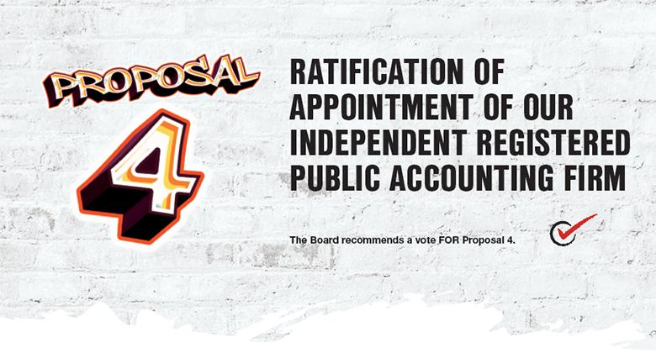

The Audit Committee is responsible for the appointment, compensation, retention, and oversight of the independent registered public accounting firm retained to audit the Company’s financial statements. The Audit Committee conducts an annual evaluation of the independent registered public accounting firm’s qualifications, performance, and independence. The Audit Committee exercises sole authority to approve all audit engagement fees.

The Audit Committee ensures the regular rotation of the lead audit partner, as required by law. The Audit Committee is also involved in reviewing, evaluating, and selecting the new lead audit partner, based on their qualifications, when the previous lead audit partner is required to rotate off the audit engagement. In evaluating and selecting a lead audit partner, the Audit Committee provides selection criteria to KPMG LLP to which KPMG LLP responds with a roster of qualified candidates. Two members of the Audit Committee, along with the Audit Committee Chair and the Lead Independent Director, interview the candidates. The Chief Executive Officer, Chief Financial Officer, and Chief Accounting Officer also interview the candidates. The Audit Committee Chair and proposed lead audit partner meet in executive session. The Audit Committee Chair then recommends his selection to the Audit Committee for its consideration and approval.

The Audit Committee has appointed KPMG LLP as our independent registered public accounting firm for the 2022 fiscal year. We are asking shareholders at this meeting to ratify this appointment of KPMG LLP for 2022. KPMG LLP has served as our independent registered public accounting firm since 1995. The Audit Committee and the Board believe that the continued retention of KPMG LLP to serve as the Company’s independent registered public accounting firm is in the best interests of the Company and its shareholders. Although ratification is not required by our By-Laws or otherwise, the Board is submitting the appointment of KPMG LLP to our shareholders for ratification because we value our shareholders’ views regarding this appointment and because we view it as a good corporate governance practice. In the event that shareholders fail to ratify this appointment, it will be considered a recommendation to the Board and the Audit Committee to consider selecting a different firm. Even if the appointment is ratified, the Audit Committee may in its discretion select a different independent registered public accounting firm at any time during the year if it determines that such a change would be in the best interests of the Company and its shareholders.

Representatives of KPMG LLP will be present at the Annual Meeting and will have an opportunity to make a statement and respond to appropriate questions.

2022 PROXY STATEMENT | 99

PROPOSAL 4: RATIFICATION OF APPOINTMENT OF OUR INDEPENDENT REGISTERED PUBLIC ACCOUNTING FIRM

AUDIT AND NON-AUDIT FEES

The following table shows the fees we paid to KPMG LLP for the audit of the Company’s annual financial statements for 2020 and 2021, as well as the fees billed for other services KPMG LLP provided during these two fiscal years:

 | 2020 | 2021
Category | ($) | ($)
Audit Fees⁽¹⁾ | 4,056,000 | 5,397,000
Audit-Related Fees⁽²⁾ | 324,000 | 3,061,000
Tax Fees⁽³⁾ | 304,000 | 515,000
Total | 4,684,000 | 8,973,000

- Audit fees consisted of professional services provided in connection with the audit of our annual financial statements, reviews of financial statements included in our Quarterly Reports on Form 10-Q, as well as work generally only the independent auditor can reasonably be expected to provide, such as statutory audits.

- Audit-related fees consisted principally of audits of financial statements of certain employee benefit plans, the Foot Locker Foundation, and due diligence related to certain acquisitions.

- Tax fees consisted of corporate income tax compliance assistance and tax compliance related to certain acquisitions.

AUDIT COMMITTEE PREAPPROVAL POLICIES AND PROCEDURES

The Audit Committee has a policy that all audit and non-audit services to be provided by our independent accountants, including services for our subsidiaries and affiliates, are to be approved in advance by the Audit Committee, regardless of the estimated cost for providing such services. The Audit Committee has delegated this authority to the Audit Committee Chair to approve fees between meetings, and then the fees are reviewed with the Audit Committee at a subsequent meeting. Management reviews the total amount and nature of the audit and non-audit services provided by the independent accountants since its prior meeting, including services for our subsidiaries and affiliates, with the Audit Committee at regularly-scheduled meetings.

- FOOT LOCKER, INC.

PROPOSAL 4: RATIFICATION OF APPOINTMENT OF OUR INDEPENDENT REGISTERED PUBLIC ACCOUNTING FIRM

AUDIT COMMITTEE REPORT

In accordance with the charter adopted by the Board, the Audit Committee assists the Board in fulfilling its oversight responsibilities of the Company’s accounting policies and practices, as well as financial reporting. The Audit Committee is responsible for the appointment, compensation, and oversight of the independent registered public accounting firm. The Company’s management is responsible for preparing our financial statements and establishing and maintaining adequate internal controls over financial reporting.

The Audit Committee consists of six independent directors named below, as independence is defined under the NYSE rules. All of the Audit Committee members meet the expertise requirements under the NYSE rules.

The Audit Committee held nine meetings in 2021. At its meetings during 2021, the Audit Committee discussed with management, the Company’s independent registered public accounting firm (KPMG LLP), and the Company’s internal auditors the assessment of the Company’s internal control over financial reporting. The Audit Committee also discussed with KPMG LLP its attestation report and opinion on the Company’s internal control over financial reporting contained in the Annual Report. The Audit Committee regularly meets privately with KPMG LLP, the internal auditors, and the Vice President of Internal Audit during the year.

The Audit Committee reviewed and discussed with management and KPMG LLP the audited financial statements for the 2021 fiscal year, which ended January 29, 2022. The Audit Committee also discussed with KPMG LLP the matters required to be discussed by applicable PCAOB and SEC standards. The Audit Committee, both with and without management present, discussed and reviewed the results of KPMG LLP’s examination of the financial statements and the overall quality of the Company’s financial reporting.

The Audit Committee engages in an annual evaluation of the independent registered public accounting firm’s qualifications. In evaluating and selecting the Company’s independent registered public accounting firm, the Audit Committee considered, among other things:

- historical and recent performance of the current independent audit firm;

- an analysis of known significant legal or regulatory proceedings related to the firm;

- external data on audit quality and performance, including PCAOB reports;

- industry experience;

- audit fee revenues;

- firm capabilities and audit approach; and

- the independence, tenure, and partner rotation of the audit firm.

The Audit Committee also considers the advisability and potential impact of selecting a different independent registered public accounting firm. The Audit Committee obtained from KPMG LLP the written disclosures and the letter required by applicable PCAOB requirements regarding the independent accountant’s communications with the Audit Committee concerning independence, and has discussed with KPMG LLP its independence and any relationships that may affect its objectivity. The Audit Committee also considered whether the non-audit services provided to the Company by KPMG LLP are compatible with maintaining KPMG LLP’s independence. The Audit Committee has satisfied itself that KPMG LLP is independent.

As a result of this evaluation, the Audit Committee approved the appointment of KPMG LLP as the Company’s independent registered public accounting firm for the fiscal year ending January 29, 2022, subject to shareholder ratification.

Based on the review and discussions referred to above, the Audit Committee recommended to the Board that the audited financial statements be included in the Annual Report.

Members of the Audit Committee


GUILLERMO G. | VIRGINIA C. | MATTHEW M. | DARLENE | ULICE | DONA D.
MARMOL | DROSOS | MCKENNA | NICOSIA | PAYNE, JR. | YOUNG
Chair | Member | Member | Member | Member | Member
 |  |  |  | 2022 PROXY STATEMENT |  | 101



DIRECTORS AND EXECUTIVE OFFICERS

The table below shows the number of shares of Common Stock reported to us as beneficially owned by each of our directors and NEOs, and by all directors, NEOs, and other executive officers as a group, as of the Record Date, including shares of Common Stock that they have a right to acquire within 60 days after the Record Date by the exercise of stock options.

Mr. Johnson beneficially owned 1.5% of the total number of outstanding shares of Common Stock as of the Record Date. No other director or NEO beneficially owned 1% or more of the total number of outstanding shares as of the Record Date. Each person has sole voting and investment power for the number of shares shown, except as otherwise noted below:

 | Common Stock | Stock Options
 | Beneficially Owned | Exercisable Within
 | Excluding Stock | 60 Days After | DSUs, RSUs,
 | Options | 3/21/22 | and PSUs | Total
Name | (#)⁽¹⁾ | (#) | (#)⁽²⁾ | (#)
Bracken | 4,022 | 36,599 | 19,123 | 59,744
Drosos | – | – | – | –
Feldman | 76,274 | – | 31,739 | 108,013
Gray | 7,626 | 65,871 | 13,710 | 87,207
Johnson | 344,206 | 974,230 | 105,948 | 1,424,384
Marmol | 44,408 | – | 1,136 | 45,544
Martin | 28,271 | 82,384 | 19,841 | 130,496
McKenna | 12,008 | – | 1,136 | 13,144
Nicosia | 6,045 | – | 1,569 | 7,614
Oakland | 17,983 | – | 7,117 | 25,100
Page | – | 2,777 | 15,725 | 18,502
Payne | 13,297 | – | 2,450 | 15,747
Peters | 145,601⁽³⁾ | 194,553 | 37,048 | 377,202
Talwar | 17,263⁽³⁾ | – | 7,433 | 24,696
Underhill | 15,443 | – | 1,136 | 16,579
Walker | 4,829 | – | 2,373 | 7,202
Young | 49,515 | – | 76,659 | 126,174
All 25 directors and executive officers as a group, including the NEOs | 927,220 | 1,640,476 | 402,301 | 2,969,997⁽⁴⁾

- This column includes shares held in the Company’s 401(k) Plan.

- This column includes the (a) DSUs credited to the accounts of the directors who elected to defer all or part of their annual retainer fee, (b) executives’ unvested RSUs, and (c) earned but unvested PSUs. The DSUs, RSUs, and PSUs do not have current voting or investment power.

- This information is based on the last beneficial ownership reports filed on behalf of Ms. Peters and Mr. Talwar with the SEC on March 30, 2021 and May 17, 2021, respectively, and also includes 7,209 RSUs that were accelerated in connection with Ms. Peters’s departure.

- This number represents approximately 3.1% of the shares of Common Stock outstanding at the close of business on the Record Date.

- FOOT LOCKER, INC.

SHARE OWNERSHIP

PRINCIPAL SHAREHOLDERS

The table below provides information on shareholders who beneficially owned more than 5% of our Common Stock as of December 31, 2021 according to reports filed with the SEC. To the best of our knowledge, there are no other shareholders who beneficially own more than 5% of a class of the Company’s voting securities.

 | Amount and Nature | Percent
 | of Beneficial Ownership | of Class
Name and Address of Beneficial Owner | (#) | (%)
Vesa Equity Investment S.à r.l., EP Investment S.à r.l., and Daniel Křetínský | 12,750,317^{(a)} | 12.9^{(a)}
39 Avenue John F. Kennedy
L-1855 Luxembourg, Luxembourg
The Vanguard Group, Inc. | 11,309,861^{(b)} | 11.27^{(b)}
100 Vanguard Boulevard
Malvern, Pennsylvania 19355
BlackRock, Inc. | 7,742,626^{(c)} | _{7.7}(c)
55 East 52nd Street
New York, New York 10055
FMR LLC | 8,622,922^{(d)} | 8.591^{(d)}
245 Summer Street
Boston, Massachusetts 02210
Boston Partners | 5,474,042^{(e)} | 5.45^{(e)}
One Beacon Street, 30th Floor
Boston, Massachusetts 02108

- Reflects shares beneficially owned as of July 14, 2021 according to Form 4 filed with the SEC. As reported in this Form 4, Vesa Equity Investment S.à r.l. is the record holder of the reported shares of Common Stock. The principal shareholder of Vesa Equity Investment S.à r.l. is EP Investment S.à r.l., the ultimate beneficial owner of which is Daniel Křetínský. Each of Mr. Křetínský and EP Investment S.à r.l. may be deemed to hold shared voting power with respect to 12,750,317 shares and shared dispositive power with respect to 12,750,317 shares, and to be an indirect beneficial owner of the shares owned by Vesa Equity Investment S.à r.l.

- Reflects shares beneficially owned as of December 31, 2021 according to Amendment No. 12 to Schedule 13G filed with the SEC. As reported in this schedule, The Vanguard Group, an investment adviser, holds shared voting power with respect to 56,593 shares, sole dispositive power with respect to 11,180,393 shares, and shared dispositive power with respect to 129,468 shares.

- Reflects shares beneficially owned as of December 31, 2021 according to Amendment No. 13 to Schedule 13G filed with the SEC. As reported in this schedule, BlackRock, Inc., a parent holding company, holds sole voting power with respect to 7,434,875 shares and sole dispositive power with respect to 7,742,626 shares.

- Reflects shares beneficially owned as of December 31, 2021 according to Amendment No. 1 to Schedule 13G filed with the SEC. As reported in this schedule, FMR LLC holds sole voting power with respect to 1,024,117 shares. Each of Crosby Advisors LLC, FIAM LLC, Fidelity Institutional Asset Management Trust Company, Fidelity Management & Research Company LLC, Fidelity Management Trust Company, and Strategic Advisers LLC beneficially own shares. Abigail P. Johnson is a Director, the Chairman, and the Chief Executive Officer of FMR LLC. Neither FMR LLC nor Ms. Johnson has the sole power to vote or direct the voting of the shares owned directly by the various investment companies registered under the Investment Company Act (“Fidelity Funds”) advised by Fidelity Management & Research Company LLC (“FMR Co. LLC”), a wholly-owned subsidiary of FMR LLC, which power resides with the Fidelity Funds’ Boards of Trustees. FMR Co. LLC carries out the voting of the shares under written guidelines established by the Fidelity Funds’ Boards of Trustees.

- Reflects shares beneficially owned as of December 30, 2021 according to Amendment No. 1 to Schedule 13G filed with the SEC. As reported in this schedule, Boston Partners, an investment adviser, holds sole voting power with respect to 4,089,913 shares, shared voting power with respect to 9,361 shares, and sole dispositive power with respect to 5,474,042 shares.

2022 PROXY STATEMENT | 103



Nominations and
Shareholder Proposals | Procedure | Deadline
Proposals for | Under SEC Rule 14a-8, if a shareholder would like us to include a proposal in our | December 9, 2022
Inclusion in Our 2023 | Proxy Statement and form of proxy for the 2023 annual meeting, our Secretary must
Proxy Materials | receive the proposal at our Corporate Headquarters in order to be considered for
 | inclusion in the 2023 proxy statement.

Director Nominations Under our proxy access by-law, a shareholder, or a group of up to 20 shareholders,
for Inclusion in Our owning at least 3% of the outstanding Common Stock continuously for at least three
2023 Proxy Materials years as of the date of the notice of nomination, may nominate and include in the
(Proxy Access) Company’s proxy materials director nominees constituting up to two individuals or
20% of the Board, whichever is greater (subject to certain limitations set forth in the By-Laws), provided that the shareholder(s) and nominee(s) satisfy the requirements specified in the By-Laws. Notices of proxy access nomination for the 2023 annual meeting should be addressed to our Secretary at our Corporate Headquarters. You should carefully review the requirements specified in the By-Laws, which are available at investors.footlocker-inc.com/by-laws.

No earlier than November 9, 2022 and no later than December 9, 2022

Other Proposals or
Nominations for the
2023 Annual Meeting

For any shareholder proposal that is not submitted under SEC Rule 14a-8, and any nomination of directors not submitted pursuant to our proxy access by-law provision, our By-Laws describe the procedures that must be followed. Proposals for nomination for directors and other items of business should be addressed to our Secretary at our Corporate Headquarters and must contain the information specified in the By-Laws, which are available at investors.footlocker-inc. com/by-laws.

No earlier than January 18, 2023 and no later than February 17, 2023. However, if we hold the 2023 annual meeting on a date that is not within 25 days before or after the first anniversary of the prior year’s annual meeting, then we must receive the notice no later than ten days after the earlier of the date we first provide notice of the meeting to shareholders or announce it publicly.

By Order of the Board of Directors

SHEILAGH M. CLARKE

Executive Vice President, General Counsel and Secretary

April 8, 2022

- FOOT LOCKER, INC.



Q: What constitutes a quorum for the Annual Meeting?

- We will have a quorum and be able to conduct the business of the Annual Meeting if the holders of a majority of the shares outstanding and entitled to vote are present at the meeting, either in person or by proxy. We will count abstentions and broker non-votes, if any, as present and entitled to vote in determining whether we have a quorum.

Q: Who may vote at the Annual Meeting?

- Only shareholders of record on the books of the Company as of the Record Date are entitled to vote at the Annual Meeting, and any adjournments or postponements of the meeting, on the items of business described in this Proxy Statement. There were 96,089,997 shares of Common Stock outstanding as of the Record Date. Each share of Common Stock is entitled to one vote.

Q: Can I vote shares held in employee plans?

- If you hold shares of Common Stock through the 401(k) Plan or the 1165(e) Plan, your proxy card includes the number of shares allocated to your plan account. Your proxy card will serve as a VIF for these shares for the plan trustee to vote the shares. The trustee will vote only those shares for which voting instructions have been given. To allow sufficient time for voting by the trustees of these plans, your voting instructions must be received by 11:59 p.m. EDT on May 15, 2022.

Q: Could matters be voted on at the Annual Meeting other than the proposals on page 1?

- We do not know of any other business that will be presented at the Annual Meeting. If any other matters are properly brought before the meeting for consideration, then the persons named as proxies will have the discretion to vote on those matters for you using their best judgment.

Q: What happens if I do not vote my shares?

- This depends on how you hold your shares and the type of proposal. If you hold your shares in “street name,” such as through a bank or brokerage account, it is important that you cast your vote if you want it to count for Proposals 1, 2, and 3. If you do not instruct your bank or broker regarding how to vote your shares, no votes will be cast on your behalf on Proposals 1, 2, and 3 because the broker does not have discretionary authority to vote. This is called a “broker non-vote.” Your bank or broker will have discretion to vote any uninstructed shares on Proposal 4.

If you are a “shareholder of record,” meaning your stock ownership is reflected directly on the books and records of the Company’s transfer agent, or if you hold your shares through the 401(k) Plan or 1165(e) Plan, no votes will be cast on your behalf on any of the proposals if you do not cast your vote.

Q: How will the votes be counted?

- Votes will be counted and certified by an independent inspector of election.

If you abstain from voting or there is a broker non-vote on any matter, your abstention or broker non-vote will not affect the outcome of such vote because abstentions and broker non-votes are not considered to be votes cast.

Q: Can I change my mind after voting my shares?

- Yes, you may revoke your proxy at any time before it is used by:

  - sending a written notice to our Secretary at our Corporate Headquarters,

  - delivering a valid proxy card with a later date,

  - providing a later-dated vote by telephone, scanning, internet, or app, or

  - voting at the Annual Meeting.

Q: How do I attend the Annual Meeting?

- We are pleased to welcome shareholders to the Annual Meeting. The Annual Meeting will be held in a virtual format only to provide a safe experience for our shareholders and team members. All shareholders will be afforded the same rights they would have had at a physical meeting.

2022 PROXY STATEMENT | 105

FREQUENTLY ASKED QUESTIONS

The live audio webcast of the meeting will begin promptly at 9:00 a.m. EDT. Online access to the audio webcast will open shortly prior to the start of the meeting to allow time for you to log-in and test your device’s audio system. We encourage you to access the meeting in advance of the designated start time. A support line will be available on the meeting website shortly prior to, and during, the meeting to assist shareholders with any technical difficulties they may have accessing or hearing the meeting.

To be admitted to the Annual Meeting, you will need to log-in to virtualshareholdermeeting.com/FL2022 using the 16-digit control number found on your Notice, proxy card, VIF, or email previously sent to shareholders entitled to vote at the Annual Meeting.

Even if you plan on attending the Annual Meeting, we encourage you to vote your shares in advance using one of the methods described in this Proxy Statement to ensure that your vote will be represented at the Annual Meeting.

Q: Will there be a question and answer session at the Annual Meeting?

- Shareholders may submit a question in advance of the meeting by emailing the Company at ir@footlocker.com. Live questions may be submitted online shortly prior to, and during, the Annual Meeting by logging in with the 16-digit control number at virtualshareholdermeeting.com/FL2022. We will answer questions during the meeting that are pertinent to the Company as time permits and in accordance with our rules of conduct for the Annual Meeting, which will be available on the virtual meeting website. Questions and answers may be grouped by topic and substantially similar questions may be grouped and answered once.

Answers to any pertinent questions that are not addressed during the meeting may be published following the meeting on our corporate website at footlocker.com/corp.

Q: Will the Annual Meeting be available for replay?

- A replay of the Annual Meeting will be made publicly available approximately 24 hours after the Annual Meeting at virtualshareholdermeeting.com/FL2022. The replay will be available for one year.

- The Company will pay for the cost of the solicitation of proxies, including the preparation, printing, and mailing of the proxy materials.

Proxies may be solicited, without additional compensation, by our directors, officers, or team members by mail, telephone, facsimile, in person, or otherwise. We will request banks, brokers, and other custodians, nominees, and fiduciaries to deliver proxy materials to the beneficial owners of the Common Stock and obtain their voting instructions, and we will reimburse those firms for their expenses under both SEC and NYSE rules. In addition, we have retained Innisfree M&A Incorporated to assist us in the solicitation of proxies for a fee of $15,000 plus out-of-pocket expenses.

Q: Why did I receive a notice but no proxy materials?

- We are furnishing proxy materials to our shareholders primarily over the internet under the SEC’s notice and access rules instead of mailing full sets of the printed materials. We believe that this procedure reduces costs, provides greater flexibility to our shareholders, and decreases the environmental impact of our Annual Meeting. For additional information regarding our commitment to the environment, see our Global Environmental and Climate Change Statement available at investors.footlocker-inc.com/climate. On or about April 8, 2022, we started mailing a Notice to most of our shareholders in the United States. The Notice contains instructions on how to access our Proxy Statement and Annual Report on the internet and vote online. If you received a Notice, you will not receive paper copies of the proxy materials, unless you request them. If you received a Notice and would like to receive paper copies of the proxy materials, please follow the instructions on the Notice for requesting the materials, and we will promptly mail the materials to you.

We are mailing to shareholders, or making available to shareholders via the internet, this Proxy Statement, form of proxy card, and our Annual Report on or about April 8, 2022.

Q: What is “householding” and how does it affect me?

- The Company has adopted the “householding” procedure approved by the SEC, which allows us to deliver one set of documents to a household of shareholders instead of delivering a set to each shareholder in a household, unless we have been instructed otherwise. This procedure is more environmentally friendly and cost-effective because it reduces the number of copies to be printed and mailed. Shareholders who receive proxy materials in paper form will continue to receive separate proxy cards/VIFs to vote their shares. Shareholders who receive the Notice will get instructions on submitting their proxy cards/VIF via the internet.

If you would like to change your householding election, request that a single copy of the proxy materials be sent to your address, or request a separate copy of the proxy materials, please contact Broadridge Financial Solutions, Inc. using their contact information provided under Helpful Resources on page 107. We will promptly deliver the proxy materials to you upon receipt of your request. If you hold your shares in street name, please contact your bank, broker, or other record holder to request information about householding.

- FOOT LOCKER, INC.

Annual Meeting

Board of Directors

Board
Committees
Committee Charters
Audit Committee
Finance Committee
Human Capital Committee

Responsibility Committee

ESG

Impact Report

Financial Reporting

Annual Report

Foot Locker, Inc.

Corporate Website
Leadership Team
Investor Relations

Governance Documents

Anti-Corruption Policy
By-Laws
Certificate of Incorporation
Code of Business Conduct
Code of Business Conduct Waivers
Conflict Minerals Policy
Corporate Governance Guidelines
Global Environmental and Climate Change Statement Global Human Rights Statement

Global Occupational Health and Safety Statement Global Sourcing Guidelines

Global Water Stewardship Statement Procedures for Communications with the Board

Contacts

To Request Copies of our Annual Report, Committee Charters, or Governance Documents

Company Contacts

Board or General Counsel and Secretary

sclarke@footlocker.com

Investor Relations

ir@footlocker.com

or mail to our Corporate Headquarters,

attention to the applicable contact

Corporate Headquarters

Foot Locker, Inc.

330 West 34th Street
New York, New York 10001
212-720-3700

virtualshareholdermeeting.com/FL2022


investors.footlocker-inc.com/board

investors.footlocker-inc.com/bcommittees

investors.footlocker-inc.com/audit

investors.footlocker-inc.com/finance
investors.footlocker-inc.com/comp
investors.footlocker-inc.com/gov

investors.footlocker-inc.com/impactreport

investors.footlocker-inc.com/ar

footlocker.com/corp

investors.footlocker-inc.com/management
investors.footlocker-inc.com/ir

investors.footlocker-inc.com/acp

investors.footlocker-inc.com/by-laws
investors.footlocker-inc.com/coi
investors.footlocker-inc.com/cobc
investors.footlocker-inc.com/cobcwaivers
investors.footlocker-inc.com/conflictminerals
investors.footlocker-inc.com/cgg
investors.footlocker-inc.com/climate
investors.footlocker-inc.com/humanrights
investors.footlocker-inc.com/safety
investors.footlocker-inc.com/gsg
investors.footlocker-inc.com/water

investors.footlocker-inc.com/boardcomms

To Request Copies of the Internet Notice or Proxy Materials

Broadridge Financial Solutions, Inc.

(Tabulator/Inspector of Election)
proxyvote.com
sendmaterial@proxyvote.com
800-579-1639

To Change Your Householding Election

Broadridge Financial Solutions, Inc.

Householding Department
51 Mercedes Way
Edgewood, New York 11717

For Questions or Assistance Voting

Innisfree M&A Incorporated

(Proxy Solicitor)
Shareholders in the United States and Canada: 877-750-2689
Shareholders in all other locations: 412-232-3651
Banks and brokers: 212-750-5833

2022 PROXY STATEMENT | 107

This page intentionally left blank.




330 WEST 34TH STREET

NEW YORK, NEW YORK 10001

TO VOTE, MARK BLOCKS BELOW IN BLUE OR BLACK INK AS FOLLOWS:

VOTE BY INTERNET

Before The Meeting - Go to www.proxyvote.com or scan the QR Barcode above

Use the Internet to transmit your voting instructions and for electronic delivery of information up until 11:59 P.M. Eastern Time the day before the cut-off date or meeting date. Follow the instructions to obtain your records and to create an electronic voting instruction form.

During The Meeting - Go to www.virtualshareholdermeeting.com/FL2022

You may attend the meeting via the Internet and vote during the meeting. Have the information that is printed in the box marked by the arrow available and follow the instructions.

VOTE BY PHONE - 1-800-690-6903

Use any touch-tone telephone to transmit your voting instructions up until 11:59 P.M. Eastern Time the day before the cut-off date or meeting date. Have your proxy card in hand when you call and then follow the instructions.

VOTE BY MAIL
Mark, sign and date your proxy card and return it in the postage-paid envelope we have provided or return it to Vote
Processing, c/o Broadridge, 51 Mercedes Way, Edgewood, New York 11717.

D67373-P64618 KEEP THIS PORTION FOR YOUR RECORDS DETACH AND RETURN THIS PORTION ONLY
THIS PROXY CARD IS VALID ONLY WHEN SIGNED AND DATED.

 | FOOT LOCKER, INC.
 | Proposals - The Board of Directors recommends a vote FOR each of
 | the nominees, FOR Proposal 2, 1 Year for Proposal 3, and FOR
 | Proposal 4.
 | 1. Elect Ten Directors to the Board to Serve for One-Year Terms.
 |  |  |  |  |  |  |  |  |  |  |  |  |  |  |  |  | For | Against | Abstain
 | Nominees: |  |  |  |  |  |  |  |  |  | For | Against | Abstain |  |  |  | For | Against
 | 1a. | Virginia C. Drosos |  |  |  |  |  |  |  |  |  |  |  | 2. Vote, on an Advisory Basis, to Approve the Company's Named
 |  |  |  |  |  |  |  |  |  |  |  |  |  | Executive Officers' Compensation.
 | 1b. | Alan D. Feldman |  |  |  |  |  |  |  |  |  |  |  |  | 1 Year |  | 2 Years | 3 Years | Abstain
 | 1c. | Richard A. Johnson |  |  |  |  |  |  |  |  |  |  |  | ₃. Vote, on an Advisory Basis, on whether the Shareholder Vote to
 |  |  |  |  |  |  |  |  |  |  |  |  |  | Approve the Company's Named Executive Officers' Compensation
 | 1d. | Guillermo G. Marmol |  |  |  |  |  |  |  |  |  |  |  | Should Occur Every 1, 2, or 3 Years.
 | 1e. | Darlene Nicosia |  |  |  |  |  |  |  |  |  |  |  |  |  |  | For | Against | Abstain
 | 1f. | Steven Oakland |  |  |  |  |  |  |  |  |  |  |  | 4. Ratify the Appointment of KPMG LLP as the Company's Independent
 |  |  |  |  |  |  |  |  |  |  |  |  |  | Registered Public Accounting Firm for the 2022 Fiscal Year.
 | 1g. | Ulice Payne, Jr. |  |  |  |  |  |  |  |  |  |  |  | NOTE: Such other business as may properly come before the meeting or
 |  |  |  |  |  |  |  |  |  |  |  |  |  | any adjournment thereof.
 | 1h. | Kimberly Underhill
 | 1i. | Tristan Walker
 | 1j. | Dona D. Young |  |  |  |  |  |  |  |  |  |  |  | Please indicate if you plan to attend this meeting.
 |  |  |  |  |  |  |  |  |  |  |  |  |  |  |  |  | Yes | No
 | Please sign exactly as your name(s) appear(s) hereon. When signing as attorney, executor, administrator, or other fiduciary, please give full title as such. Joint owners should each sign personally. All holders must sign. If a
 | corporation or partnership, please sign in full corporate or partnership name by authorized officer.
 | Signature [PLEASE SIGN WITHIN BOX] |  |  |  |  |  |  |  | Date |  |  |  |  | Signature (Joint Owners) | Date

Important Notice Regarding the Availability of Proxy Materials for the Annual Meeting:

The Notice and Proxy Statement and Annual Report with Form 10-K are available at www.proxyvote.com.

D67374-P64618


FOOT LOCKER, INC.

Annual Meeting of Shareholders

May 18, 2022 at 9:00 A.M. Eastern Daylight Time

This proxy is solicited by the Board of Directors of Foot Locker, Inc.

Andrew E. Page, Sheilagh M. Clarke, and John A. Maurer, or any of them, each with the power of substitution, are hereby authorized to vote the shares of the undersigned at the Annual Meeting of Shareholders of Foot Locker, Inc., to be held on May 18, 2022, at 9:00 A.M., local time, virtually at www.virtualshareholdermeeting.com/FL2022, and at any adjournment or postponement thereof, upon the matters set forth in Foot Locker, Inc.'s Proxy Statement and upon such other matters as may properly come before the Annual Meeting, voting as specified on the reverse side of this card with respect to the matters set forth in the Proxy Statement, and voting in the discretion of the above-named persons on such other matters as may properly come before the Annual Meeting.

IF YOU ARE NOT VOTING BY TELEPHONE OR INTERNET, PLEASE SIGN AND DATE THE REVERSE SIDE OF THIS PROXY CARD AND PROMPTLY RETURN IT IN THE ENCLOSED ENVELOPE. THE PERSONS NAMED ABOVE AS PROXIES CANNOT VOTE THE SHARES UNLESS YOU SIGN AND RETURN THIS CARD OR VOTE BY TELEPHONE OR INTERNET. YOU MAY SPECIFY YOUR CHOICES BY MARKING THE APPROPRIATE BOXES, BUT YOU NEED NOT MARK ANY BOX IF YOU WISH TO VOTE IN ACCORDANCE WITH THE BOARD OF DIRECTORS' RECOMMENDATIONS.

EMPLOYEE PLANS

IF YOU ARE A PARTICIPANT IN THE FOOT LOCKER 401(k) PLAN OR THE FOOT LOCKER PUERTO RICO 1165(e) PLAN, BY SIGNING AND RETURNING THIS PROXY CARD (OR VOTING BY TELEPHONE OR INTERNET), YOU WILL AUTHORIZE THE PLAN TRUSTEES TO VOTE THOSE SHARES ALLOCATED TO YOUR ACCOUNT AS YOU HAVE DIRECTED.

Continued and to be signed on reverse side

